
Instant Payments Namibia
Date: 22 October 2025
Document: INSTANT PAYMENT SOLUTION FUNCTIONAL SPECIFICATIONS
DOCUMENT (FSD) V_10.0

Disclaimer: This document contains confidential information intended solely for the use of authorised recipients within or engaged by the Bank of Namibia. Unauthorised disclosure, copying, distribution, or use of any part of this document is strictly prohibited. Any person who is not an intended recipient is hereby notified that any review, dissemination, or reliance on this document’s content is not permitted. If you have received this document in error, please notify the Bank of Namibia immediately and delete all copies of this document from your

Table of Contents

PART A: PRELIMINARY 6
- REFERENCES AND VERSION HISTORY 6
  - Version History 6
- DOCUMENT REFERENCES 9
- PURPOSE OF THIS DOCUMENT 9
- STAKEHOLDER SUMMARY 10
  - Non-Industry Stakeholder List 10
  - Industry Stakeholder List 11
- DEFINITION OF TERMS AND ACRONYMS 12
  - Abbreviations 12
  - Definitions 14
- SOLUTION OVERVIEW 18
  - Introduction 18
  - IPS Design Principles 19
  - Overview of Enabled Use Cases and Channels 20
  - Enabled use cases: P2P, P2B, G2P, and B2P, merchant cash-out, Merchant cash- in, and ATM cash-out. 21
  - Participation Overview 22
  - Alias / Handle Overview 25
  - Switching Services 26
  - Fraud and Risk Management 27
  - Supporting Services 27
- SCOPE 28
  - Document Scope 28
  - Solution Scope 28
  - Industry Projects to Consider. 29
PART B: SOLUTION FRAMEWORK 30
- OVERVIEW OF APPLICATION PROGRAMMING INTERFACES 30
  - Financial Transactions APIs 30
  - Non-Financial Transactions APIs 31
- ALIAS / HANDLE MANAGEMENT 33
  - Alias / Handle Model 33
  - Alias Registration 35
- USER REGISTRATION PROCESS 37
  - Device Binding Flow on Mobile Application 37
  - Mobile App First Time Registration 40
  - Registering User Store of Value 48
  - Central USSD First Time Registration 49
  - Setting IPS Pin 55
- ALIAS DIRECTORY 57
  - Mobile Number Rules 57
  - Merchant Unique Code Rules 58
  - General Alias Directory Rules 58
  - Alias Directory Operations 59
  - First Time User ID Registration Flow 60
  - Creation of IPS Number as Numeric ID Existing User 62
  - Deregistration of a Mobile Number 62
  - Deregistration of a Unique Number 62
  - Transfer of Mobile Number between IPS Participants 63
  - Register to Alias Directory 64
  - ReqValAdd API 66
  - Get Address API 67
  - IPS Participants Sync 69
- FUNCTIONAL FLOWS 70
  - P2P Transactions: Send Money (Mobile App) 70
  - USSD P2P Transaction: Send Money 76
  - P2B/M Transactions (Mobile App) 79
  - USSD P2M Transaction: Merchant payment 82
  - B/G2P Transactions: Bulk Payment 85
  - Merchant Cash-Out (Mobile App) 88
  - USSD Merchant Cash-out Transaction 91
  - Merchant Cash-In (Mobile App) 94
  - USSD Merchant Cash-In Transaction 96
  - ATM Cash-out 99
- NEGATIVE SCENARIOS 107
  - Registration Negative Scenarios 107
  - Transaction Negative Scenarios 110
  - Error Codes 114
- USER PROFILE MANAGEMENT SERVICES 115
  - Set Pin and Changing Pin 115
  - Balance Enquiry 117
- DISPUTE MANAGEMENT PROCESS & QUERY MANAGEMENT 119
  - Dispute Management 119
  - Chargeback 122
  - Pre-Arbitration 123
  - Arbitration 123
- FRAUD AND RISK MANAGEMENT 127
  - FRM Capability Overview 127
  - Purpose and Objectives 127
  - Rule Configuration and Execution 128
  - IPS Transaction Flow with eFRM 129
  - Operational Behaviour 129
  - Configuration of EFRM Rules 130
PART C: PARTICIPANT ONBOARDING 131
- INFRASTRUCTURE REQUIREMENTS 131
- ONBOARDING AND CERTIFICATION 132
- Participant Onboarding 132
- Certification Phase 132
- Certification Process Diagram 134
- Production and Go-live 135
- HANDLE MANAGEMENT 136
  - Handle Registration 136
  - Handle Deregistration, Deactivation, and Reactivation 139
- BACK OFFICE AND SETTLEMENT SERVICES 140
  - Participant Identification Codes 140
  - Back Office Management 141
  - Back Office Process flow 144
  - Settlement Process 146
  - Pacs.009 File Specifications 148
  - Settlement Flow 148
  - Settlement Times 154
  - Settlement Reporting 155
  - Participant Net Settlement Reports 155
  - Liquidity Management 156
PART D: IPS PRICING MODEL 157
- PRICING COMPONENTS 157
  - Onboarding Fee 157
  - Participation Fee 157
  - Switching Fees and Interchange Rates 158
  - Exiting Fee 161
  - Additional Fees 161
PART E: IPS BUSINESS AND PRODUCT RULES 161
- IPS BUSINESS RULES 162
  - USSD Rules 162
  - . Mobile Application Rules 162
  - Purpose Codes 163
  - Initiation Modes 163
  - Transaction Limits, Purpose Codes, and Initiation Modes 164
- IPS PRODUCT RULES 168
- SERVICE LEVEL AGREEMENT 168
ANNEXURES 168

PART A: PRELIMINARY

REFERENCES AND VERSION HISTORY

Version History

Version | Date | Description | Author
1.0 | 08 November 2024 | First version of the FSD to Industry | Bank of Namibia
2.0 | 22 November 2024 | Second version with industry input incorporated (clean) | Bank of Namibia
3.0 | 03 December 2024 | - Revised the onboarding and 2 step verification process.  - Included the IPS pricing model.  - Clarified central USSD functionality.  - Revised ATM cash-out flow  - Included the dispute management and charge back process.  - Included business rules for USSD, and mobile applications | Bank of Namibia
4.0 | 09 December 2024 | - Fixed ATM withdrawal rule (no predefining and blocking funds at OTP generation stage)  - NPCI input incorporated. | Bank of Namibia
5.0 | 13 December 2024 | - 2 stage verification flow revised.  - Clarification of transaction limits  - Gramma fixes | Bank of Namibia and NPCI
6.0 | 16 January | - 2 stage verification revised  - Settlement reconciliation files added in excel doc on page 126 | NPCI
7.0 | 26 February 2025 | - ATM cash withdrawal flow updated | Bank of Namibia
8.0 | 23 April 2025 | - ReqValAdd API flow revised.  - Bulk payment flow included  - Purpose codes and initiation modes included.  - Reference to ID numbers for Government payments removed | Bank of Namibia

Version | Date | Description | Author
- MNO Verification flows revised
- USSD registration flow revised
- Clearing and settlement process revised.
8.1 | 10 June 2025 | - Section 10.3. Enhanced two- stage verification on mobile application wording.  - Section 10.4. Enhanced first time registration through Central USSD wording  - Section 11.11. Cleaned up ReqValAdd API table.  - Section 12.4. Enhanced B/G2P Transactions: Bulk Payment rules. | Instant Payments Namibia
9.0 | 31 July 2025 | - Section 10:3 Updated verification flow and removed OTP from MNO  - Section 10.4 Added USSD onboarding using mobile wallet Pin  - Section 10.5 Added Mobile APP Onboarding using Mobile Wallet PIN , Debit card and National ID  - Section 11.1 Update MNO Logic in Mobile number rules  - Section 11.2 Updated Merchant code rule  - Removed mapper.ipn from the FSD  - Section 20.5. Added Pacs.009 File Specifications  - Section 20.6 Added settlement flows (including the exception handling in 20.6.1 -20.6.3  - Reference to enabler in payment flows removed throughout the document | Instant Payments Namibia and NPCI
10.0 | 22 October 2025 | - Section 10.3 and 10.4 Amended the User onboarding flows for both USSD and Mobile Application to reflect the steps for linking of the mobile number to the long handle.  - Included Merchant cash in in the use cases. | Instant Payments Namibia and NPCI

Version | Date | Description | Author
- Section 11.1 Updated the MNO logic to make provision when a new MNO is onboarded
- Section 12.2 Removed payment via Account + IFSC.
- Section 12.3 Updated the MMID from 7 digits to 8 digits
- Section 12.6 Amended Merchant cash inflow to incorporate additions in the product rules.
- Amended section 16 EFRM capability and overview and added more detail regarding the EFRM Solution.
- Section 20.3.3 Added an additional point to the existing back-office process flow steps.
- Section 20.6.1 pacs.009 flow updated
- USSD Rules: amended the rules across to include Merchant cash in
- Section 10:4 Added General Rules covering SPV alias allocation, alias creation before SoV selection, and use of mobile number for USSD transactions.
- Amended settlement windows in section 20.
- Added Section 21.6 IPS Fee and Interchange structure
- Amended section 22 Transaction limits, purpose codes and initiation mode
Table 1: Version history

DOCUMENT REFERENCES
The following documents were referenced in the formulation of this functional specification document:
Title | Abbreviation
Bank of Namibia Open Banking Position Paper | BON OB
Bank of Namibia Quick Response Code Guidance Note | BON QR Code
Bank of Namibia Solution Design Document Version 0.2 | SDD
Determination for the Authorisation of Payment System Operators and System Participants in the National Payment System | PSD-6
Determination on Card Interchange and ATM Surcharging | PSD-11
Determination on the Issuance of Electronic Money in Namibia | PSD-3
Namclear New Services Functional Specification V6.0 | Namclear SFS
Payment System Management Act 14 of 2023 | PSM Act
Instant Payments Namibia Product Rules v.0.9 | IPN Product Rules
Instant Payment Solution Technical Specifications v.0.6 | IPS TSD
Table 2: Document references

PURPOSE OF THIS DOCUMENT

This document sets out to cover the functional requirements specifications (FRS) pertaining to the Instant Payment Solution (IPS). The purpose of the FRS is to define the functional scope by clearly outlining the functional capabilities, features, and use cases of the IPS. The target audience of this document are the prospective IPS participants (IPSPs) who have obtained the necessary approvals to participate on the IPS as well as the NPCI International Payments Limited (NIPL) who is the solutions and technology partner. This document will be used by the IPSPs to create user journeys, onboard IPS users onto the IPS switch and develop the functional specifications of the IPS use cases for go-live. It will be a living document that will be updated as additional use cases and functional flows are created. The technical specifications will be

addressed in a separate document which will be referred to as the Technical Specification Document (TSD).

STAKEHOLDER SUMMARY

Non-Industry Stakeholder List

No | Stakeholders | Type
1 | Bank of Namibia (BoN) | Solution Owner
2 | Communications Regulatory Authority of Namibia (CRAN) | Communications Regulator
3 | Instant Payments Namibia (IPN) | Fintech – Solution Operator
4 | Ministry of Finance and Public Enterprises | Government Ministry
5 | Ministry of Gender Equality, Poverty Eradication and Social Welfare | Government Ministry
6 | Namibia Financial Institutions Supervisory Authority (NAMFISA) | NBFI (Non-payment) Regulatory
7 | Namibia Revenue Authority (NAMRA) | Revenue Authority
8 | National Payment System and Financial Surveillance Department | Regulator
9 | NPCI International Payments Limited | Solutions and Technology Partner
10 | Payments Association of Namibia | Industry Body
11 | PWC Advisory Services | Project Manager
Table 3: Non-industry stakeholder list

Industry Stakeholder List

No | Stakeholders | Type
1 | Adumo | Third Party Payment Service Provider (Enabler)
2 | ATM Solutions | Third Party Payment Service Provider (Enabler)
3 | Banco Atlantico* | Bank (SOV Provider)
4 | Bank BIC* | Bank (SOV Provider)
5 | Bank Windhoek | Bank (SOV Provider)
6 | Buddy Industries* | Third Party Payment Service Provider (Enabler)
6 | Collexia | Payment Facilitator (Enabler)
7 | Currency Management and Banking Operations (Bank of Namibia) | Banker to Government (IPS Participant)
8 | EasyPay* | Third Party Payment Service Provider (Enabler)
9 | Ecentric Switch | Third Party Payment Service Provider (Enabler)
10 | First National Bank | Bank (SOV Provider)
11 | Hyphen* | Third Party Payment Service Provider (Enabler)
12 | Innervations | Third Party Payment Service Provider (Enabler)
13 | Letshego Bank | Bank (SOV Provider)
14 | MobiCash | Third Party Payment Service Provider (Enabler)
15 | Nam-mic Payment Solution | E-money Issuer (SOV Provider)
16 | Namclear | Payment System Operator (ACH)
17 | Nampost | Payment Instrument Issuer (SOV Provider)
18 | Nedbank Namibia | Bank (SOV Provider)
19 | Nutun Transact* | Third Party Payment Service Provider (Enabler)
20 | Payat* | Payment Facilitator (Enabler)
21 | PayMate | Payment Facilitator (Enabler)

No | Stakeholders | Type
22 | RealPay | Payment Facilitator (Enabler)
23 | Selcom | Payment Facilitator (Enabler)
24 | Standard Bank of Namibia | Bank (SOV Provider)
25 | Virtual Card Service – DPO | TPPP & Payment Facilitator (Enabler)
26 | Virtual Technology Services | E-money Issuer (SOV Provider)
27 | Vivo Energy* | E-money Issuer (SOV Provider)
28 | MTC Maris | E-money Issuer (SOV Provider)
Table 4: Industry stakeholder list

Note: * Did not form part of the Solution Design Sessions

DEFINITION OF TERMS AND ACRONYMS

Abbreviations

Abbreviation / Acronym | Description
2-FA | Two-factor authentication
ACH | Automated Clearing House
AML | Anti-Money Laundering
APP | Application
API | Application Programming Interface
ATM | Automated Teller Machine
B2G | Business-to-Government
CL | Common Library
FIC | Financial Intelligence Centre
FRM | Fraud Risk Management
G2P | Government-to-Person

Abbreviation / Acronym | Description
IFSC | Indian Financial System Code
IPP | Instant Payment Programme
IPS | Instant Payments Solution
IPSP | Instant Payment Solution Participant
IPN | Instant Payment Namibia
ISO | International Standards Organisation
MNO | Mobile Network Operator
NISS | Namibia Interbank Settlement System
NPCI | National Payment Corporation of India
NIPL | NPCI International Payment Limited
OTP | One Time Pin
PCH | Payment Clearing House
P2P | Person-to-Person
P2B/G | Person-to-Business, Person-to-Government
PIN | Personal Identification Number
POS | Point of Sale
PSP | Payment Service Provider
QR | Quick Response
QDMS | The Query and Dispute Management System is a service that will be provided by the Instant Payment Switch Operator to be used by the Instant Payment Switch Participants, in raising disputes or queries related to the instant payment transactions, on behalf of their customers.
RDS | Recommendations
SDK | Software Development Kit
SLA | Service Level Agreement
SoV | Store of Value
SPV | Special Purpose Vehicle

Abbreviation / Acronym | Description
SPOC | Single Point of Contact
SWIFT | Society for Worldwide Interbank Financial Telecommunications
TATs | Turnaround times
T+1 | Transaction date plus one business day
USSD | Unstructured Supplementary Service Data
IRCS | IPS Real Time Clearing and Settlement
Table 5: Abbreviations

Definitions

Term | Description
Action date | The date on which the transaction is to be actioned and settled. This is also referred to as Day 1.
Alias or Handle | A unique identifier that substitutes an individual or a merchant’s store of value details. The alias / handle is used to identify the user during a financial or nonfinancial transaction on the instant payment switch.
Alias directory | A digital registry that maps the full form alias version of the user with his/her mobile number, and a merchant with its unique number.
Beneficiary | A customer or merchant who receives money through the instant payment switch. Beneficiary’s store of value is credited as part of the payment transaction.
Charge back | A charge that is returned after a customer successfully disputes an item on an already completed transaction with his/her Store of Value (SoV).
Clearing (clear) | The process of transmitting, reconciling and, in some cases, confirming payment orders prior to settlement and possibly including the netting of instructions and the establishment of final positions for settlement. This is a back-office function by the Instant Payment Switch Operator.
Clearing cycle | The timeframe within a single business day which the settlement obligations are calculated.
Creditor | Refers to the beneficiary who receives the instant credit transfer.

Term | Description
Customer | Refers to a payer, or payer in an instant payment transaction. Customer is also used interchangeably with user, debtor, creditor, remitter, or beneficiary.
Daily Transaction Maximum Limit | The total amount a user is allowed to transact within a particular day.
Debtor | The remitter (person or merchant) that initiates a credit transfer instruction and whose store of value is debited as a result.
Deemed | In an event where the status of the transaction (success or failure) is not determined at the instant payment switch, the transaction is marked with a “Deemed” status. Such transactions are reconciled manually during the settlement process.
Dispute | A disputed transaction refers to a situation where a customer disputes a charge on their store of value. This could be on account of possible fraudulent or unauthorised transactions. A dispute is usually raised by the originator of the transaction.
Electronic money (e- money) | Means monetary value as represented by a claim on its issuer, that is:  - Stored electronically,  - Issued on receipt of funds,  - Accepted as a means of payment by persons other than the issuer, and.  - Redeemable upon demand for cash in Namibian Dollar.
Enabler | A non-bank payment service provider that is not authorised to provide a store of value but is authorised to be an indirect participant on the instant payment switch. The enabler may also be contracted by an instant payment participant to onboard new instant payment user, or simply provide instant payment use case services on mobile application.
Full form alias or Handle | A payment address of the individual or merchant in an abstract form that identifies store of value details in a normalised notation. A full form alias or handle appears before the IPSP’s identifier of the store of value provider and can be in the form of fullformalias@IPSP.
Good standing | A state of the user’s store of value that shows no derogatory status that will  inhibit the sending and receiving of funds.
Participant identifier | An identifier given to an instant payment solution (IPSP) participant which is used to identify transactions emanating from or being routed to the IPSP. The handle is preceded by the at symbol (@), for example, @IPSP.

Term | Description
Instant Payment Namibia | The Special Purpose Vehicle entity with company registration 21/2024/1112, authorised to operate the Instant Payment Solution.
Instant Payment Solution participant (IPSP) | A bank or non-bank that connect directly to the IPS switch, onboards, registers, and authenticates new customers, creates an IPS full form alias, does the device binding and support IPS PIN creation. The IPSP provide payment (credit / debit) services to users. IPSPs provide IPS customers with an option to choose any store of value provider available on the IPS to link to a full form Alias. The IPSP need not be the remitter bank or beneficiary bank but can be both.
Instant Payment Switch (Solution) | The central payment and clearing system operated by Instant Payments Namibia to facilitate the real-time processing and routing of instant payment transactions between instant payment switch participants.
Instant payment transaction | Refers to a payment process where funds are transferred from the payer to the payee in real-time, with immediate confirmation of the transaction's success or failure. The transaction happens within a few seconds, allowing the recipient to access and use the funds almost instantly.
Interchange | Refers to the fee or compensation that one IPSP pays to another when facilitating an instant payment transaction.
Inward Clearing | The process which sorts and bundles instant payment transactions received from other participants via the instant payment switch, and which must be paid by the receiving participant to the store of value provider.
Originator | The person or merchant that issues an instant payment instruction.
Outward clearing | The process which sorts and bundles instant payment transactions received from a particular IPSP’s customer, and which must be paid by another IPS participant, including the capture of associated payment data.
Payee IPSP | An entity that onboards the customer, creates an IPS full form alias, performs device binding (first factor of authentication), and support IPS PIN creation. Essentially, the payee IPS participant holds the payee information to process the transaction over IPS. The payee IPS participant may not always be the beneficiary store of value provider.
Payer IPSP | An entity that onboards the customer, creates an IPS full form alias, performs device binding (first factor of authentication), and support IPS PIN creation. Essentially, the payer IPS participant holds the payer information to process  / receive the transaction over IPS. The payer IPS participant may not always be the remitter store of value provider.

Term | Description
Remitter | Payer Store of Value Provider. Responsible to issue and store the IPS PIN set by the user, checks / validates and approve balance.
Refund | A refund is raised against a transaction that is successfully completed. It is a process where the transaction amount is given back to the customer when a customer successfully disputes the amount, product or service which does not meet expectations. This is typically applicable for person to business payments and payments performed offline.
Restful API services | IPS uses the Restful services where asynchronized communication is carried out using XML schema over HTTPS protocol. This includes the parameters needed, how data is requested, the structure of the data produced and any error messages to be displayed if rules are not correctly observed. The Restful services will be referenced by the service provider to ensure that the data request is valid. The IPS services will have an acknowledgement and a response for a very request done through the APIs.
Reversal | Reversal is initiated when either a beneficiary store of value provider is not available, or a decline is received from the beneficiary store of value provider in an online message. It is a term that describes the transaction that is returned to a payer’s store of value provider.
Settlement | The process of crediting or debit net positions between store of value providers in Real-Time Gross Settlement System (NISS).
Short form alias or handle | A mobile number for individuals and an 8-digit unique number for merchants which are linked (mapped) to the full form alias of the users, which are stored in the alias director together with the full form alias.
Store of Value | Means a bank account or electronic wallet provided by a banking institution or a non-banking payment instrument issuer licensed by the Bank of Namibia in terms of the Payment System Management Act 14 of 2023.
Store of Value Provider | Means a banking institution or a non-banking payment instrument issuer licensed by the Bank of Namibia in terms of the Payment System Management Act 14 of 2023. The store of value provider is authorised to participate directly on the instant payment switch. The store of value provider can choose to either be or not be an IPS participant.
Transaction Frequency per Daily Transaction Limit | The number of times a user can perform a transaction within a particular day, regardless of the Daily Transaction Maximum Limit.
Table 6: Definitions

SOLUTION OVERVIEW

Introduction
This document has been prepared to articulate the Instant Payment Solution’s (IPS) functional specifications. This document is the result of multiple Design Phase Focus Group Discussions involving representatives from the industry. Its primary aim is to disclose the functionality of the IPS being introduced by the Bank of Namibia (the Bank) and co-created by the industry participants. The IPS intends to introduce fast payments, achieve e-money wallets interoperability with bank accounts, and introduce use cases and functionalities that will enhance financial inclusion, specifically in the rural areas and the informal sector of Namibia.

The solution being introduced is a payment and clearing switch that enables both banking institutions and non-banking financial institutions to provide instant payment services in a multidimensional payment ecosystem. The IPS is API-based, which will enable IPSPs to seamlessly interface various payment applications such as mobile applications, USSD, internet banking, and QR code payments, among others. The IPS is compatible with both e-money wallets and bank accounts as SOVs for customers. The IPS allows for interoperability across payment channels, devices, and institutions for inclusive participation (see Figure 1). It also allows interoperability between multiple identifiers such as mobile numbers and unique aliases / handles for both individuals and merchants.

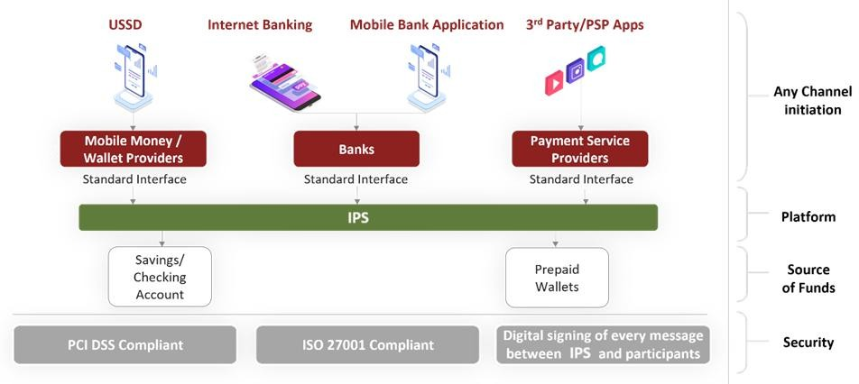

Figure 1: Instant Payment Platform Overview

IPS Design Principles
During design phase, five (5) design principles were formulated to be the north star for cocreating the IPS. These principles were taken from the lens of the consumer and are as follows:
No | Principle | Description
1 | Affordable | Deliver a payment solution that is affordable for lower income consumers
2 | Easy to use | Provide an intuitive payment alternative to cash, one that is inclusive of all consumer segments
3 | Interoperable & agnostic | A system that is compatible with various devices, channels and platforms addressing different needs of the consumer.
4 | Accessible and always on | An interface that is convenient and always available
5 | Secure payments | The safety features of the platform allow consumers to be protected and ensures safety of transactions
Table 7: Design principles

Overview of Enabled Use Cases and Channels
The following use-cases, features and channels have been approved for go-live and phase 1 of the IPS rollout. All IPSPs should be in a position to provide all seven (7) use cases. The list is not exhaustive but has been limited for go-live with additional use cases to be added post go-live.

Uses cases | User type | Features | Channels | Alias
P2P | Individual customer and sole trader | - Send money.  - Receive money.  - Preapproved authorised payments | - Central USSD  - Mobile App  - Internet banking (up to the participant) | - 15–20-character full form alias: (john123@sovprovider)  - 9-digit short form alias: 841235684 (linked to full form alias)
P2B/M | Individual customer to merchant | - Pay merchant | - Central USSD  - Mobile App  - Internet banking (up to the participant)  - Static and Dynamic QR Code | Payment to  - merchant full form alias of 15-20 characters: merchant123@sovprovider  - merchant short form alias: 8-digit unique number mapped to full form
G2P | Government agencies to person | - Government pension and grants through Bank of  Namibia | - Bank of Namibia (CMBO) | - Bulk payments from IPN handle: account-no@ifsc- code.ifsc.npci  - Note: These will be Pre- Auth transactions
B2P | Business to person | - Preauthorised business payments (one to many) | - Business | - Bulk payments from IPN handle: account-no@ifsc- code.ifsc.npci  - Note: These will be Pre- Auth transactions
Cash in at merchant | Individual customer cash in at merchant | - Merchant pays merchant as P2P | - Mobile app  - QR Code  - Central USSD | - Individual short form alias, long form alias or QR code.
Cash-out at merchant | Individual customer | - Cash-out by scanning | - Mobile App  - Central USSD | - Merchant QR code  - Merchant unique code

Uses cases | User type | Features | Channels | Alias
 | cash-out at merchant | merchant QR code  - Cash-out by inserting merchant unique code in USSD menu
ATM  withdrawal | Individual customer withdrawal at ATM | - Individual withdrawal from ATM using short form alias (mobile number) and OTP | - ATM  - Central USSD | Short form alias (mobile number)
Table 8: IPS use cases overview.

The IPS will use proprietary IPS QR code specifications until such a time QR code specification are standardised in Namibia. These will be shared with the participants along with the Technical Specification Document (TSD). Once standardised, the IPS Operator will ensure that IPS QR code specifications align to the national QR code standards.

Enabled use cases: P2P, P2B, G2P, and B2P, merchant cash-out, Merchant cash-in, and ATM cash-out.
When the solution goes live in September 2025, seven (7) use cases are envisaged to be enabled. These use cases are P2P, P2B/M, G2P, B2P, merchant cash-in, merchant cash-out and ATM withdrawals which are all significant and relevant to immediately enhancing financial inclusion and securing adoption from the public. P2P refers to person to person instant payments in an interoperable ecosystem. P2P also includes payments to sole traders that will be identified under separately for processing purposes. P2B refers to person to business / merchant payments. Merchants are assigned merchant aliases to also identify them for various reasons, i.e., tax, BIPA requirements etc. G2P refers to Government / Public Enterprises to Person payments while B2P refers to Business to Person payments. G2P and B2P will have similar flows wherein either the

government agency or a merchant will be assigned a merchant ID to enable one to many preauthorised payments. The technical message payloads contain the necessary fields (payment messages have the necessary data fields) to enable both retail and business payments. Merchant initiate transactions using customised names, which are conditional on certain rules. This is to cater for concerns regarding fraud such as impersonation fraud, where someone would use a customized name identifier that would impersonate a business. Merchant cash-in allows individuals to fund their own store of value, in person at a merchant while merchant cash-out allows individuals to withdraw funds from their store of value, in person at the merchant. ATM cash out will allow for store of values to cash out at any IPS enabled ATM providing interoperability.

All IPS use cases will allow for on-us processing by IPS Participants. Where both the payer and payee are customers of the same IPSP, the transaction shall be processed internally by the IPSP but must still be logged at the IPS switch for settlement, reconciliation and reporting purposes.

Participation Overview
The payment service provider (PSP) landscape consists of several payment players, organized according to 2 main categories; Banks and Non-banking financial institutions (NBFIs). The NBFI category is further demarcated into 4 categories namely payment instrument issuers (PIIs), payment facilitators (PFs), third party payment providers (TPPPs) and virtual asset service providers (VASPs). For the purposes of this document, VASPs are out of scope. With regards to Store of Value (SoV) Providers, only banks and payment instrument issuers are authorised to provide customers with store of value i.e., bank accounts and e-money wallets. In the card and EFT stream, only banks are direct participants now with one non-bank. The law however allows for payment instrument issuers to directly participate in both card and EFT, if they have the capability and the necessary approvals. PFs and TPPPs cannot directly participate in the card and EFT streams but provide auxiliary services to clients such as banks (gateways, switching) and merchants (mainly debit order services). Currently both banks and payment instrument issuers provide e-money wallets as store of value. PFs and TPPPs may not provide e-money wallets unless

they are authorised as payment instrument issuers (PIIs). As such on the IPS, only banks and PIIs will be considered as SoV providers while PFs and TPPs, also referred to as Enablers can provide auxiliary services such as mobile applications and integration services for go-live. This position will be revisited after go-live once security measures and open banking measures have been introduced to protect store of value providers and their customer's information. A participant that provides both store of values and acquires merchants or individual customers on the IPS will be referred to as an IPSP. Note that it is possible for a participant be onboarded only as a store of value provider or only as an IPSP that does not provider store of values.
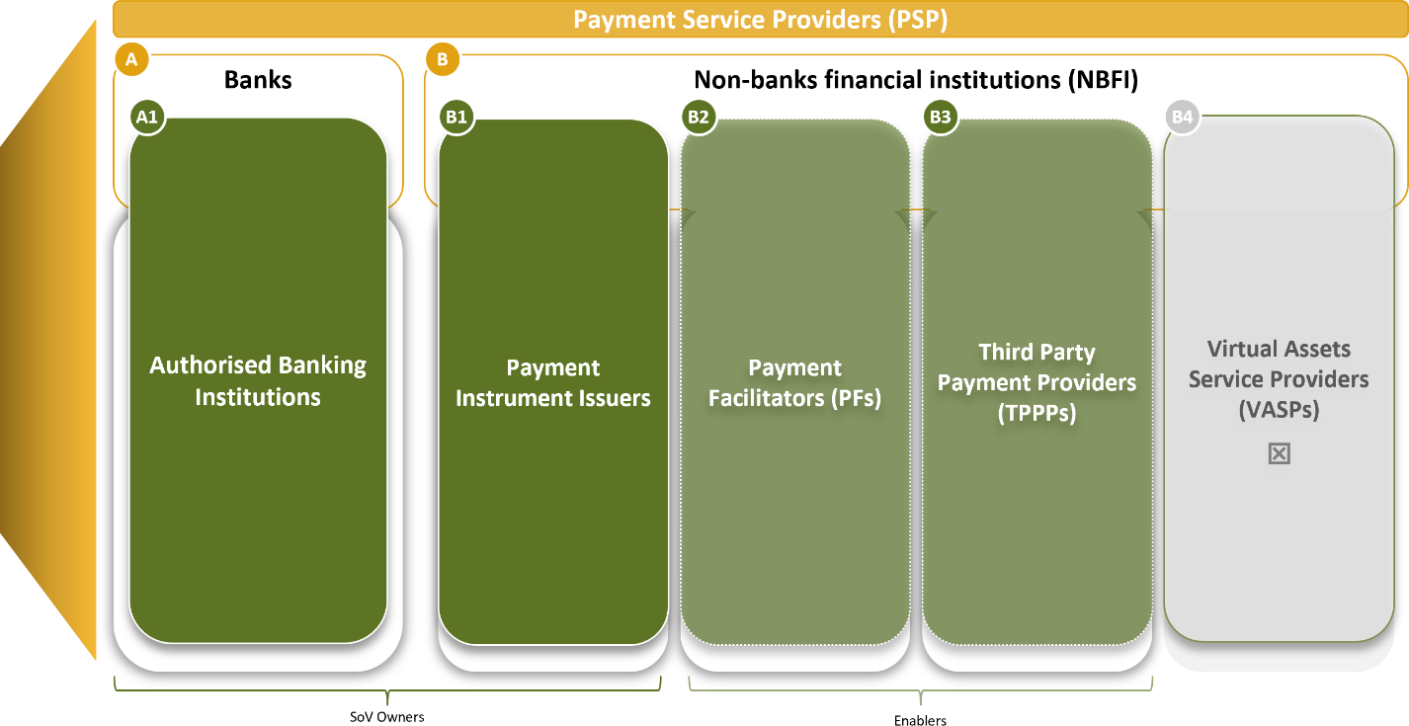

Figure 2: Payment Service Provider (PSP) landscape

Participation within the Instant Payment Solution (IPS) will be determined by both Regulation and the rules of the IPS Operator. Using the existing Nambian payment ecosystem, the current licensing regime is used to determine the level of participation in the IPS environment. The Payment System Management Act 14 of 2023 allows for payment system operators and payment service providers to operate payment systems and provide payment services in Namibia. In this regard, the IPS Operator is regarded as the payment system operator and is allowed to have system participants. For purposes of IPS switch, only participants that send and receive

instructions related to sending and receive instant payments to the IPS switch will be regarded as IPSPs. Store of value providers only receive instructions to either credit or debit a store of value and respond to the IPS switch with confirmation. While there is a difference in the roles of an IPS participant and a store of value provider, both roles can be executed by the same entity depending on the transaction and whether there is an Enabler involved. An Enabler will not be considered as an IPS participant or a store of value provider. An enabler may provide a mobile application and partner with an IPSPs to provide instant payment services.
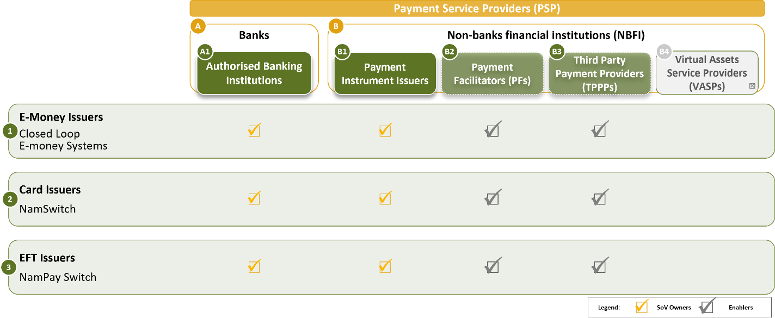

Figure 3: Payment Service Provider (PSP) payment streams

In terms of participation on the IPS, both banks and payment instrument issuer store of values will be enabled. Store of value providers will play both the role of store of value provider for their clients as well as an IPSPs for both their clients and enablers. This means that store of value providers can be referred to as IPSPs while enablers (PFs and TPPPs) will be allowed to provide payment services through their mobile applications and through partnership arrangements with an IPSPs. This therefore means that enablers will not qualify for an IPS handle but may onboard customer by assigning handles issued by the IPSP or the store of value providers onto their mobile applications client facing channels. The limitations of enablers to directly participate as IPSPs is dependent on them acquiring a payment instrument issuer license.

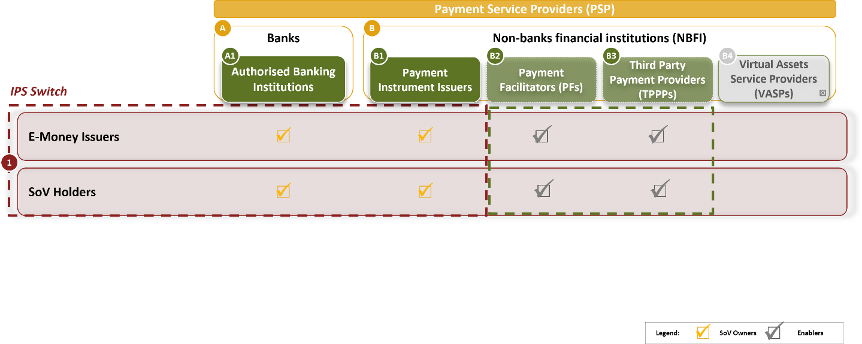

Figure 4: IPS Switch enablers

Alias / Handle Overview
IPS users will be required to have an alias (the term handle will be used interchangeably with alias in this document and accompanying documents such as the Product Rules and Operational Rules) that enables them to access and transact on the IPS. This is to provide a standardised experience for the users, enablers, IPSPs and store of value providers without relying on the conventional account numbers or mobile money wallet identifiers. Only a store of value provider or an IPSP will be able to provide a user with a full form alias. This full form alias construct can then be linked to the customer’s store of value of choice. For convenience, a user can link their mobile number to their full form alias and only provide the mobile number to anyone who wants to send money to them. For a merchant, a full form construct will also be provided which can be linked to a unique number that a merchant can expose to a buyer. The merchant unique number can also be used to pay a merchant using USSD which reduces the need to enter a full form alias in the USSD menu. Given the setup of the solution, a mobile number can only be used as a short form alias meaning it cannot be included in the full form alias construct. This is to avoid challenges and limitation associated to mobile numbers as they can be recycled, and users also have multiple bank accounts within a particular institution and across various institutions.

From a merchant perspective, only sole traders can use mobile numbers to receive payments which will still be identified as a P2P transaction. However, sole trader will be categorised with a standard MCC, for further identification in reporting/settlements. For bigger merchants, a customised name will be provided for making and receiving payments. The customised name must be related to the business and can only be in a full form for example as TheFoodStore@IPSPhandle.

Switching Services
The IPS solution will accommodate 2 stores of value (SOVs) namely a bank account or an e-money wallet. The type of bank accounts to be enabled at go-live include current accounts, basic bank accounts and savings accounts. E-money wallets from both banks and non-banks will also be enabled. The IPS will perform switching and routing services for instant payment transactions between bank accounts and e-money wallets. The IPS operator will provide participants with access management controls for their respective organisations to access the back-office portal for various services such as reconciliation, raising deputes, credit adjustments and accessing various reports such as raw data files and NTSL reports. Whether the IPS Switch is triggered from a bank account or wallet, the clearing message will carry a mandatory unique store of value reference of the beneficiary in the form of the full form alias (AliasIdentifier@handle) routed through the alias directory.

In terms of channel access, IPS users will be able to access instant payment services through mobile applications of IPS participants or Enablers, a central USSD menu provided by the IPS Operator or through internet banking channels of the banks. Both static and dynamic interoperable QR codes will also be exposed by both individuals and merchants to receive payment.

Fraud and Risk Management
From a fraud and risk management perspective, central fraud management capabilities will focus on surveillance, monitoring, notifications, and fraud prevention. The IPS Operator will monitor – at the systems level – for any suspicious activities that match predefined patterns such as multiple same value transactions during unusual hours and notify participants for further action. Participants may manually request a limited number of customised rules. This capability will be automated for a greater number of rules. Case management capabilities include viewing the notifications with details, along with search filtering and capability for participants to provide feedback on FRM. Fraud score injection for every identified case, based on the transaction outcome. For fraud score injection, the FRM system will inject a fraud score into the transaction message, based on machine learning algorithms and several configurable input parameters. The FRM rules will be provided in a separate document.

Supporting Services
The IPS Operator will provide supporting services for IPS participants which includes a self-service portal, 24-hour helpdesk, query management, SLA management and reporting for the central IPS switch. IPS supporting services will leverage current services such as the service desk and automated query management processes. IPS participants may enhance these capabilities for future iterations of the IPS.

SCOPE

Document Scope
This document strictly covers the functional requirements pertaining to the Instant Payment Solution. The functionalities and use cases covered herein are for go-live, with additions and modifications envisaged after go-live. All out-of-scope use cases and functionalities will be activated after go-live, with their functional and technical specifications to be defined post- launch. This document will be updated with new functionalities and use cases as they are developed by the IPS Operator. The technical requirements are not covered in this document and will be provided for in the Instant Payment Technical Specification Document.

Solution Scope

Function / Service | In Scope for Go-live | Out of Scope for Go-live
Use cases | P2P, P2B, G2P, B2P, Merchant  cash-in and cash-out, ATM cash- out | P2G, B2G, B2B
Features | Send money.  Make a payment / pay a bill. Cash-out at Merchant and ATM Cash-in at Merchant  Bulk payments Static QR payments  Dynamic QR payments | Request to pay. Mandate payments Cross-border payments
Identifier | Mobile number Customised name | Company registration Unique Token  Other identifiers
Construct | Full form alias construct Short form alias construct | Account number

Function / Service | In Scope for Go-live | Out of Scope for Go-live
Services | Alias and handle registration Alias and handle deregistration
SOV | Current account Savings account Basic bank account  Electronic money wallet | Prepaid cards  Unit trust accounts Investment accounts Vouchers
Channels | Participant mobile applications Issuer mobile application Internet banking  Universal USSD ATMs | Central mobile application Participant USSD
Table 9: Solution scope

Industry Projects to Consider.
This document acknowledges that there are other ongoing projects that may impact or are complementary to the successful implementation of the IPS. Some projects are directly impactful while others are indirectly impactful meaning that they are industry projects that can derail the IPP given resources constrains at industry level:
- NISS Version Upgrade
- NISS ISO Migration Project
- Open Banking Project
- QR Code Standard Specifications
- Interchange Project
- CMA cross-border low value payments migration to SADC-RTGS

PART B: SOLUTION FRAMEWORK

OVERVIEW OF APPLICATION PROGRAMMING INTERFACES

This section provides an overview of the various APIs that are made available on the IPS. The available APIs are for both financial transactions and non-financial transactions (Meta). Financial APIs are used to complete the debit and credit transactions between the remitter and beneficiary store of value providers. The success code for an API call to is always 00. In terms of error codes, a separate document referenced under section 13 provides the various error messages.

Financial Transactions APIs
The following tables provides information about the following APIs that are supported by IPS for financial transactions. Every API shall have the request and response in a predefined format.
API | Description
Request Pay Details | This is the primary API that is used by the IPS participants to initiate the payment request to the IPS Switch. This API is used for sending back the response of financial transactions that are initiated through the ReqPay API to the IPS participants. The different kinds of ReqPay APIs are specified in the TSD as they may be applicable.
Request Authentication Details | This API is used to authorize a payment and translate IPS participants’ specific payment addresses to any of the common global addresses of the customer, such as account number that the IPS can understand. Following is the request format of the Request Authentication Details API.
Table 10: Financial transactions API summary detail

Non-Financial Transactions APIs
Meta APIs are used to complete the IPS based transactions through the automation process in real time. This table provides information about the non-financial transaction APIs that are used to validate accounts during customer on boarding, address sending and receiving money, and provides phishing using whitelisting APIs.
API | Description
List PSP | The IPS Operator maintains a list of all registered IPS participants and their details. This API allows IPS participants to request the list of all registered IPS participants for local caching. The data is used to validate the payment address before initiating any instant payment transaction.
List Account Providers | This API allows IPS participants to get a list of all stores of value providers who are connected by using the IPS. IPS participants maintain the list for registered store of value providers before registering a customer store of value within their application.
List Keys | The IPS Operator maintains a list of all public keys for encryption purposes. This API allows IPS participants to request and cache the list of public keys of the IPS Operator. The IPS Operator provides the trusted and certified libraries that IPS participant use for credential capture and PKI public key encryption at the time of capture.
List Verified Addresses | This API allows IPS participants to request a list of verified address entries to protect customers from attempts to spoof well-known merchants, such as e-commerce players, mobile network operators, and bill payment entities.
List Account | This API allows IPS participants to find a list of accounts that are linked to the mobile number by a particular store of value provider. As part of the ATM PIN introduction, the remitter store of value provider responds with a new cred block with subtype as ATM PIN, its type and length, where PIN length can be 4 or 6 digits. This information is used to capture ATM PIN in the common library.
Manage Verified Address Entities | This API allows IPS participants to manage and access the common collection of verified address entries.
Validate Address | This API allows IPS participants to validate the beneficiary address when the customer wants to add a beneficiary within the IPS participant’s application to send or collect money.

API | Description
Set Credentials | This API is required to provide a unified channel for setting and changing the IPS PIN across various store of value providers. This feature is critical as customers can easily change the IPS PIN by using the mobile.
Mobile Banking Registration | This API allows the new and existing customers to set a new IPS PIN
Check Transaction Status | This API allows IPS Operator to request for the status of the IPS transaction. The IPS switch can request for the transaction status only after the specified timeout period.
OTP Request | This API allows IPS participants to request an OTP for a specific customer from a remitter.
Balance Enquiry | This API allows IPS participants to enquire the account balance of a user.
Heartbeat request | This API monitors the IPS system, checks the connection with IPS participants.
Transaction Confirmation | This API allows PSPs to confirm the status of the IPS transaction.
Reset credentials | An API to invoke the common library when the user wants to reset their PIN.
Get Address | This API shall be used for checking the availability of an ID before creating a new record as well as for fetching status in case of timeout of CREATE/MODIFY/DELETE record.
Register Alias Directory | This API will facilitate IPS Mobile Applications to Register/Modify user IDs at the alias directory. Using this API user can create the user ID more than once and can be linked to an active full form alias.
Alias Directory Confirmation | Alias Directory will send the  notification of Porting of Mobile Number to old PSP.
Table 1: Non-financial transactions API summary detail

ALIAS / HANDLE MANAGEMENT

Alias / Handle Model
Instant payment transactions involve the movement of funds through bank accounts and e- money wallets in an interoperable setup. During the transaction, a user will not be required to share his/her account or wallet details but instead only share a virtual payment addresses which is referred to as an alias or handle. An alias is simply a handle of the user that is used to identify the store of value details of the user at the user’s store of value provider. Instead of providing account details or wallet information, the user simply provides a full form or short form alias to make or receive payments regardless of the type of store of value or provider.
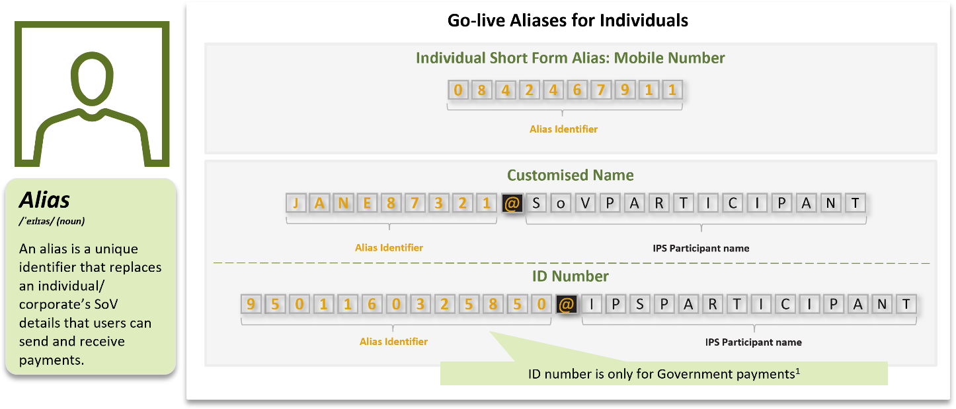
Figure 5: Individual aliase model

A long form alias will comprise of a customised alphanumeric followed by the identifier of the store of value provider or the IPSP. For example, if Jane has a store of value with SoV provider A, her long form alias will be Jane123@SoV1. The identifier after the “@” is used to identify the store of value provider during transaction routing. A user is allowed to have multiple aliases at one or more store of value providers. A short form alias is simply the mobile number of the user that is linked to the full form alias. For example, Jane can link her full form (Jane123@SOV1) to her mobile number 814567890.

However, a mobile number cannot be a part of full form alias. When someone wants to pay Jane, they simply ask for her mobile number and make payment. Note that Jane may also choose to provide the payer with her full form handle. Jane can also generate a QR code on her mobile application to receive payment.

Merchants will also have a full form alias and a short form alias. A merchant’s full form can also be alphanumeric, but the short form alias will be an 8-digit unique number assigned to the merchant by their store of value provider or IPS participant based on their own logic. For multilane shops, a participant may assign a merchant ID and long form handle for each lane (till) linked to one merchant account. Merchants will also be able to generate both static and dynamic QR codes to receive payment and facilitate cash-out services. For government payments, a beneficiary handle containing the beneficiary’s account number and the IFSC of the beneficiary store of value provider will be used to process instant payments on behalf of the government.
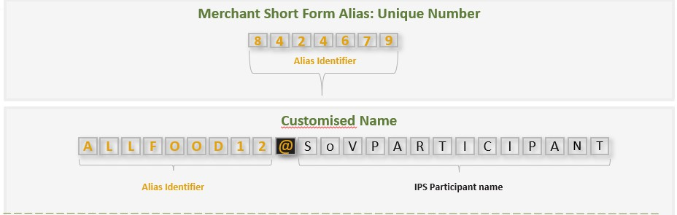

Figure 6: Merchant alias model

The short form alias (mobile number for individuals and unique number for merchants) together with the full form alias will be stored in the alias directory of the IPS Operator at onboarding to enable the payer to only enter the payee’s mobile number when making a payment or sending money. At any point in time, only one full form alias can be linked to a mobile number. A user can link and delink a full form to their mobile number at any time.

Alias Registration
    - Individual and merchant registration
Alias registration can only be done in the following manner:

Entity | Description
Enabler | An Enabler can register a user, only if it has an arrangement with an IPSP to access store of value providers. An Enabler can therefore assign the user a full form alias that belongs to the IPSP or the store of value provider of the user.
Store of Value Provider | A store of value provider can onboard its own customers as well as a new customer by assigning them a full form handle and linking it to a store of value of the customer.
IPSP | An IPSP can play 2 roles in registration. First, it can assist Enablers access store of value providers during registration. This applies to cases where the user being registered by the Enabler does not have a store of value with the IPS participant of the Enabler. Second, it can assign its own handle during registration if the user has a store of value with the IPS participant. An IPSP can also be a SoV provider.
Table 12: Alias registration
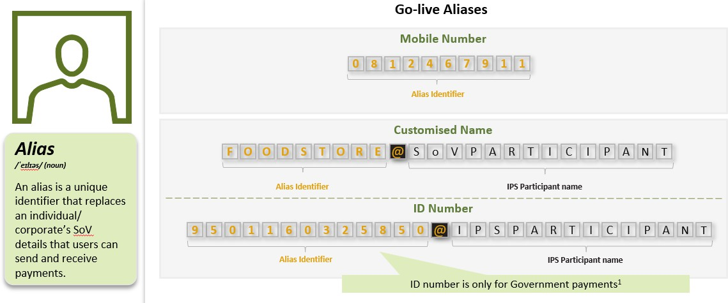

Figure 7: Go-live aliases

    - Government payment registration
For government payment registration, the Currency Management and Banking Operations (CMBO) department of the Bank of Namibia will register government payment recipients in collaboration with the IPSPs. Government payments will leverage off existing accounts and wallets and all recipients will be provided with a full form alias to be used by CMBO. The alias will be in the form of account-no@ifsc-code.ifsc.npci. Government payments will be preauthorised payments made to government beneficiaries through the aforementioned full form alias. Government agencies will be required to verify the recipient’s information before assigning them with an alias and obtaining consent for payments to be made through the IPS.

USER REGISTRATION PROCESS

This section speaks to how a user will be onboarded for the first time to use services on the IPS. A user can self-onboard using a mobile application of the IPSP / Store of Value Provider or the central USSD menu provided by the IPS operator. Onboarding entails the user first performing device binding, then linking their preferred store of value to a full form alias on the IPS and setting an IPS PIN. Merchant onboarding is done by the merchant acquirer and is left up to the participants to decide on the best approach to onboard merchant and assign them with a full form alias, a merchant code, and both static and dynamic QR codes, were relevant and applicable.

Device Binding Flow on Mobile Application
Before a mobile number can be used to register on the IPS through a mobile application, it must be verified and bind to the mobile device wherein the sim card is placed. Thereafter, the user will follow a verification process for the mobile number before creating an IPS Pin. The following device binding process is provided:

Use Case ID | IPS-DB001
Use Case Name: | Device binding
Use Case Description: | This use case describes how a user binds their device to their mobile number
End Objective: | The user successfully binds their device and mobile number
Primary Actors: | User
Secondary Actors | IPS Participant  Store of value provider  Mobile Network Operator (MNO)
Trigger Event: | The user downloads and opens the mobile application of the IPSP / store of value provider and intends to register on the IPS
Business Rules for IPS Participants

- Participant to obtain verification through the respective mobile network operator.
- Participant to store device binding information of the user.
- Only one mobile number can be bound to a mobile device at a time.
(Note: Here the binding would be one mobile number to one device to one app and that SIM should be present in the device with active status.)
- Mobile number should be linked to store of value being used on the IPS.
- The mobile number cannot be entered but should be prepopulated.
- Participant must integrate with their SMS Gateway provider to get the VMN (Virtual Mobile Number) on which the SMS will be sent from user device.
- SMS Gateway will send a response of this SMS to the Participant along with the mobile number.
- Participant must provide API endpoint to receive this response from SMS Gateway.
- Participant must acquire short code from SMS Gateway provider.
- If a customer removes the sim card from the mobile device and inserts it later again, the device binding process should be repeated.
Business Rules for IPS Operator
- Integrate with the MNOs to verify mobile numbers against ID numbers
Conditions
- The user can bind their device using an Enabler’s mobile application (This is only possible if the Enabler and the PSP have a relationship) or the IPS participant’s mobile application. This flow covers all device binding scenarios regardless of the mobile application provider.
- The actions from the mobile application are triggered by the user (consent).
- SMS Gateway to be provided by the Mobile Network Operators.

Basic Flow

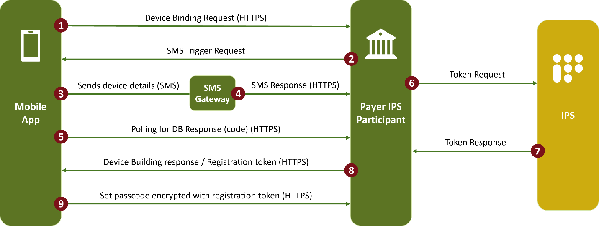
Figure 8: Device binding
Step ID | Actors | Action | Notes and references
1 | Mobile App | Send a device binding request to the Payer’s IPS  participant.
2 | Payer IPS participant | Response to the mobile application with an SMS trigger request.
3 | Mobile App | Sends device details via SMS to the SMS Gateway.
4 | SMS Gateway | Sends an SMS response to the payer IPS Participant.
5 | Mobile App | Initiates a polling for device binding response to the payer IPS participant.
6 | Payer IPS participant | IPS participant requests a token from the IPS switch. | This token is used to identify the device and link it to the full form and short form alias of the user.
7 | IPS Switch | IPS switch responds to the payer IPS participant with a token.

8 | Payer IPS participant | Payer IPS participants respond to the mobile application with a device binding response including the registration token. | The user receives a notification that the device has been bind to the mobile number.
9 | Mobile App | Sets passcode encrypted with registration token which is send to the Payer IPS participant for storage in the Common Library (CL). | This stage is done with the 2- stage verification process.
End of use case
Table 13: Use case ID IPS-DB001

Mobile App First Time Registration

Once the device binding process is successful, the second process is for the user to select their preferred store of value provider and thereafter select the store of value (account or wallet) they intend to register on the IPS. The user is then taken through the verification process with the store of value provider, and the mobile network operator, if necessary. Finally, the user is assigned with a handle and is required to set an IPS Pin. This detailed process is outlined below.

IPSPs are required to enable their mobile applications to allow IPS Users to self-register on their mobile devices. In the case of a bank account linked to a debit card, verification is conducted by the store of value provider, requiring the User to enter the last 6 digits of the debit card along with the expiry date and PIN. If a bank account is not linked to a debit card, verification is done through the store of value provider and the mobile network operator using the user’s national ID. In the case of an e-money wallet, verification is done by the store of value provider by validating the wallet PIN; e-money wallets that do not require a PIN cannot be onboarded onto the IPS. All scenarios require the User to set a 6-digit IPS PIN (separate from their debit card PIN or e-money wallet PIN).

    - Account Onboarding through Debit Card: Mobile App

Basic Flow: Account (Debit card)

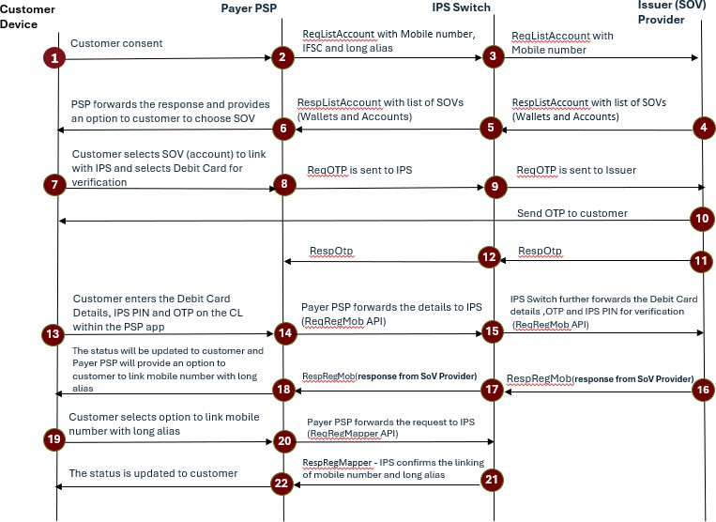

Figure 9: Mobile APP: Account (Debit card)
Step ID | Actors | Action | Notes and references
1 | User | Commences with verification process on device and provides consent to verify using Debit card.
2 | Payer PSP | Sends ReqListAccount (Mobile Number, IFSC, Long Alias) to IPS Switch.
3 | IPS Switch | Forwards ReqListAccount to Issuer SoV Provider to fetch all linked wallets/accounts.
4 | Issuer SoV Provider | Returns RespListAccount containing list of SoVs (wallets and accounts)
5 | IPS Switch | Sends the RespListAccount back to Payer PSP.

6 | Payer PSP | Displays returned list and prompts user to select preferred SoV.
7 | User | Selects the SoV (account) to link with IPS and chooses Debit Card verification.
8 | Payer PSP | Sends ReqOTP to IPS to initiate Issuer OTP flow
9 | IPS Switch | Forwards ReqOTP to Issuer SoV Provider
10 | Issuer SoV Provider | Sends OTP to the user’s registered mobile number
11 | Issuer SoV Provider | Sends RespOTP to IPS confirming OTP
12 | IPS Switch | Forwards RespOTP to Payer PSP so user can input OTP.
13 | User | Enters Debit Card Details (last 6 digits, expiry date and PIN), IPS PIN and OTP
14 | Payer PSP | Forwards Debit Card details, IPS PIN, and OTP to IPS via ReqRegMob API
15 | IPS Switch | Forwards ReqRegMob payload to Issuer SoV Provider for validation.
16 | Issuer SoV Provider | Validates Debit Card details, OTP, and stores IPS PIN; returns RespRegMob
17 | IPS Switch | Forwards RespRegMob response from Issuer SoV Provider
18 | Payer PSP | Updates registration status on user interface
19 | User | Chooses option to link mobile number with long alias
20 | Payer PSP | Sends ReqRegMapper to IPS for alias mapping.
21 | IPS Switch | Executes mapping and returns RespRegMapper confirmation.
22 | Payer PSP | Updates final status to customer (registration + alias link completed)

End of use case
Table 14: Mobile APP: Account (Debit card)

    - Account Onboarding through National ID: Mobile App
The table below depicts the 2-stage verification process through which as user is verified by both a participant and an MNO. The customer should provide consent for both the IPSP and MNO to verify their information. If the customer declines to provide consent, the verification process fails.
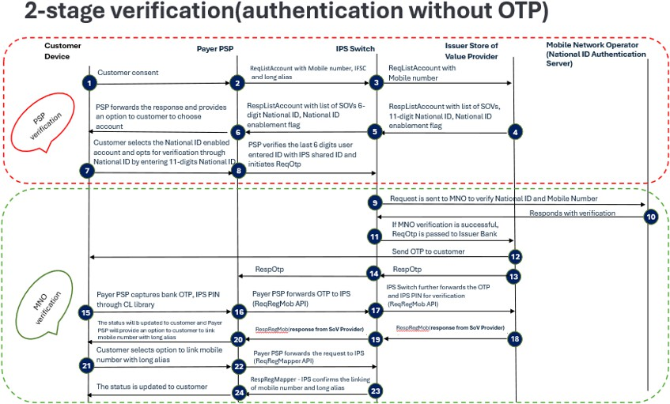
Figure 10: Account Onboarding using National ID Flow
Step | Actors | Actions | Notes and references
IPSP verification
1 | User | Commences with verification process on device and provides consent to verify using National ID.
2 | Payer PSP | Sends ReqListAccount to capture  mobile number, IFSC and long alias
3 | IPS switch | Forwards request to Issuer SoV Provider to fetch all accounts and wallets (SoVs) linked to the verified  mobile number.
4 | Issuer SOV provider | Responds with RespListAccount  containing all SoVs, 11-digit

National ID, and National ID
enablement flag.
5 | IPS switch | Sends RespListAccount response to the PSP, but only shares the last 6 digits of the National ID. | Full 11-digit ID stored encrypted within IPS for MNO verification.
6 | Payer PSP | Displays the list of SoVs and prompts the user to select one that supports National ID verification.
7 | User | Selects the National ID-enabled account and opts for verification via National ID by entering all 11 digits  on the PSP app. | National ID entered on PSP app (not on CL).
8 | Payer PSP | Validates last 6 digits of National ID entered with the ID shared by IPS.  Sends ReqRegOTP to IPS Switch for verification using National ID.
9 | IPS Switch | Requests the MNO to verify National ID and mobile number by sharing the encrypted 11-digit National ID and verified mobile  number with MNO.
MNO verification
10 | MNO | MNO responds with verification to  the IPS if mobile number is registered and linked. | If mobile number is not  linked to user, the verification process fails
11 | IPS Switch | If MNO verification succeeds, forwards the request to the Issuer  SoV Provider to generate bank OTP.
12 | Issuer SoV Provider | Sends OTP to the user’s registered  mobile number.
13 | Issuer SoV Provider | Forwards RespOTP to Payer PSP  through IPS to prompt the user for OTP entry.
15 | User | Enters the bank OTP and sets IPS  PIN (set and confirm) on the PSP interface (CL library).
16 | Payer PSP | Sends OTP and IPS PIN to IPS via  ReqRegMob API.
17 | IPS Switch | Forwards OTP and IPS PIN to the Issuer SoV Provider for final  confirmation.
18 | Issuer SoV Provider | Validates OTP and confirms PIN registration; responds with  success/failure to IPS.

19 | IPS Switch | Sends confirmation back to the  Payer PSP.
20 | Payer PSP | Updates App with registration  status from bank (success/failure).
21 | User | Customer selects option to link  mobile number to long alias
22 | Payer PSP | Sends ReqRegMapper request to  IPS to link alias.
23 | IPS Switch | Confirms successful linking of long alias with registered mobile number.
24 | Payer PSP | Updates the status to customer  (registration + alias link completed).
Table 15: Mobile App: ID

    - Account Verification Rules
- Verification of a bank account should be done by validating the customer’s debit card which entails using the last 6 digits of the debit card, the expiry date and the PIN. Upon successful verification, the SOV provider should send the customer an OTP which completes the 2-factor authentication.

- In case of verification through a customer’s debit card information at the bank, national ID
verification is not required.
- If the customer does not have a debit card, national ID verification is required whereby the mobile number detected in the mobile phone should be verified at the MNO to see whether that mobile number is linked to the User’s national ID number. The user enters the full 11- digit National ID, and IPS verifies the last 6 digits of that ID shared by the issuer. IPS then sends a verification request to the MNO. Upon successful verification, the MNO sends a success response which then allows the User to proceed with setting an IPS PIN.

- For verification through the national ID, both the participant and the MNO should verify 2 parameters i.e., mobile number and the last 6 digits of the customer’s ID against their respective records of the customer. If there is a successful match, the SoV Provider should send the customer an OTP to complete the 2-factor authentication process. Example: If National ID is “98203733790”, then the last 6 digits that shall be verified are “733790”. If the debit card details do not match the record at the participant, the verification fails.
- If the 2 parameters used during the national ID verification do not match the records at both the participant and the MNO, the verification fails.
- Successful verification is confirmed when the user enters the valid OTP sent by the store of value provider and the OTP is successfully validated by the SoV provider by comparing the OTP entered by the User and the OTP issued by the SoV provider.

- The verification is considered complete only when both MNO and SoV providers send successful response to IPS. Customer should not be allowed to set an IPS PIN until both the processes i.e., MNO verification and SoV OTP verification are completed.
    - Wallet Onboarding through Wallet PIN: Mobile App

Basic Flow: Wallet PIN

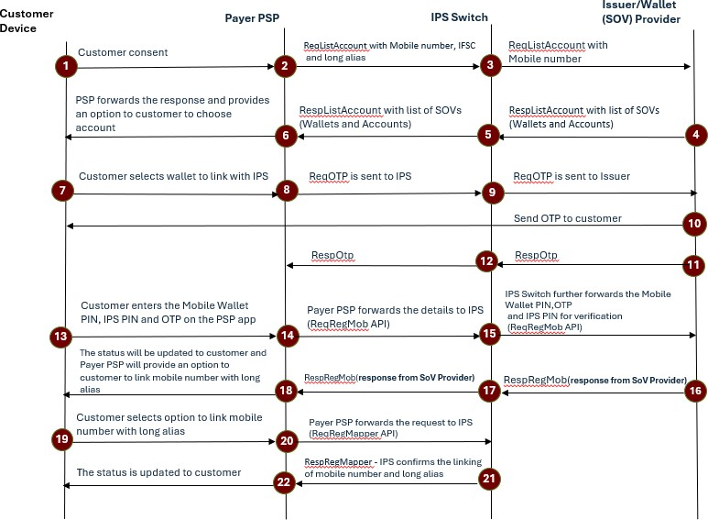

Figure 11: Mobile Wallet PIN
Step ID | Actors | Action | Notes and references
1 | User | Commences with verification process on device and provides consent to verify using Wallet Pin.
2 | Payer PSP | Sends ReqListAccount request to IPS Switch, including the user’s mobile number, IFSC, and long alias.

3 | IPS Switch | Forwards the ReqListAccount request to the selected Issuer SoV Provider (Wallet Issuer).
4 | Issuer SoV Provider | Responds with the list of Store of Value Providers linked to the mobile number.
5 | IPS Switch | Sends RespListAccount (list of SoVs – wallets & accounts) back to Payer PSP.
6 | Payer PSP | Assigns the long alias and presents an option to the user to set up an IPS PIN using their wallet PIN
7 | User | Selects the (SoV) wallet to link with IPS.
8 | Payer PSP | Sends ReqOTP to IPS for the selected wallet.
9 | IPS Switch | Forwards ReqOTP to Issuer/Wallet (SoV) Provider.
10 | Issuer SoV Provider | Sends OTP to customer (registered mobile).
11 | Issuer SoV Provider | Sends RespOTP to IPS confirming OTP dispatch.
12 | IPS Switch | Forwards RespOTP to Payer PSP
13 | User | Enters Mobile Wallet PIN, sets IPS PIN (set & confirm), and enters OTP in the PSP app (CL library).
14 | Payer PSP | Forwards details to IPS via ReqRegMob API (Wallet PIN, IPS PIN, OTP).
15 | IPS Switch | Forwards ReqRegMob to Issuer (SoV) Provider for verification and IPS PIN registration.
16 | Issuer SoV Provider | Verifies Wallet PIN and OTP, returns RespRegMob (response from bank) to IPS.
17 | IPS Switch | Forwards RespRegMob (response from bank) to Payer PSP.
18 | Payer PSP | Updates App with registration status from bank (success/failure).

19 | User | Chooses “Link mobile number with long alias” (alias  directory link).
20 | Payer PSP | Sends ReqRegMapper to IPS to link the mobile number to long alias.
21 | IPS Switch | IPS confirms the linking of mobile number and long  alias.”
22 | Payer PSP | Updates the status to customer (registration + alias link completed).
End of use case
Table 15: Mobile Wallet: PIN

Registering User Store of Value

Use Case ID | IPP-AR001
Use Case Name: | First time registration through an IPS Participant
Use Case Description: | This use case describes the registration process for a first-time user of the IPS. The user never had an alias registered on the IPS before
End Objective: | The user is successfully registered
Primary Actors: | User
Secondary Actors | - SoV Provider  - IPSP
Trigger Event: | The user approaches or is approached by an IPS participant to register an alias on the IPS
IPS Participant Business Rules
- The IPS Participant must provide the User with a list of all Store of Value Provider onboarded onto the IPS Switch.
- The user must not be allowed to proceed if the selected SoV is not active or has derogatory status (fraud related). In the non-active derogative state, the store of value provider must reject the registration request.

- The user must be shown the full form alias details; this includes the handle associated with the user’s
store of value.
- The user must be given the option to stop proceeding / exit the alias registration at any stage of the user journey up to the successful notification step.
- The user may only be able to have one default alias at any given time.
- The User (with consent) will be able to override any previous default alias registrations in the
Operator’s Alias Directory.
Pre-conditions
- The user must have a registered store of value with the SoV Participant.
- The user must have an active connection / signal to use the IPS Product (App or USSD).
- The user must be using the sim card connected to the alias that the user intends to register.
- The SoV would need to be active and have no derogatory status regarding fraud; and not be backlisted/hot listed (in the case where one is created as part of the FRM solution).
- The user registering an alias has met regulatory requirements as the individual would have an existing SoV with a SoV Participant (such as KYC requirements).
Post-conditions
- The user must receive a notification that the user’s alias, SoV and PIN have been registered.
- The user must be notified of the associated store of value linked to the user’s alias.

Central USSD First Time Registration

The registration process through USSD will be different from that of mobile application. For Go- live, USSD registration will be provided by the IPS Operator. Registration through a participant's USSD channel will not be permitted. USSD has a limited functionality which will not allow Users to verify themselves using OTP. In case of a bank account, verification will be done through the store of value provider which requires the User to enter the last 6 digits of the debit card linked to the account and the expiry date. Bank accounts that do not have a debit card linked to it cannot be onboarded using the central USSD channel. In the case of a e-money wallet, verification will be done through the store of value provider by validating the wallet PIN. E-money wallets that

do not require a User to enter a PIN will not be onboarded onto the IPS. Given the limited functionality of USSD, verification through the MNOs (national ID verification) will not be feasible for go-live.
    - General Rules for USSD Registration

Use Case ID | IPP-AR002
Use Case Name: | Alias registration through USSD
Use Case Description: | In this use case, the user registers a full form construct using the USSD menu.
End Objective: | User registers an Alias
Primary Actors: | - User  - Central USSD
Secondary Actors | - User SoV Provider  - MNO
Trigger Event: | A user opens the IPS central USSD channel
IPS participant business rules
- The user must not be allowed to proceed if the selected SoV is not active or has derogatory status (fraud related). In the non-active derogative state, the bank must reject the request.
- The user must be shown the full Alias details; this includes the handle associated with the user’s store of
value.
- The user must be given the option to stop proceeding / exit the Alias registration at any stage of the user journey up to the successful notification step.
- The User (with consent) may be preboarded by the SoV Provider, but the full form alias should not be active until the user accepts the terms of service and adds a IPS pin.
IPS switch business rules
- Non-bank store of value providers to be issued with an identifier by the IPS Operator.
- The process of linking the mobile number to the full form alias should be automated for USSD – Customer’s consent is only needed.

- For USSD registrations, the SPV acting as a PSP on IPS is responsible for generating and allocating the alias.
- The alias is created before SoV selection and is linked to the user’s registered mobile number.

    - Account Onboarding through Debit Card: USSD

Basic Flow: Account

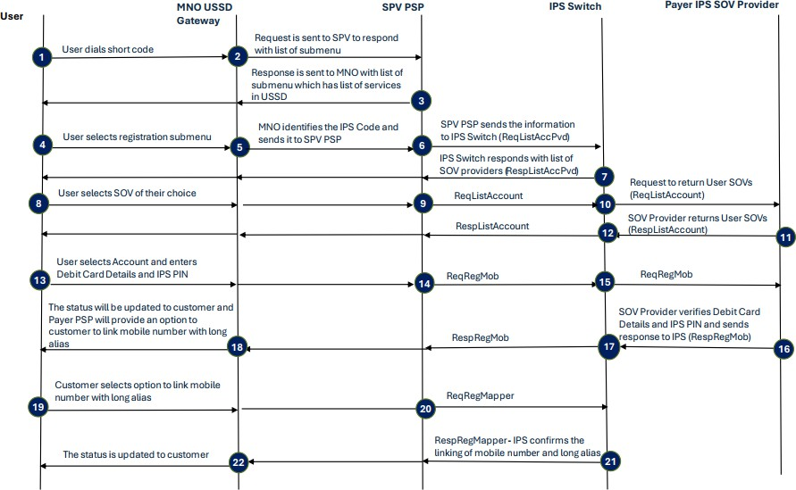
Figure 12: USSD registration Account
Step ID | Actors | Action | Notes and references
1 | User | The user dials USSD code (*140*140#)
2 | MNO Gateway | Identifies the IPS code and sends it to the USSD PSP
3 | USSD PSP | The USSD PSP returns the IPS menu to the MNO
4 | User | Selects registration from the submenu
5 | MNO Gateway | Identifies the registration code and sends to USSD PSP

6 | USSD PSP | Sends the registration request to the IPS switch through ReqListAccPvd
7 | IPS Switch | Returns all Store of Value Providers registered on the IPS
8 | User | Selects the preferred SOV Provider
9 | USSD PSP | Sends the information to the IPS switch and requests for the store of values of the User
10 | IPS Switch | Requests the User’s SOVs from Payer’s SOV Provider  through ReqListAccount
11 | Payer SOV Provider | Returns all applicable SOVs of the User
12 | IPS Switch | Returns all applicable SOVs of the User to the USSD PSP for the User to make a selection.
13 | User | Selects accounts.  Selects to verify using debit card  Enters debit card last 6 digits and expiry date User sets IPS PIN
14 | USSD PSP | Initiates verification process to the IPS switch through ReqRegMob
15 | IPS Switch | Sends verification and registration request to the Payer SOV Provider
16 | Payer SOV Provider | Verifies debit card details and IPS PIN and sends verification success to the IPS switch through RespReqMob.
17 | IPS Switch | Relays this information to the USSD PSP which further reaches the MNO gateway
18 | MNO Gateway | User gets confirmation that they have successfully linked their account to IPS, receives a long alias and is given the option to link their mobile number to their long alias.
19 | User | Selects the option to link their mobile number to long alias
20 | USSD PSP | Triggers a request to the IPS switch through ReqRegMapper to map User’s mobile number to long alias.
21 | IPS Switch | Confirms the linking of the mobile number to the long alias through ResReqMapper to the USSD PSP

 | 22 | MNO Gateway | User gets notification that their mobile number has been mapped to the long alias and registration is now complete.
End of use case
Table 16: Use case ID IPP-UC80

    - Wallet Onboarding through Wallet PIN: USSD

Basic Flow: Wallet

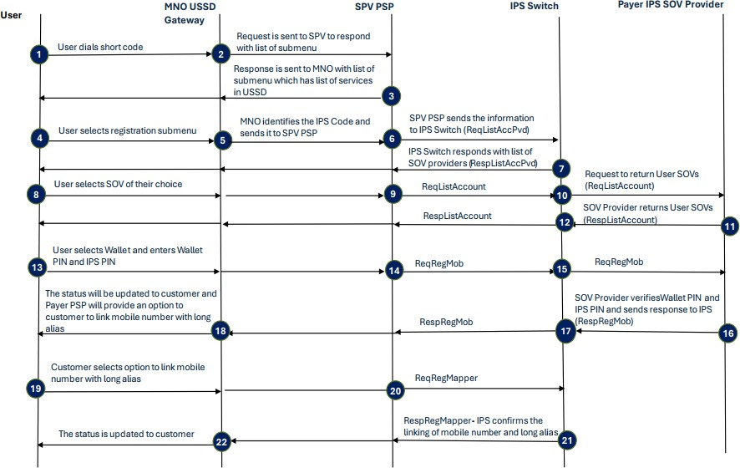

Figure 13: USSD registration Wallet
Step ID | Actors | Action | Notes and references
1 | User | The user dials USSD code (*140*140#)
2 | MNO Gateway | Identifies the IPS code and sends it to the USSD PSP
3 | USSD PSP | The USSD PSP returns the IPS menu to the MNO
4 | User | Selects registration from the submenu

5 | MNO Gateway | Identifies the registration code and sends to USSD PSP
6 | USSD PSP | Sends the registration request to the IPS switch through ReqListAccPvd
7 | IPS Switch | Returns all Store of Value Providers registered on the IPS
8 | User | Selects the preferred SOV Provider
9 | USSD PSP | Sends the information to the IPS switch and requests for the store of values of the User
10 | IPS Switch | Requests the User’s SOVs from Payer’s SOV Provider  through ReqListAccount
11 | Payer SOV Provider | Returns all applicable SOVs of the User
12 | IPS Switch | Returns all applicable SOVs of the User to the USSD PSP for the User to make a selection.
13 | User | Selects wallet  Selects to verify using wallet PIN Enters wallet PIN  Sets IPS PIN | Wallet PIN should be between 4 to  6 digits only
14 | USSD PSP | Initiates verification process to the IPS switch through ReqRegMob
15 | IPS Switch | Sends verification and registration request to the Payer SOV Provider
16 | Payer SOV Provider | Verifies Wallet PIN and IPS PIN and sends verification success to the IPS switch through RespReqMob.
17 | IPS Switch | Relays this information to the USSD PSP which further reaches the MNO gateway
18 | MNO Gateway | User gets confirmation that they have successfully linked their Wallet to IPS, receives a long alias and is given the option to link their mobile number to their long alias.
19 | User | Selects the option to link their mobile number to long alias
20 | USSD PSP | Triggers a request to the IPS switch through  ReqRegMapper to map User’s mobile number to long alias.

 | 21 | IPS Switch | Confirms the linking of the mobile number to the long alias through ResReqMapper to the USSD PSP
 | 22 | MNO Gateway | User gets notification that their mobile number has been mapped to the long alias and registration is now complete.
End of use case
Table 17: Use case ID IPP-UC80

Setting IPS Pin
Once the user has been verified, he/she will be allowed to set an IPS Pin. The CL (Common Library) screen of the store of value provider should appear.
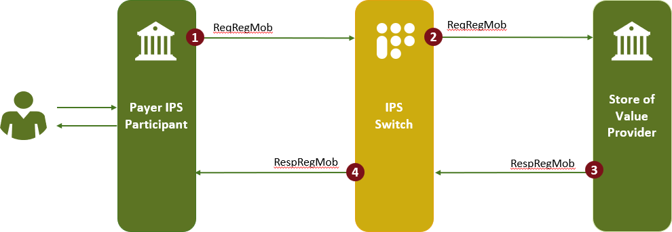

Figure 14: Setting IPS Pin
1 | IPS Participant | The CL screen encrypts all details and sends  them to IPS switch for verification.
2 | IPS Switch | Invokes an API, ReqRegMob, to the store of  value provider and sends all details.
3 | SoV Provider | The issuing store of value provider decrypts all details, verifies them, invokes an API, RespRegMob, to the IPS switch and shares a  response with it.

4 | IPS Switch | Sen ds the information to the IPS Participant.
# | IPS Participant | The SoV provider saves the PIN details of the customer for future authorizations.  The PIN is set.
End of Use Case
Conditions
- IPS Pin is always set against a store of value.
- IPS Pin should be 6-digits.
- If an IPS PIN is already set through an IPS supported application against a store of value, then the customer does not need to set the PIN again on any other IPS-supported application against the same store of value.
- If the IPS PIN is already set against a store of value in one application, the SoV Provider shall revert with the tag mbeba=”Y”. The application does not prompt the user to set the PIN against the same store of value on another application.
In case of mbeba=”N”, the application prompts the user to set a IPS PIN.

ALIAS DIRECTORY

The centralized alias directory is used for customer onboarding. The Directory will be maintained as a separate service in the IPS switch ecosystem to help link full form aliases to mobile numbers for individual customers and unique numbers for merchants. Post completing the new user on- boarding process, users shall be prompted to link their mobile number or unique number for Numeric ID generation. For purpose of this section, an individual number or merchant ID linked to their respective full form alias will be collectively referred to as a “user ID”.

Mobile Number Rules
- Users will not be allowed to enter their mobile number when registering a store of value on the IPS.
- Only a mobile number that is linked to a store of value (bank account or wallet) can be used for onboarding and mapping.
- Any leading zero “0” in the user mobile number or user mobile number starting with country code “+264” must be removed by the IPS participants and the mobile number shall be 9-digit. For example, Jane can choose to provide her mobile number as 0812345679 or
+264812345679 but her IPS participant must ensure to remove the leading zero “0” or “+264”
when linking her mobile number to a full form in Alias Directory.
- To ensure proper routing and validation of mobile-based payment instructions, each participant and the IPS switch must implement logic to identify the Mobile Network Operator (MNO) based on the mobile number prefix:

  - MTC numbers begin with the prefix 081.
  - Telecom Namibia (TN) numbers begin with the prefix 085.

- In the IPP format, the leading zero is omitted, and mobile numbers are represented as 9-digit numeric strings:
  - MTC mobile number appears as 812XXXXXX

  - TN mobile number appears as 852XXXXXX
- Participants must use this prefix logic to:
  - Validate the issuer network associated with a mobile number.
  - Route the transaction accordingly in systems that require MNO identification.
  - Support network-specific error handling or routing in cases of failure or timeouts
  - This logic must be consistently applied for all IPP-compliant transactions initiated via mobile numbers.
- In the alias directory, Jane’s mobile number will be stored as 812345679 linked to her full form e.g., jane123@SoV1.
- Mobile numbers can only be reused after 6 months. And since the customer is not inserting the mobile number but rather this is automatically linked to the account / wallet, the customer will in any case have to update their KYC at the participant before binding a mobile number.
- Where a new Mobile Network Operator (MNO) is added in future, routing logic at the IPS switch must be updated to include the new MNO prefix ranges.

Merchant Unique Code Rules
- Each participant to assign merchant codes based on their own logic. For multilane shops, a participant may assign a merchant ID and long form handle for each lane (till) linked to one merchant account.
- The merchant unique code cannot exceed 8 digits or else it will conflict with the mobile numbers already stored in the directory.
- Only SMEs, MSMEs, and large merchants qualify for unique codes, sole traders will be treated as individuals meaning their full form aliases can be linked to their mobile numbers.

General Alias Directory Rules
- Mobile Numbers and Unique numbers will be unique within the alias directory.
- Only one full form alias can be linked to a mobile number or a unique merchant number at a point in time, in an ‘Active’ State.

- Mobile Number (short form alias) can be made ‘Inactive’ with a given IPS participant. However, in this case the long form alias with the same IPS participant may remain active and the user can receive money over his/her long form alias. Having said this, the same mobile number linked to a full form alias with a different IPS participants may exists in the alias directory.
- Any merchant unique number can be deregistered. The ‘Deregistered’ unique number will be existing for the merchant to be made ‘Active’ within 6 months.
- IPSPs can block/unblock mobile numbers or merchant IDs.
- Transfer of merchant IDs between IPS participants is not allowed.
- Transfer of Mobile Numbers between full form aliases of different IPS participants will be allowed.
- When the user de-register’s the mobile application, the IPS participant must deactivate the corresponding mobile number.
- The alias linking in the Directory will happen based upon customer consent.
- Unique numeric ID for Merchant should not be more than 8-digit long.
- Unique numeric ID for Merchant with all the same digits (0-9) is not allowed.

Alias Directory Operations
- During the linking of a user ID, consent from the user will be taken for storing the data (Numeric ID / Mobile Number).
- Then the registration process will begin by sending the request through ReqRegMapper API. The ReqRegMapper API will store the details in alias directory in an encrypted format.
- The ReqRegMapper API shall perform various operations in the alias directory given below:
  - Add – Create a new user ID at the time of registration of the full form alias.
  - Modify – Modify the user ID against full form alias by selecting any of the created user IDs or Update the user ID as Mobile Number against the full form alias.

First Time User ID Registration Flow

Use Case ID | IPS-AD001
Use Case Name: | Creation of IPS ID as mobile number by new user
Use Case Description: | This use case describes how a user links their mobile number to their full form alias to create an IPS user ID
End Objective: | Mobile number linked to full form alias
Primary Actors: | User
Secondary Actors | IPS participant
Trigger Event: | A new user while onboarding selects the store of value provider, sends the mobile number, store of value code and gets the account or wallet number verified through ListAccount API
IPS participant business rules
- The user already has an active full form alias.
- Then user selects a PIN and sends it via ReqOtp API to Issuer SoV Provider and the OTP will get initiated and validated by the user against his/her credentials on the common library page.
- Once the PIN has been set, the IPS Participant will prompt a request of creating a User ID. On taking consent, a User ID shall be entered by the user.
- On entering the User ID, the ReqGetAdd API will be triggered to check the availability of the ID.
IPS Switch business rules
All RegMapper API requests will be validated against the Org ID and Handle with the addr tag to avoid invalid requests.
Basic Flow

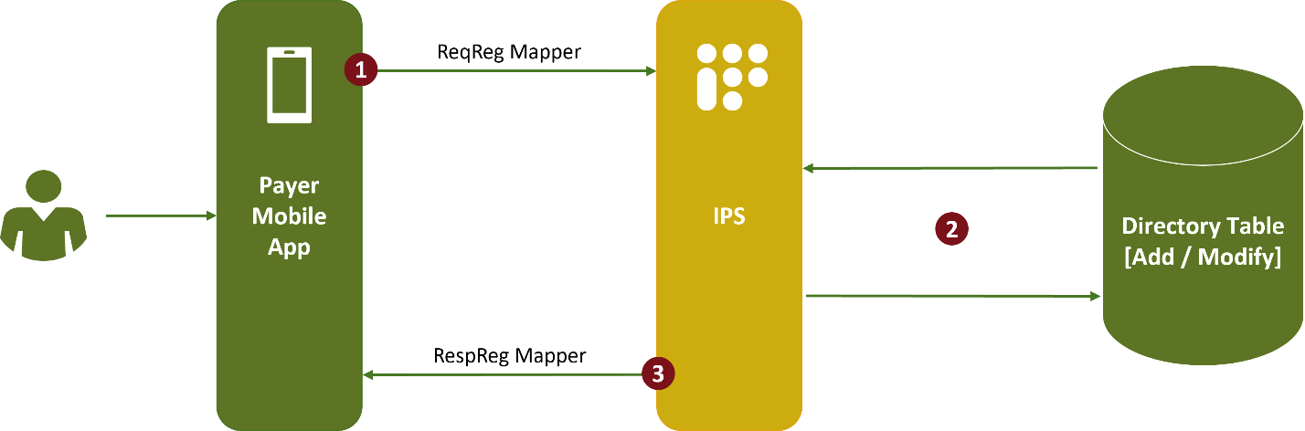
Figure 15: First time user ID registration flow
Step ID | Actors | Action | Notes and  references
1 | IPS  participant | On success response, the IPS Participant shall initiate ReqRegMapper API with full form alias and Numeric ID (Numeric ID can be mobile number) to the IPS switch.
2 | IPS Switch | IPS switch sends a request for the Alias Directory to store  the user’s ID and link it to the full form alias.
3 | Alias Directory | Alias Directory stores the details. It will check and validate in both, Master, and Audit tables within the Directory. Alias Directory responds to the IPS switch
4 | IPS Switch | The IPS sends response to IPS Participant through RespRegMapper API to the IPS switch and customer is successfully on boarded with the user ID.
End of use case
Table 18: Use case ID IPS-AD001

Creation of IPS Number as Numeric ID Existing User
- Existing user with a full form alias already linked to a mobile number can override this link in the alias directory.
- Linking a new mobile number to an existing full form will override the initial link that exists in the alias directory.
- Since the mobile number linked to a full form should be the same mobile number to which the store of value can be identified, the user will be required to update their KYC details at their store of value provider.
- In this scenario, there will be a validation from the store of value provider to ensure that the Device ID of the initiator is the same as the Mobile Number being linked.

Deregistration of a Mobile Number
- During de-registration of a mobile number, ReqRegMapper API will initiate the Modify
‘DEREGISTER’ request through ReqRegMapper API to IPS switch from the sender.
- The IPS switch will validate the mobile number for active/inactive status and change status
of the mobile number to ‘DEREGISTER’.
- There is no cooling period for the deletion of mobile number. If the mobile number must be reused as a user ID, then a registration process must be followed.

Deregistration of a Unique Number
- For a merchant unique ID, the exact same unique number, which was successfully registered previously, will go through the process of deregistration by using the ReqRegMapper API.
- Once the merchant ID is deregistered there will be a cooling off period of 6 months which is configurable, and the ID will not be allocated to other users. However, the ID can be reclaimed by the same full form alias of the merchant through which it has been deleted.
- In case of a deregistration request, the expiry will be shared in the response and the IPS Participant can refer the same to calculate the cooling period of the Merchant ID.

Transfer of Mobile Number between IPS Participants
- User will be allowed to transfer Mobile Numbers as User IDs between IPS Participants.
- During such modifications, the user must select the update mobile number as User ID option from the application on which the number has to be activated.
- Then the user App will validate the details using GetAddress API with type ‘PORT’ and display the existing ID which has been already active in a different application such as MobileNumber@Activehandle using Get Address API.
- During this operation, the ‘addr’ tag is populated if the ID exists and already mapped to any other IPS Participant.
- The IPS Operator will populate the ‘addr’ only when the ID is in status ‘Active’ or ‘Inactive’
- In case of ‘Block’ the ‘addr’ will not be retrieved only the status will be fetched and portability will not be allowed.
- When the user selects the ID and decides to PORT it to the current IPS Participant, ReqReg API will initiate the modify request to the IPS switch and the mobile number shall be updated to current IPS Participant.
- The preVPA tag of ReqRegmapper will have the ID of the Old IPS Participant during the transfer. The presence of this tag is the identifier of the transfer operation.
- Once the transfer is complete ReqMapperConfirmation API will be sent to Old IPS Participant.

Register to Alias Directory

S No | Scenario | Operation (op) | setStatus | Comment
1 | Create Merchant ID as User ID | ADD | NEW
2 | Create Mobile Number as User ID | ADD | NEW
3 | Transfer of Mobile Number to different IPS Participant | MODIFY | ACTIVE | Before: CMUser@sov1, 842212345  After: CMUser@sov2, 842212345
4 | Activate the already created Merchant ID against the full form alias | MODIFY | ACTIVE | Before: Shop1@SoV1, 1234567  After: Shop1@SoV1, 6789011  (6789011 is already created and it is in 'inactive' state)
5 | Update Merchant ID against different full form alias for same IPS participant (change full form alias) | MODIFY | ACTIVE | Before: Shop1@SoV1, 1234567  After: Shop1A@SoV1, 1234567
6 | Activate by creating Merchant ID against the full form alias and deactivate the current active Merchant ID | ADD |  | Before: Shop1@SoV1, 1234567  After: Shop1@SoV1, 2121212  (212121 will be created and made to active)
7 | Deactivate the Mobile Number | MODIFY | DEREGISTER | No cooling period for mobile number deletion
8 | Deactivate the Merchant ID | MODIFY | DEREGISTER | '1234567 will be available only after 6 months.
9 | Reclaim the deactivated Merchant ID against Same full form alias | MODIFY | ACTIVE | The deleted record will be in ‘INACTIVE’ state in CM. the same can be updated to ‘ACTIVE ‘by the same user.
10 | Reclaim the deactivated the Mobile Number | MODFIY | ACTIVE
11 | Block the Mobile Number/ Merchant ID | MODIFY | BLOCK | IPS Participant will initiate a Block and  IPS Participant can block only its own

S No | Scenario | Operation (op) | setStatus | Comment
 |  |  |  | User ID
12 | Unblock the Mobile Number/ Merchant ID | MODIFY | UNBLOCK | IPS Participant will initiate the Unblock
13 | Deactivate the multiple Merchant ID | MODIFY | INACTIVE | User can initiate delete all request to IPS Participant. IPS Participant in turn will initiate the request one by one to the IPS switch
14 | Mobile number surrendered by existing user without deactivating and new user requested for the creation of a short form Alias as Mobile Number | MODIFY | ACTIVE | There is no way to differentiate the cases, when the new user request from surrendered mobile number or Existing user changing the  App  During transaction user must verify the recipient’s address
15 | Linking new Mobile Number against existing full form alias |  |  | New Profile and full form alias will be created for a New Mobile Number i.e., Fresh  Registration
16 | Creating Merchant ID and Mobile Number as a single request | Not Applicable
17 | Creating multiple Merchant ID as a single request
18 | Individual User creating a unique number (like merchant ID)
Table 19: Register scenararios for alias directory

Note: If the IPS User ID exists already, consent must be obtained from customer to modify it.

ReqValAdd API
This API has been enhanced and facilitates IPSPs to fetch “Beneficiary Name” & “full form alias” that have been linked with the User ID, during financial transactions.
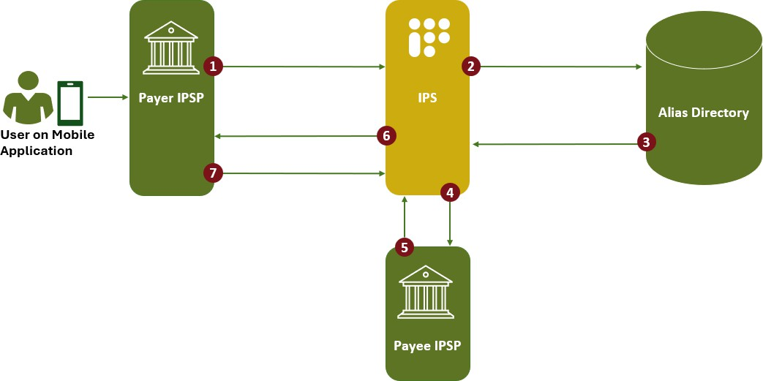

Figure 16: ReqValAdd API
Step ID | Actors | Action | Notes and references
1 | Customer | Customer enters the desired User ID (Alias Directory ID) and the payer IPSP fires a ReqValAdd API with payee’s address in the format XXXXXXXX@mapper.npci to fetch the linked full form alias
2 | IPS Switch | IPS Switch initiates request to the alias directory for fetching the linked full form alias.
3 |  | The alias directory responds back with the linked full form alias against the User ID.
4 | IPS Switch | IPS Switch then initiates ReqValAdd  to Payee IPSP.

5 |  | Payee IPS Participant responds through RespValAdd with all existing parameters
6 |  | The same response is sent by the IPS switch to RespValAdd to Payer IPS Participant. Using this, the Payer IPS Participant will display the beneficiary’s name in the App
7 |  | Once customer enters IPS PIN and authenticates, a PAY transaction shall be initiated this time using the full form obtained in the RespValAdd. The user ID (mobile number or merchant ID) should not be used as the payment address in the financial transaction | Once the step 7 is completed, the verfification flow shall be initiated i.e. section 12.1
End use case
Table 20: ReqValAdd API

Get Address API
- This API is majorly used to retrieve the full form alias linked to the merchant ID or mobile number.
- The customer can use his own credentials for enquiry. IPS participants should not allow any 3rd party to fetch the different credentials.
- This API is also used during onboarding to see the availability of the selected User ID.
- GetAdd is mandatory for the below scenarios:
  - Creation of User ID (Mobile Number / Merchant ID)
  - Transfer of Mobile Number to different IPS participants
- For Other Scenarios GetAdd is not mandatory for scenarios but IPS participants can still do GetAdd if required.
    - Types of GetAdd
GetAdd will have 3 types called ‘CHECK’, ‘FETCH’ and “PORT”.

CHECK
- Type ‘CHECK’ is used to fetch the last updated status of the User ID. Supports to retrieve the
status of both ‘Numeric ID’ and ‘Mobile Number’.
- The status of User IDs of current initiated PSP profile only can be retrieved.
- If the ‘Mobile Number’ is active or inactive in other IPS Participants, the system will throw error, and the status cannot be retrieved.
- If requested Numeric ID is in ‘Active or Inactive or Block or Deregister’ status, PSP should inform user that number is not available and in case of status ‘New’ PSP will allow to create the number as IPS User ID. ‘addr’ tag will not be populated.
PORT
- Type ‘PORT’ is used while transferring mobile number from one IPS Participant to Other IPS Participants. Supports only ‘Mobile Number’.
- User can use this to check if the mobile number is already mapped and in Áctive’ or Ínactive’
status with other IPS Participants.
- The áddr’ tag will give complete full form alias without any masking.
- Alias Directory will reject the request when ‘PORT’ is used for creation of New User ID (Mobile Number).
FETCH
- Type ‘FETCH’ will have subtype ‘ÍD|FullFormAlias’ for retrieve functionality. Subtype
‘FullFormAlias’ – Retrieves all mapped User IDs of the corresponding full form alias.
- Subtype ÍD’- User will give both Full Form Alias and User ID, the system would say if the combination exists or not.
- The status of the User ID of current initiated IPS Participants profile only can be retrieved.

IPS Participants Sync
The approach to sync the list of IPS User IDs Registered / Modified / Deleted between IPS Participants and the IPS alias directory has been described below.

- Firstly, any operation that is performed on the User ID will be notified in a response to the IPS Participants through Online.
- During ‘PORT’ (Transfer of Mobile Number from One IPS Participant to Other IPS Participants), the Previous IPS Participant will also be notified through ReqMapperConfirmation API.
- Also, the status of User ID can be retrieved through Online using ReqGetAdd API ‘Check’ & ‘Fetch’ option anytime.
Along with above provision, the IPS Operator will also facilitate SoV Provider/ IPS Participant providing a Day Wise Report through the IPS Real Time Clearing and Settlement (IRCS) system. In the provided Alias Directory Report an entry will be made for every operation or the changes performed on the User ID in a corresponding day.
Field Name | Description
addr | Full form alias of the Customer
cmId | User ID
cmId Type | Merchant ID | Mobile Number
Code | Merchant Code in case of P2M Transaction
Status | NEW|ACTIVE|INACTIVE|DEREGISTER|BLOCK|UNBLOCK
Channel | Mobile
lastUptdTs | Last Updated Time Stamp
expiryTs | Expiry Time Stamp
API Name | ReqRegMapper
Operation | ADD|MODIFY
Table 21: Alias directory report entry

Note: The Mobile Number will be masked as NNNXXXXNNN. N- Number , X – Masked Value. The report will be provided in a CSV format as Mapper_BBB_DDMMYY_NC.csv / pgp /zip

FUNCTIONAL FLOWS

The following functional flows aim to indicate how messages will flow between IPS participants and the IPS Switch. Different financial and non-financial flows are provided for. It also provides more detail around the use cases, the business rules for both the IPS participants and the IPS Switch. The functional flows for the following use cases are provided:
- Send Money (P2P) Payee Detail Verification
- Send Money (P2P)
- Send Money (P2P) USSD payment
- Merchant Payment (P2B/M) Use Case
- Cash-in at Merchant Use Case
- Cash-out at Merchant Use Case
- G2P (Bulk Payment Use Case)
- Cash-out at ATM

P2P Transactions: Send Money (Mobile App)

    - Verification
The first step in any IPS payment process is the verification step whereby the IPS Switch verifies the details of the beneficiary. The verification phase is done as the first step of a 2-step payment process. This ensures that the payment reaches the intended beneficiary.
Use Case ID | IPP-UC101
Use Case Name: | Send Money: Verification of payee details from one SoV Provider to another SoV Provider
Use Case Description: | This use case describes how a payer verifies the mobile number of the payee before a credit transfer is made
End Objective: | Verified mobile number
Primary Actors: | User

Secondary Actors | - Payer SoV Provider  - Payee SoV Provider
Trigger Event: | The user inserts a mobile number into the channel and initiates a credit transfer to the mobile number.
IPS Participant Business Rules
- Both payer and payee are registered on IPS.
- Payee not blacklisted.
- The Payer SoV provider’s channel should enable the payer to first verify payment details before the
credit is initiated.
- The payer should be able to pay to both a mobile number or the full form alias construct.
- The User should first enter their IPS pin before they can access the various IPS services. The 2-factor authentication will therefore be required before a payment is made.
IPS Switch Business Rules
- The payee’s mobile number should have been linked to an active full form alias.
- The full form construct linked to the beneficiary’s mobile number is what will be validated in this use
case.
- For validating the beneficiary details based on sender entered beneficiary alias, ReqValAdd API is used and response to this API from Payee IPS participant will be through RespValAdd API.
Basic Flow

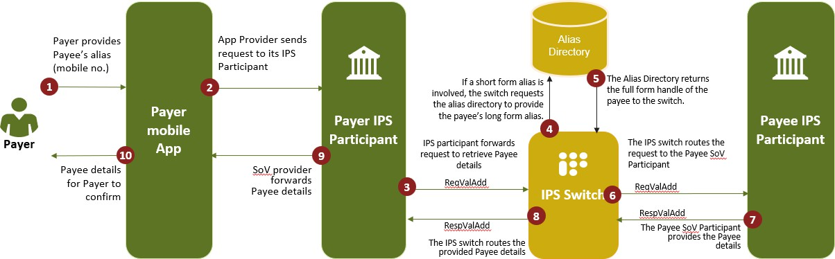

Figure 17: P2P Transactions: Send Money through IPS Participant

Step ID | Actors | Action | Notes and references
1 | Payer | Payer access their preferred IPS channel (e.g. APP provided by the Issuer (App Provider), or the universal USSD) and navigates to the send money option and provides the Payee’s alias (mobile number). | The User should first enter their IPS pin before they can access the various IPS services. The 2-factor authentication will therefore be required before a payment is made.
2 | App Provider | Sends the request to its IPS participant.
3 | Payer IPS Participant | IPS participant forwards request to the IPS Switch to retrieve Payee details.
4 | IPS Switch | If a short form alias is involved, the switch requests the  alias directory to provide the payee’s long form alias. | The switch sends the short form alias in the format of  xxxx.mapper@npci
5 | Alias Directory | The Alias Directory returns the full form handle of the payee to the switch.
6 | IPS Switch | The IPS switch routes the request to the Payee SoV Participant.
7 | Payee SoV Provider | The Payee SoV Participant returns the Payee details (full name and surname, SoV details etc.) to the IPS switch.
8 | IPS Switch | The IPS switch routes the provided Payee details to the Payer’s IPS participant for the Payer to confirm that they are paying the intended Payee.
9 | Payer SoV Provider | The Payer Participant routes back the payee’s details to  the Payer’s Mobile App.
10 | User | App Provider requests the User to confirm payee details before making the credit transfer. | If it is the incorrect details, user starts the process over again.
End of use case
Table 21: Use case ID IPP-UC101

    - Credit Transfer
The second step is the credit transfer which is only initiated after the beneficiary’s details are verified and it is confirmed that there is no derogatory status on the beneficiary’s store of value. A credit transfer can be initiated through a mobile application of the IPSP or on the central USSD. IPSPs may enable pre-approved credit transfer on internet banking. A credit transfer can involve 3 participants i.e., a Payer IPSP that is providing the Mobile Application (who can be different from the Remitter SOV provider), the Remitter SOV provider (who has the User’s store of value), and the beneficiary SOV provider. The Payer IPSP can also be the Remitter SOV provider, if such an IPSP is licensed to provide users with store of value facilities i.e., bank accounts and/or e- money wallets.

Use Case ID | IPP-UC102
Use Case Name: | Send Money: Credit transfer from one SoV Provider to another SoV Provider
Use Case Description: | This use case describes how a payer initiates a credit transfer through a mobile number from the payer SoV Provider directly to payee SoV Provider
End Objective: | The payee receives the credit transfer
Primary Actors: | - Payer  - Payee
Secondary Actors | - Payer SoV Provider  - Payee SoV Provider
Trigger Event: | The mobile number inserted by the payer is verified and the payer initiates a credit transfer to the mobile number
IPS Switch Business Rules
- Both payer and payee registered on IPS.
- Payee not blacklisted.
- The payee’s mobile number should have been linked to an active full form alias.

IPS Participant Business Rules
1. Beneficiary should receive a notification from their SoV Provider to which their mobile number (used in the payment process) is linked to their full form alias construct.
Basic Flow

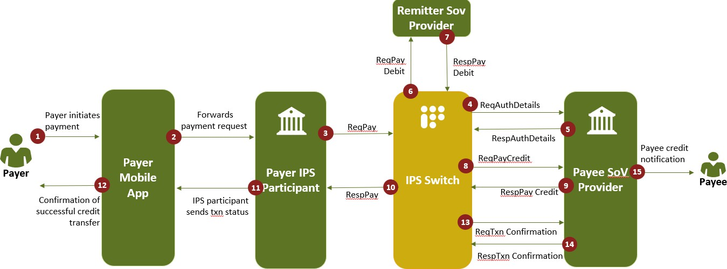

Figure 18: Credit Transfer
Step ID | Actors | Action | Notes and references
1 | Payer | Payer confirms Payee details using their preferred IPS channel and initiates the payment | The User should first enter their IPS pin before they can access the various IPS services. The 2-factor authentication will therefore be required before a payment is made.
2 | Mobile App Provider | Forwards the payment request to its IPS Participant
3 | Payer’s IPS  Participant | ReqPay – The Payer’s IPS Participant initiates the credit transfer by sending the request to the IPS switch
4 | IPS Switch | ReqAuthDetail – The IPS switch validates that the Payee details are still active at the Payee Participant | This API seeks to check whether payee alias exists and valid (can receive funds)

5 | Payee SoV Provider | RespAuthDetail – The Payee Participant confirms that the Payee details are still active
6 | IPS Switch | ReqPay Debit – The IPS switch sends a request to the  Payer SoV Participant to debit the Payer’s SoV
7 | Payer SoV Provider | RespPay Debit – The Payer SoV Participant confirms that the Payer SoV has been debited
8 | IPS Switch | ReqPay Credit - The IPS switch sends a request to the Payee SoV provider to credit the Payee’s SoV
9 | Payee SoV Provider | RespPay Credit - The Payee SoV provider confirms that the Payee SoV has been credited
10 | IPS Switch | ReqTxnConfirmation – Following receipt of the ResPay, the IPS switch provides the Payer’s IPS Participant with the confirmation that the respective Payer and Payee SoVs have been debited and credited accordingly | .
11 | Payer’s IPS  Participant | Payer Debit Notification – The Payer SoV Provider provides the Payer with a notification that their SoV has been debited
12 | Mobile App Provider | Provides payer with confirmation of successful credit transfer
13 | IPS Switch | Requests the payee SoV provider to confirm transaction
14 | Payee SoV Provider | RespTxnConfirmation - The Payee SoV provider provides the IPS switch with a confirmation that the Payee has received a notification of the credit to their SoV
15 | Payee SoV Provider | Provide payee with a notification that their store of value has been credited
End of use case
Table 22: Use case ID IPP-UC102

USSD P2P Transaction: Send Money

Use Case ID | IPP-UC103
Use Case Name: | USSD P2P payment
Use Case Description: | In this use case, the user makes a credit transfer through the central USSD channel
End Objective: | User makes a credit transfer
Primary Actors: | - User  - USSD Gateway Provider
Secondary Actors | - User SoV Provider  - MNO
Trigger Event: | A user opens the IPS central USSD channel to make a payment
IPS Switch Business Rules
Basic Flow

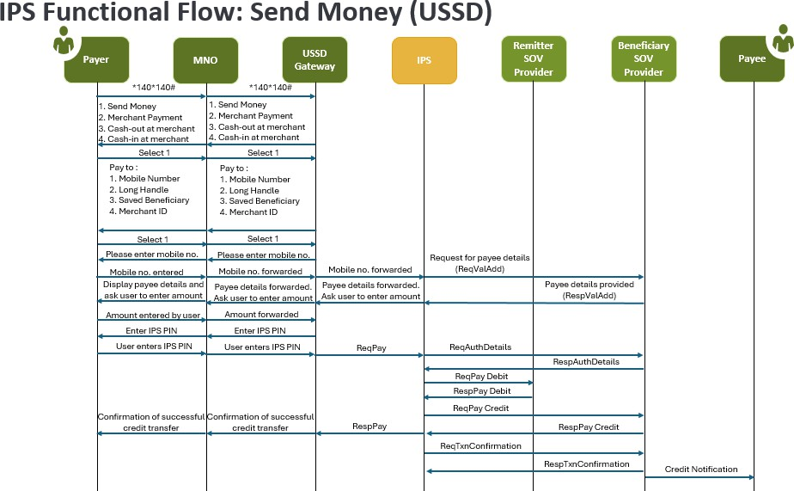
Figure 19: USSD P2P transaction: send money

Step ID | Actors | Action | Notes and references
1 | User | The user enters USSD code (e.g., 140*140#) on his phone.
2 | USSD  Gateway (PSP) | The application server responds back with a menu list.
3 | User | User then selects "Send money" from the list of menu options.
4 | USSD  Gateway (PSP) | Returns various options to send money
5 | User | Selects to send money to a mobile number
6 | USSD  Gateway (PSP) | Requests User to enter mobile number
7 | User | Enters mobile number of beneficiary
8 | USSD  Gateway (PSP) | Sends mobile number to IPS switch
9 | IPS | Resolves mobile number in alias directory and sends request to beneficiary SoV Provider to provide payee details
10 | Beneficiary SoV Provider | Returns beneficiary information to IPS switch
11 | IPS | Returns payee details to USSD gateway and requests user to enter amount
12 | USSD  Gateway (PSP) | Requests user to enter amount by also displaying payee details
13 | User | Checks payee details and enters amount

14 | USSD  Gateway (PSP) | Requests User to enter IPS PIN
15 | User | Enters PIN and Reqpay will be initiated
16 | USSD  Gateway (PSP) | Initiates Reqpay to the IPS
17 | IPS | Initiates a request to the Beneficiary SOV provider to authenticate payee details and account status
18 | Beneficiary SOV Provider | Provides a positive response
19 | IPS | Initiates ReqPay Debit to the Remitter SoV Provider
20 | Remitter SOV Provider | Responds with a RespPay Debit to the IPS
21 | IPS | Initiates a ReqPay Credit to the Beneficiary SOV Provider
22 | Beneficiary SOV Provider | Responds with a ResPay Credit to the IPS
23 | IPS | Provides a transaction success confirmation to the USSD Gateway
24 | USSD  Gateway (PSP) | Provides a transaction success confirmation to the User
25 | IPS | Provides a transaction success confirmation to both Remitter and Beneficiary SOV Providers
26 | Beneficiary SOV Provider | Provides Payee with a credit notification
End of use case
Table 23: Use case ID IPP-UC103

P2B/M Transactions (Mobile App)
In this use case, the user makes a credit transfer to a merchant or business. Take note that the terms are used interchangeably. The payment can be initiated through the payer’s IPSP or SoV provider. All P2M transactions initiated through the IPS switch (rail) should be completed on the IPS switch, including on-us P2M transactions.

Use Case ID | IPP-UC201
Use Case Name: | Making a payment to a business or a merchant
Use Case Description: | The payer through a Mobile Application makes a payment to a merchant by  scanning a QR code, entering the merchant’s unique ID or long alias.
End Objective: | Business / Merchant receives the payment
Primary Actors: | - Payer  - Merchant
Secondary Actors | - SoV Provider
Trigger Event: | The payer initiates a payment to the merchant
IPS Switch Business Rules
- Merchant or business does not apply to sole trader, they are covered under P2P Transactions.
- Merchant QR payments should be enabled and should be different from the QR being used for cash- out.
- Merchant ID should be enabled both short form and full form.
- For full form, it can be alpha numeric between 15 to 20 characters.
- For short form it will be a numeric 8 digit.
IPS Participant Business Rules

- The merchant is onboarded and has an IPS alias.
- The merchant has a Static QR code which is presented to the payer.
- The merchant is loaded onto the SoV Provider’s mobile application as a beneficiary.
- The merchant has a merchant ID that can be used to receive payments from the USSD channel.
Basic Flow

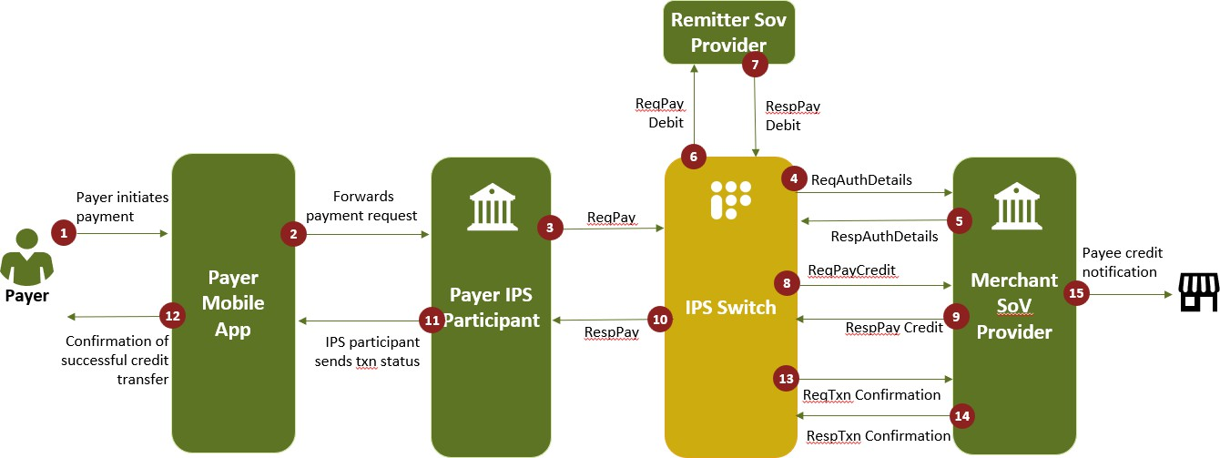

Figure 20: P2B / M Transactions: Make a payment
Step ID | Actors | Action | Notes and references
1 | Payer | Initiates a credit payment on the Enabler or SoV Provider application, scanning the QR code or central USSD channel. | The User should first enter their IPS pin before they can access the various IPS services. The 2-factor authentication will therefore be required before a payment is made.
2 | Mobile App Provider | Routes a request pay to its IPS Participant.
3 | IPS  Participant | Routes a request pay to the IPS switch.
4 | IPS Switch | Routes the transaction to the merchant’s SoV Provider using the @handle provided requesting for authorisation of merchant details.

5 | Merchant’s SoV Provider | Returns merchant details to the IPS switch with merchant’s SoV good standing status.
6 | IPS Switch | Requests the Payer’s SoV provider to debit Payer’s SoV.
7 | Payer SoV Provider | Responds to the request and debits payer’s SoV.
8 | IPS Switch | Requests the Merchant’s SoV Provider to credit the merchant’s SoV.
9 | Merchant’s  SoV Provider | Provides response to the IPS switch that the Merchant’s  SoV is credit.
10 | IPS Switch | Informs payer’s IPS participant that the payer has been debited and a credit to the Merchant’s SoV provider has been made.
11 | Payer IPS Participant | Sends transaction status to the Payer Mobile App Provider.
12 | Payer Mobile App Provider | Provider payer with confirmation of successful credit transfer.
13 | IPS Switch | Informs Merchant IPS participant that the merchant has been credited and the payer has been debited.
14 | Merchant IPS Participant | Provides transaction confirmation to the IPS switch.
15 | Merchant IPS Participant | Informs merchant of successful credit transfer.
End of use case
Table 24: Use case ID IPP-UC201

USSD P2M Transaction: Merchant payment

Use Case ID | IPP-UC202
Use Case Name: | USSD P2M payment
Use Case Description: | In this use case, the user pays a merchant through the central USSD channel
End Objective: | User makes a merchant payment
Primary Actors: | - User  - USSD Gateway Provider
Secondary Actors | - User SoV Provider  - MNO
Trigger Event: | A user opens the IPS central USSD channel to pay a merchant
IPS Switch Business Rules
Basic Flow

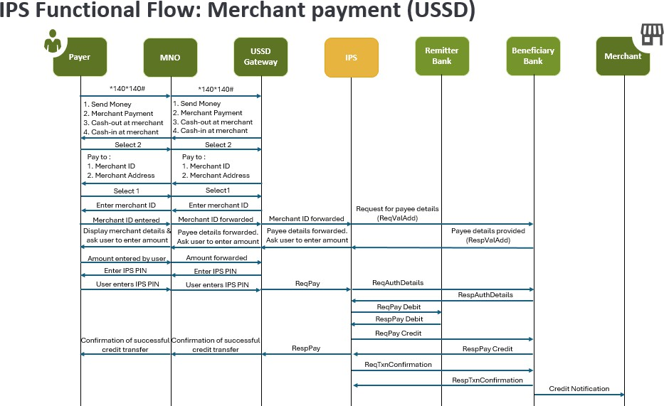
Figure 21: Merchant payment USSD
Step ID | Actors | Action | Notes and references
1 | User | The user enters USSD code (e.g., 140*140#) on his phone.
2 | USSD  Gateway (PSP) | The application server responds back with a menu list.
3 | User | User then selects Merchant payment from the list of menu options.
4 | USSD  Gateway (PSP) | Returns various options to payment merchant
5 | User | Selects to pay merchant using merchant ID
6 | USSD  Gateway (PSP) | Requests User to enter Merchant ID
7 | User | Enters Merchant ID

8 | USSD  Gateway (PSP) | Sends Merchant ID to IPS switch
9 | IPS | Resolves Merchant ID in alias directory and sends request to beneficiary SoV Provider to provide payee details
10 | Beneficiary SoV Provider | Returns beneficiary information to IPS switch
11 | IPS | Returns payee details to USSD gateway and requests user to enter amount
12 | USSD  Gateway (PSP) | Requests user to enter amount by also displaying payee details
13 | User | Checks payee details and enters amount
14 | USSD  Gateway (PSP) | Requests User to enter IPS PIN
15 | User | Enters PIN and Reqpay will be initiated
16 | USSD  Gateway (PSP) | Initiates Reqpay to the IPS
17 | IPS | Initiates a request to the Beneficiary SOV provider to authenticate payee details and account status
18 | Beneficiary SOV Provider | Provides a positive response
19 | IPS | Initiates ReqPay Debit to the Remitter SoV Provider
20 | Remitter SOV Provider | Responds with a RespPay Debit to the IPS
21 | IPS | Initiates a ReqPay Credit to the Beneficiary SOV Provider
22 | Beneficiary SOV Provider | Responds with a ResPay Credit to the IPS

23 | IPS | Provides a transaction success confirmation to the USSD Gateway
24 | USSD  Gateway (PSP) | Provides a transaction success confirmation to the User
25 | IPS | Provides a transaction success confirmation to both Remitter and Beneficiary SOV Providers
26 | Beneficiary SOV Provider | Provides Payee with a credit notification
End of use case
Table 25: Use case ID IPP-UC202

B/G2P Transactions: Bulk Payment
For B/G2P bulk payments, the beneficiary details are shared with Payer IPSP / BON and the IPSPS or BON will perform a one-time debit of the total amount (outside of IPS), generate a reference and send individual credit request to the IPS switch to credit multiple beneficiaries. These payments are preapproved.

Use Case ID | IPP-UC301
Use Case Name: | Government or business bulk payments to persons
Use Case Description: | In this use case, the government makes a bulk payment to multiple persons. These payments can comprise of grants, pension payouts or salaries. Similar use case for merchants that intend to make bulk payments i.e., salaries. This is a one-to-many use case
End Objective: | Multiple persons receive payment
Primary Actors: | - CMBO as Government’s IPS participant.  - Merchant to use Store of Value Provider as IPSP
Secondary Actors | Multiple payees

Trigger Event: | Government triggers a bulk payment credit transfer
IPS Participant Business Rules
- Government / business can share the bulk processing file in the pre-defined format to the bank / processing entity where Government / Business holds a SoV.
- The IPS switch needs confirmation of the bulk debit by the acquiring PSP on the SoV of the merchant, (the details of the same shall be provided in the pay request) as a prerequisite to issuing the credit instruction.
- The Payer SOV Participant and Payer IPS participant has to be the same entity.
- The Beneficiary SOV Participant must be on-boarded on IPS to avail the service.
- The Participant then:
  - Performs debit on the business / government SoV (the process of debit is based on the arrangements with banks and government / business). Also, this type of transactions is pre- authorised debit and shall not require PIN authentication.
  - The CMBO or a participant de-bulk the file and sends the individual transaction requests to the IPS switch.
- Subsequently, the IPS switch will send a payment request (ReqPay Credit) to the beneficiary’s IPSP to credit each beneficiary.
- IFSC code and account number combination, resolved directly by IPS, is represented as account- no@ifsc-code.ifsc.npci (e.g. 12345678901@BWLI0483772.ifsc.npci)
- SoV provider needs to pass above in the address field ReqPay request to IPS.
- Debit / Debit reversal is outside the scope of IPS in this use-case (as there is no Debit request to IPS).
- In case of a pre-approved transaction failing to credit the beneficiary, the relevant response code will be provided. It is the responsibility of the Payer IPS Participant to handle the reversal of the transaction.
- In case of credit timeout, transaction will be settled in the next settlement cycle.
CMBO / Merchant Business Rules
- The platform used to initiate the payment instructions is to be determined by CMBO or the payer IPSP.

- The debulking and scheduling of recurring payments is to be performed by the CMBO / merchant IPS participant prior to being sent to the IPS switch which only processes payments individually (i.e. not batched).
- The CMBO / Merchant and their IPS participants are to determine their arrangement of when the bulk debit of the Government account or merchant's SoV is to take place. The only requirement is for this confirmation to be provided by the time of the crediting of the beneficiary’s SoV.
- Payer IPSP is to receive the Payee details (account or wallet number plus IFSC) associated with the alias being paid prior to the crediting of the payee’s SoV. This pre-authorisation should be done prior to submitting the bulk payment file.
- The Payer and Payee IPSP are to issue payment confirmations to the merchant and beneficiary respectively to confirm the successful transaction. The merchant may receive a bulk payment notification.




Basic Flow
Credit Transfer
IPS Functional Flow: Bulk Payment
Functional flow: G2P (Bulk Payment Use Case)

ReqPay ReqPay
1 2 Credit
Beneficiary details 3
shared with Payer IPS Participant / BON and
BON will perform a SoV IPS SoV
one−time debit of the Participant Participant
Government total amount (outside
Agency / of IPS) and send an 4
Merchant / individual request to 5
IPSP IPS for credit RespPay RespPay
6 Credit
Payment status
notification to Government Agency

1

Figure 22: Bulk payment
Step ID | Actors | Action | Notes and references

1 | Government / Merchant / IPSP | Prepares the files and share it with the respective SOV participant (or CMBO for Government payments) for Debit.
2 | Government / Merchant / IPSP | Debit the amount and share the Credit request to IPS.
3 | IPS Switch | Upon receiving the ReqPay request from SoV participant, IPS will initiate the credit request to respective SoV Participants for Credit.
4 | Payee participants | Responds to the IPS Switch through RespPay and credit the beneficiary account.
End of use case
Table 26: Use case ID IPP-UC301

Merchant Cash-Out (Mobile App)

Use Case ID | IPP-UC401
Use Case Name: | Merchant cash out
Use Case Description: | In this use case, the user can perform a cash out operation by scanning the merchant’s QR code, or making a payment to a merchant’s unique code, or long alias.
End Objective: | Merchant dispenses cash
Primary Actors: | - Merchant  - User
Secondary Actors | - Merchant SoV Provider /  - User SoV Provider
Trigger Event: | A user approaches the merchant till and request to cash out from their SoV
IPS Participant Business Rules

- The user approaches the merchant then scans their QR code or enters their merchant ID or long alias.
- The user needs to complete the user journey before any action can commence from the merchant
- The Merchant’s QR code for cash-out should be different from the QR code used to make a payment to the merchant.
Post-conditions
Basic Flow

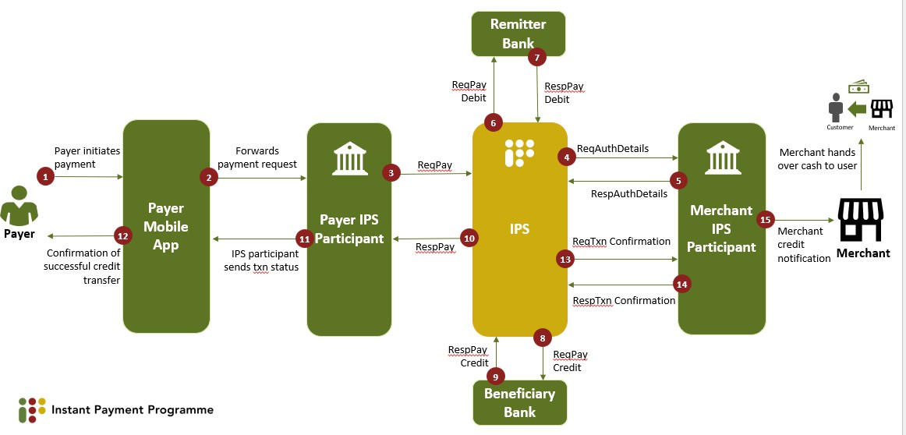
Figure 23: Merchant Cash-Out
Step ID | Actors | Action | Notes and references
1 | User | Initiates a cash out request by providing merchant details through one of the supported identifiers QR Code (App only), Long Handle, or Unique Code. The Merchant captures the request via Mobile App. | Which is treated as a payment to the merchant.
2 | Payer Mobile App/USSD Provider | Submits a payment request to the IPS participant.
3 | IPS  participant | Initiates a request to authorise the merchant’s details.
4 | IPS Switch | Passes on the request to the Merchant’s IPS participant.

5 | Merchant IPS participant | Responds with authorisation of the merchant details.
6 | IPS Switch | Requests for the user’s store of value to be debited.
7 | Remitter bank | Response with confirmation that the store of value is debited.
8 | IPS Switch | Requests beneficiary store of value provider to credit merchant.
9 | Beneficiary bank | Beneficiary bank responds that merchant’s store of  value is credited.
10 | IPS Switch | Provides payer IPS participant with confirmation that payment was successful.
11 | Payer IPS participant | Informs the Mobile App/USSD Provider that payment was successful.
12 | Payer Store of Value Provider | Informs the user that store of value has been debited and cash will be dispensed by the merchant.
13 | Merchant | Hands over cash to user. | Once a credit notification has been received from the beneficiary bank or IPS participant.
End of use case
Table 27: Use case ID IPP-UC401

USSD Merchant Cash-out Transaction

Use Case ID | IPP-UC402
Use Case Name: | USSD MCO
Use Case Description: | In this use case, the user pays a merchant to get cash from the Till
End Objective: | User receives cash
Primary Actors: | - User  - USSD Gateway Provider
Secondary Actors | - User SoV Provider  - MNO
Trigger Event: | A user opens the IPS central USSD channel to cash-out at a merchant
IPS Switch Business Rules
Basic Flow

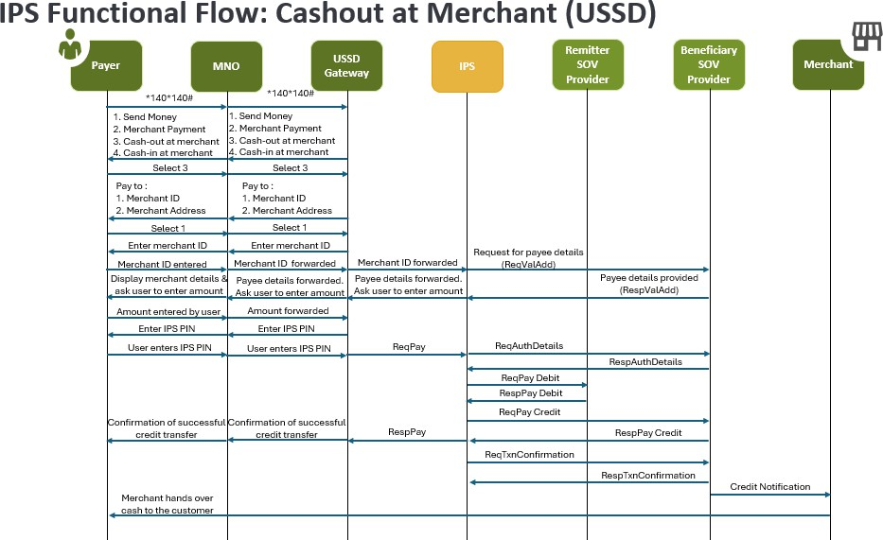
Figure 24: Cashout at merchant (USSD)
Step ID | Actors | Action | Notes and references
1 | User | The user enters USSD code (e.g., 140*140#) on his phone.
2 | USSD  Gateway (PSP) | The application server responds back with a menu list.
3 | User | User then selects cash-out at merchant from the list of menu options.
4 | USSD  Gateway (PSP) | Returns various options to cash-out at merchant
5 | User | Selects to cash-out at merchant using merchant ID
6 | USSD  Gateway (PSP) | Requests User to enter Merchant ID
7 | User | Enters Merchant ID

8 | USSD  Gateway (PSP) | Sends Merchant ID to IPS switch
9 | IPS | Resolves Merchant ID in alias directory and sends request to beneficiary SoV Provider to provide payee details
10 | Beneficiary SoV Provider | Returns beneficiary information to IPS switch
11 | IPS | Returns payee details to USSD gateway and requests user to enter amount
12 | USSD  Gateway (PSP) | Requests user to enter amount by also displaying payee details
13 | User | Checks payee details and enters amount
14 | USSD  Gateway (PSP) | Requests User to enter IPS PIN
15 | User | Enters PIN and Reqpay will be initiated
16 | USSD  Gateway (PSP) | Initiates Reqpay to the IPS
17 | IPS | Initiates a request to the Beneficiary SOV provider to authenticate payee details and account status
18 | Beneficiary SOV Provider | Provides a positive response
19 | IPS | Initiates ReqPay Debit to the Remitter SoV Provider
20 | Remitter SOV Provider | Responds with a RespPay Debit to the IPS
21 | IPS | Initiates a ReqPay Credit to the Beneficiary SOV Provider
22 | Beneficiary SOV Provider | Responds with a ResPay Credit to the IPS

23 | IPS | Provides a transaction success confirmation to the USSD Gateway
24 | USSD  Gateway (PSP) | Provides a transaction success confirmation to the User
25 | IPS | Provides a transaction success confirmation to both Remitter and Beneficiary SOV Providers
26 | Beneficiary SOV Provider | Provides Payee with a credit notification
27 | Merchant | Hands over cash to the user
End of use case
Table 28: Use case ID IPP-UC402

Merchant Cash-In (Mobile App)

Use Case ID | IPP-UC501
Use Case Name: | Merchant cash in
Use Case Description: | In this use case, a User approaches a merchant with cash and request to cash-in their store of value (account or wallet). The Merchant can initiate the transaction through their mobile application, merchant application or Till. The merchant can pay to a user’s mobile number, long alias or by scanning the User’s QR code.
End Objective: | User SoV is credited
Primary Actors: | - Merchant  - User
Secondary Actors | - Merchant SoV Provider /  - User SoV Provider

Trigger Event: |  | A user approaches the merchant till and request to cash in to their SoV providing their alias (Mobile Number, Long Handle, or QR Code).
Basic Flow

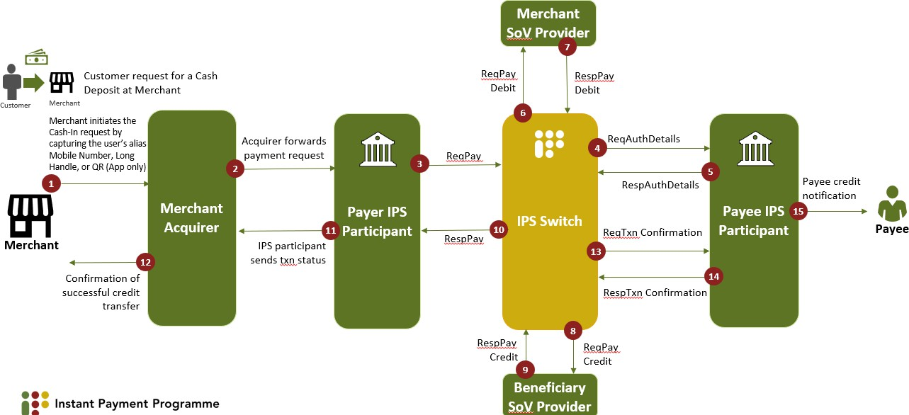

Figure 25: Merchant Cash-In
Step ID | Actors | Action | Notes and references
1 | Merchant | Receives cash and initiates a payments to the customer.
2 | Merchant Acquirer | Forward the payment request to the IPS participant.
3 | IPS  participant | Initiates reqpay to the IPS switch
4 | IPS Switch | IPS switch requests the User’s store of value provider to verify payee details
5 | Payee SoV Provider | Returns verification to the IPS switch
6 | IPS switch | Sends debit request to payer SoV
7 | Payer SoV Provider | Payer SoV Provider debits the amount and responds back to IPS.

8 | IPS Switch | IPS sends the credit request to the beneficiary’s SoV Provider via ResPay Credit Api
9 | Merchant SoV Provider | Beneficiary SoV is credited and sends back the response to IPS.
10 | IPS Switch | IPS send the credit notification to Payer IPS participant via Txn Confirmation API
11 | Payer IPS participant | Sends transaction status to the merchant’s acquirer
12 | Merchant Acquirer | Provider merchant with successful credit transfer
13 | IPS Switch | Request transaction confirmation from the Payee’s IPS participant
14 | Payee’s IPS  participant | Provides confirmation to the IPS switch
15 | Payee’s IPS  participant | Informs the payee that their store of value has been credited
End of use case
Table 29: Use case ID IPP-UC501

USSD Merchant Cash-In Transaction

Use Case ID | IPP-UC502
Use Case Name: | USSD MCI
Use Case Description: | In this use case, the merchant pays a User through the USSD channel after receiving cash from the User
End Objective: | User’s SOV is credited
Primary Actors: | - Merchant  - USSD Gateway Provider
Secondary Actors | - Merchant SoV Provider

 |  | - MNO
Trigger Event: |  | A User approaches the merchant with cash to cash-in to their SOV
IPS Switch Business Rules
Basic Flow

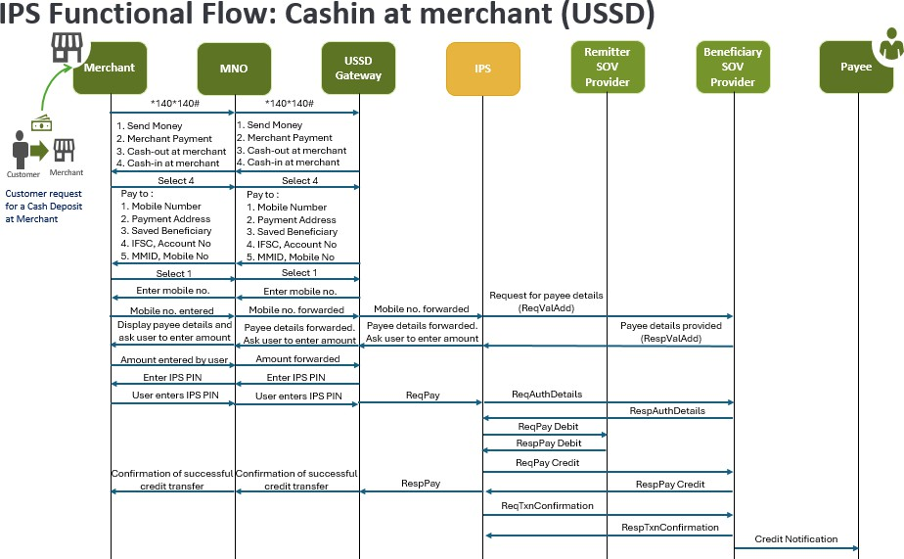
Figure 26: Cashin at merchant (USSD)
Step ID | Actors | Action | Notes and references
1 | Merchant | The merchant enters USSD code (e.g., 140*140#) on his phone.
2 | USSD  Gateway (PSP) | The application server responds back with a menu list.
3 | Merchant | Merchant then selects cash-in at merchant from the list of menu options.
4 | USSD  Gateway (PSP) | Returns various options to cash-in at merchant

5 | Merchant | Selects to cash-in at merchant using User’s mobile number
6 | USSD  Gateway (PSP) | Requests Merchant to enter User mobile number
7 | Merchant | Enters User’s mobile number
8 | USSD  Gateway (PSP) | Sends User’s mobile number to IPS switch
9 | IPS | Resolves User’s mobile number in alias directory and sends request to beneficiary SoV Provider to provide payee details
10 | Beneficiary SoV Provider | Returns beneficiary information to IPS switch
11 | IPS | Returns payee details to USSD gateway and requests Merchant to enter amount
12 | USSD  Gateway (PSP) | Requests user to enter amount by also displaying payee details
13 | Merchant | Checks payee details and enters amount
14 | USSD  Gateway (PSP) | Requests Merchant to enter IPS PIN
15 | Merchant | Enters PIN and Reqpay will be initiated
16 | USSD  Gateway (PSP) | Initiates Reqpay to the IPS
17 | IPS | Initiates a request to the Beneficiary SOV provider to authenticate payee details and account status
18 | Beneficiary SOV Provider | Provides a positive response
19 | IPS | Initiates ReqPay Debit to the Remitter SoV Provider

20 | Remitter SOV Provider | Responds with a RespPay Debit to the IPS
21 | IPS | Initiates a ReqPay Credit to the Beneficiary SOV Provider
22 | Beneficiary SOV Provider | Responds with a ResPay Credit to the IPS
23 | IPS | Provides a transaction success confirmation to the USSD Gateway
24 | USSD  Gateway (PSP) | Provides a transaction success confirmation to the User
25 | IPS | Provides a transaction success confirmation to both Remitter and Beneficiary SOV Providers
26 | Beneficiary SOV Provider | Provides Payee with a credit notification
End of use case
Table 30: Use case ID IPP-UC502

ATM Cash-out

Use Case ID | IPP-UC601
Use Case Name: | Cashing out at an ATM
Use Case Description: | In this use case, the user approaches an interoperable ATM and initiates a cash withdrawal using their mobile application or USSD
End Objective: | Interoperable ATM dispenses cash
Primary Actors: | User

Secondary Actors | - ATM Provider  - User SoV Provider
Trigger Event: | The User selects the option to withdraw cash at an interoperable ATM
IPS Switch Business Rules
- QR Code withdrawals are not activated for go-live.
- Details around specific of non-financial (validation/verification) and financial (Debit/Credit/Reversal) leg of the transactions will be covered as a part of TSD.
- The mobile number entered by the user at the ATM (step #5) is the same number that is linked to the SoV against which the withdrawal OTP is requested (step #1).
ATM Provider Business Rules
- User pre-stages before engaging the ATM including entering their IPS pin on the mobile device.
- ATM withdrawal amount / denomination to be selected by the User on the channel before approaching the ATM. If the denomination is not available, the amount cannot be withdrawn.
- Partial withdrawal is not in scope.
- If currency note is not dispensed, then full reversal will be triggered by the ATM Acquirer
- Transaction once completed, ATM provider and SoV participants will notify the user with the appropriate status of the transaction.
- The implementation of ATM ISO message conversion to UPI message standard and vice versa will have to be managed by ATM acquiring banks.
- This implementation requires that payee IPS Participant and Beneficiary ATM owning bank are the same entity.
- Generation of OTP and storing the relevant user information is performed by SoV participants. IPS switch is not involved in this process
- The mobile number entered by the user at the ATM is the same number that is linked to the SoV against which the withdrawal OTP is requested.
- SoV participants performs the auto reversal / releases block of funds, if OTP is not utilized within the stipulated time. Similarly, in an event ATM is not able to dispense the cash, ATM acquiring PSP must respond with failure response code for IPS switch to initiate the reversal request to SoV participant.

Similarly, the successful response from ATM acquiring PSP shall only be after the cash is dispensed from the ATM.
- Transaction once completed, ATM Provider and SoV participants will notify the user with the appropriate status of the transaction.
- Details around specific non-financial (validation/verification) and financial (debit/credit/reversal) leg of the transactions will be covered as a part of TSD.
- The security (encryption, certificates, SSL etc.) mechanism for data exchange between ATM provider and ATM Acquirer is out of scope of IPS.
- The security (encryption, certificates, SSL etc.) mechanism for data exchange between IPS and ATM Acquirer must be as per the IPS specification.
- Cashing out at an ATM is only applicable to e-money wallets. Bank accounts are out of scope.
Basic Flow
Functional flow: ATM Withdrawal (Success Flow- *20B)
A user wants to withdraw cash from an ATM using an OTP (Overall Flow)
 | Customer |  | 1 Open channel with 4 6B 17 21  Receives the OTP for  the preferred SoV withdrawal with the validity Transaction End Receives error  participant, enters period and visits to an ATM Ends* End message End Receives the cash  Start amount, Pin and to enter the details requests OTP
 | SoV Participa Payer IPS | nt | 10 12Received details is sent  3 SOV responds with to internal system for 17 Debits the 24  2 stores the respauth further customer SOV  Generates an OTP on amount, OTP (Verification of Full verification(OTP, PIN, Validation 13B Yes and provide Reqtxn  customer registered and mobile no. Alias and provide Amount and OTP Expiry) Passed? response confirmation to mobile no and block Begins the OTP Account details including the check for through respay Payer IPS  the funds. expiration timer related to the the availability of the No debit  same.) ^{13A}  funds in customer SoV
 | IPS  Switch + Directory | Alias |  | 23  14 18 26  9 11 Sends response to IPS participant ATM acquirer  IPS initiates Reqauth Initiates ATM Acquirer IPS receives respay debit responds with restxnconfirmation with SOV participant reqdebit provider for and Sends reqpay respay credit  along with directory appropriate action credit to ATM acquirer  usingrespay debit  No
 | ATM Acq  Payee IPS | uirer |  | 22 25  8 Sends ReqPay 15 19 ATM provides request with OTP Sends response to ATM acquirer acknowledgment of  and Wallet Pin ATM for receives the cash dispense Respay request to IPS appropriate action reqpay credit and ATM acquirer  Switch participant request credits pool account
 | ATM  ATM  Provid | er | 20C  5 No  Customer Initiates 7  the Withdraw 16 ATM initiates cash 20B *Success  6A Denomination Receives details and 20 ^{dispense} ^{and} ^{responds}  process by entering Yes with status  available at initiates the validation Informs the Customer that the  Mobile No, Wallet ATM? request to SOV participant details provided were incorrect or  Pin, OTP and verification failed 20A #Failure  Amount End
Office Use Only\Internal

Figure 27: ATM Cash-out
Step ID |  | Actors |  | Action | Notes and references

1 | Customer | Open channel with the preferred SoV participant, enters amount, Pin and requests OTP | Customer choose the amount he / she wishes to withdraw, not exceeding N$2000.00
2 | Customer SoV Provider | Generates an OTP on customer registered mobile no and block the funds.
3 | Customer SoV Provider | Stores the amount, OTP and mobile no. Begins the OTP expiration timer
4 | Customer | Receives the OTP for withdrawal with the validity period and visits to an ATM to enter the details
5 | ATM Provider | Customer Initiates the Withdraw process by entering Mobile No, Wallet Pin, OTP and Amount
6a | ATM Provider | Denomination available at ATM? | Step number 6 is optional and its discretion of ATM provider to implement the same. ATM provider can skip the step and decline the transaction at step number 20 with appropriate error codes.
7 | ATM Provider | If yes, receives details and initiates the validation request to SOV participant.
8 | ATM Acquirer | Sends ReqPay request with OTP and Wallet Pin request to IPS Switch participant.
9 | IPS Switch + Alias Directory | initiates reqauth with SOV participant after fetching full alias mapped to mobile number in directory.
10 | Customer SoV participant | SOV responds with respauth (Verification of Full Alias and provide Account details related to the same.)
11 | IPS Switch | Initiates reqdebit

12 | Customer SoV Participant | Received details is sent to internal system for further verification (OTP, PIN, Amount and OTP Expiry) including the check for the availability of the funds in customer SoV. | Approaches:  - SOV participants can block the fund (at step 2) and need not validate the funds as the same have been reserved (at step 12)  - SOV participants can block the fund (at step 2) and need not validate the funds as the same have been reserved (at step 12)  - SOV participants can block the fund (at step 2) and need not validate the funds as the same have been reserved (at step 12)
13B | Customer SoV Participant | Validation passed
17 | Customer SOV  Participant | Debits the customer SOV and provide response through respay debit
18 | IPS Switch | IPS Switch receives respay debit and sends reqpay credit to ATM acquirer
19 | ATM Acquirer | ATM acquirer receives the reqpay credit request

20 | ATM Provider | ATM initiates cash dispenses and responds with status. | In Step 20, there shall be two scenarios:  - ATM will dispense cash to the user. In case of success scenario, once the cash is dispensed, the ATM will respond ATM acquirer with success status. ATM acquirer will respond with success scenario to IPS, and the flow will proceed.  - In case of failure, the cash will not be dispensed, and the failure response will be provided to ATM acquirer. In case of failure IPS will be responded with credit failure and debit reversal* will happen.
20B | ATM Provider | Success
21 | Customer | Receives the case.
22 | ATM Acquirer | ATM provides acknowledgment of cash dispense and ATM acquirer credits pool account | If ATM acquirer doesn’t respond to IPS switch with the  status of transaction, the credit time-out* scenario will follow.
23 | IPS Switch | ATM acquirer responds with respay credit

24 | Customer SoV Participant | Reqtxn confirmation to Payer IPS
25 | ATM Acquirer | Respay
26 | IPS Switch | Restxnconfirmation
Negative response
13A | Customer SoV Participant | Validation failed.
14 | IPS Switch | Sends response to ATM Acquirer IPS provider for appropriate action using respay debit
15 | ATM Acquirer | Sends response to ATM for appropriate action
16 | ATM Provider | Informs the Customer that the details provided were incorrect or verification failed
17 | Customer | Receives error message | End
ATM flow additional notes:
1. Steps 12, 13,14 and 17 in the flow are a single step at the SOV participants end. Once SOV participants
receive details (step 12), he will validate those details and will either approve and respond with respay debit success (step 13B, 17) or reject and respond with respay debit failure (step 13A,14)
End of use case
Table 31: Use case ID IPP-UC601

Debit Reversal and Deemed Process – (#20A)
- Debit Reversal:
  - If Bene/Acquirer PSP send failure response to IPS switch, IPS switch will initiate debit reversal to Issuing bank (Payer IPS Participant).
  - If debit reversal is Success then transaction is closed.
  - If debit reversal is failed then transaction will go in deemed and will require to get settled manually in next settlement cycle.
- Credit time out:

  - If Bene/Acquire PSP is unable to send any response to IPS switch,
    - IPS switch will initiate ReqChkTxn to Bene/Acquire PSP
      - If ReqChkTxn response is Credit Success then the transaction is complete and rest of the steps as per the flow shall be followed.
      - If Bene/Acquire PSP is unable to respond to ReqChkTxn then IPS will initiate ReqPay Credit Reversal.
        - If Credit Reversal response is
          - Original Credit Success: No further actions and rest of the steps as per the flow shall be followed.
          - Original Credit Fail: Transaction will fall under Debit Reversal Flow.
          - Unable to send Credit Reversal response: Transaction will be marked as deemed and will require to get settled in the next settlement cycle.
- Credit Failure:
  - If ATM responds with failure to dispense cash, ATM acquirer will respond to IPS switch with failure.
  - The IPS switch will respond with reqpay debit reversal (Step 1 above) to the remitter bank (Payer IPS participant) and the remitter shall reverse the transaction.
Note: It is recommended that, OTP once consumed shall not be allowed to use again, irrespective of the status of the transaction, when it was used.

NEGATIVE SCENARIOS

This section provides for the plausible negative solution on the IPS covering both scenarios during registration and during a transaction. While the coverage is not exhaustive, the Technical Specifications will make provision for all plausible scenarios.

Registration Negative Scenarios
    - Negative Scenarios
There are possible negative scenarios that could occur during registration and deregistration of an alias. Some of these scenarios can be summarized as follows:

- Failure to register / deregister due to technical issues / restrictions from the IPS Participant:
  - Registration of a new IPS customer is temporary blocked by IPS Participant due to maximum number of attempts exceeded by the user.
  - User may not be able to register their default alias due to the IPS Participant having a technical issue resulting in failure to route the request to the centralised alias directory.
  - IPS participant is unable to match debit card number and pin to the store of value of the user.
  - IPS participant is unable to verify User’s identity at the Mobile Network Operator’s
database.

- Failure to register / deregister due to technical issues /restrictions from the Mobile Network Operator:
  - Mobile number registration/ deregistration fails due to a technical error caused by an MNO not being able to send OTP for verification.
  - MNO unable to provide a respond to IPS participant’s verification request.

- Failure to register / deregister due to technical issues / restrictions from the Ministry of Home Affairs:
  - Unable to verify User’s identity.
  - Unable to provide a user verification response to the IPS participant.

- Failure to register/ deregister due to technical issues /restrictions from IPS Switch:
  - User may not be able to register their customised name alias as it is currently registered and belongs to another IPS user.
  - A customised name alias may be rejected during registration due to it failing to meet the guidelines for a customised name.

    - Resolution of potential negative scenarios
Resolutions for potential failures during registration are provided in the table below, although the list is not exhaustive. The cause of actions provided are mandatory during registration. In all the cases provided below, an error message is to be provided to the User on the channel they are registering an Alias. In all the cases provided below, the SoV Provider of the User should be contacted for action.
Cases | Course of Action
1. Registration of a new IPS customer is temporary blocked by Participant due to maximum number of attempts exceeded by the user. | - User can make 3 attempts to register, there after a cooling period will apply.  - Cooling period for User to re-attempt registration for:  - the first time is 30min.  - second time is 1 hour.  - third time – contact SoV Provider for assistance.
2. User may not be able to register their default alias due to the Participant having a technical issue resulting in failure to | - The Participant informs the user of the technical difficult and advises the user to retry again later.

Cases | Course of Action
route the request to the centralised alias directory. | - The user retries again later until they have successfully registered.  - Course of action in number 1 applies.
3. Mobile number registration/ deregistration fails due to a technical error caused by an MNO not able to send verification. | - The user clicks on the option of resending the verification. If the problems persist the user enquires. with the Participant customer care centre.
4. User may not be able to register their customised name alias as it is currently registered and belongs to another IPS user. | - The Participant informs the user that the selected customised name is already registered and recommends alternatives to the user. E.g. Carwash@PSPA is already taken, Carwash4ways@PSPA is available.  - The user registers a different customised name successfully.
5. A customised name alias may be rejected during registration due to it failing to meet the guidelines for customised name. | - The Participants informs the user of the guidelines needed to be met E.g. A customised name may not contain special characters.  - The user takes the guideline into considerations and is able to register their customised name successfully.
Table 32: Resolution of potential negative scenarios

Transaction Negative Scenarios
The following table provides a list of possible exceptions and negative scenarios that can happen during an instant payment transaction. The functional flows for some of these scenarios are provided below. Some of the scenarios will be further deliberated in the Technical Specifications and / or handled in accordance with the respective IPS participants’ internal procedures. The following table provides a non-exhaustive list of negative scenarios related to an instant payment transaction.

# | Flow Description
1 | Payer fails to Pay due to general technical issue
2 | Payer fails to Pay due to IPS payment transaction limit reached
3 | Payer fails to Pay due to merchant SoV not accepting payments (frozen account, etc.)
4 | Payer fails to Pay due to payment declined by Payer SoV Participant
5 | Payer fails to Pay due to technical Issue at Payer SoV Participant
6 | Payer fails to Pay due to Payer SoV Participant payment transaction limit reached
7 | Payer fails to Pay due to wrong PIN entered
8 | Payer fails to Pay due to sending to a blocked IPS Alias
9 | Payer fails to Pay due to sending to an invalid SoV
10 | Transaction fails due to Timeout Window lapsing
11 | Transaction fails due to manual cancellation by user
12 | Payer sends money to payee and payment is "deemed successful"
13 | Payer sends money to payee and payment failed
Table 33: Transaction Negative Scenarios

Failure Scenarios

This section explains how various failure scenarios are handled during the PAY transaction. The transaction flows mentioned above will be considered while describing the failure scenarios.
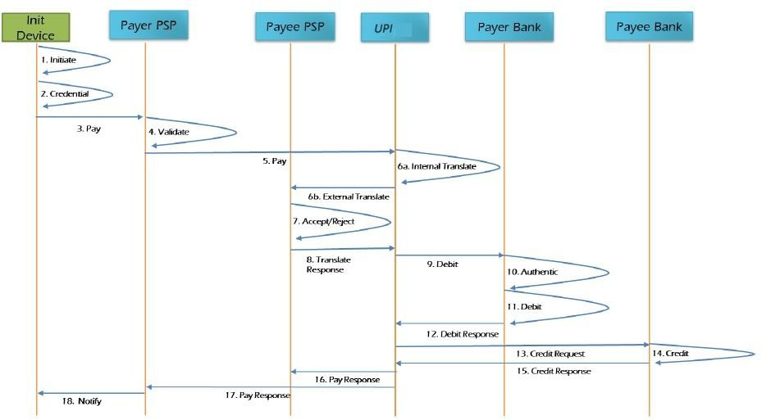

Figure 28: Failure Scenarios

Failure at step 18 – Payer IPS Participant unable to notify the Payer:

In this scenario, when the payer IPS is not able to notify the end customer on the status of the transaction, a mechanism must be put in place by the payer IPS participant to notify the customer at a later stage. This can be achieved by the payer IPS participant reinitiating the notification message to customer or by providing the customer an option to check the status of the transaction through his application, or by providing a list of all transactions (with status) in the application.

Failure at step 16/17 - Response from IPS does not reach Payee/Payer IPS Participant:

In this scenario, when the response sent by IPS does not reach Payer/Payee IPS participant, the participants should have a mechanism to initiate a Check Status API to know the status of the transaction. The participant can only initiate the Check Status API to the IPS after a time of Transaction expiry time. If no success response is received from beneficiary IPS Participant, then:
- IPS will send check status after 10 seconds of the original credit request.
- If no response for check status, then IPS will generate ReqPay Credit Reversal to bene bank.
- If no response to step 2, the transaction will get in Deemed/Pending state which will be settled the next day with either TCC/RET code (see code description below).

If there is response of credit reversal which is successfully reversed, then IPS will generate debit reversal to remitter bank.

Failure at step 15 - Response from Payee participant does not reach the IPS:

In this scenario, when the response sent by Payee participant does not reach the IPS, this transaction will be considered as deemed and will proceed for settlement. Response will be sent to Payee and SoV Provider. Regardless of the status, the transaction will be settled offline in the IPS Real Time Clearing and Settlement (IRCS).

Failure at step 15 - Declined Response from Payee participant to the IPS:

In this scenario, when the Payee participant responds with a declined response to the IPS, the IPS will send the reversal request to Payer participant and respond to Payee and SoV Provider with a declined response.

Failure at step 13 - Payee participant is not available to the IPS:

In this scenario, when the Payee participant is not available to the IPS, the IPS will send the reversal request to Payer participant and respond to Payee and Payer participants with declined response.

Failure at step 12 - Declined Response from Payer participant to the IPS:

In this scenario, when the Payer participant responds with a declined response to the IPS, the IPS will respond to Payee and Payer participants with declined response. No credit request will be initiated to Payee participant.

Failure at step 12 - Response from Payer participant does not reach the IPS:

In this scenario, when the response sent by Payer participant does not reach the IPS, the IPS will timeout the transaction. The IPS will respond to Payee/Payer participants with timeout response.

Failure at step 9 - Payer participant is not available to the IPS:

In this scenario, when the Payer bank is not available to IPS, the IPS will respond to Payee and Payer participants with declined response.

Failure at step 8 - Declined Response from Payee participant to the IPS:

In this scenario, when the Payee participant responds with a declined response to the IPS, the IPS will respond to Payer participant with declined response.

Failure at step 8 - Response from Payee participant does not reach the IPS:

In this scenario, when the response sent by Payee participant does not reach the IPS, the IPS will wait for the response till the timeout period. Payee participant may have a mechanism to re send the response within the timeout period. If the IPS does not receive response within the timeout period, the IPS will timeout the transaction and respond to Payer participant with a timeout response.

Failure at step 6 – Payee participant is not available to the IPS:
In this scenario, when the Payee participant is not available to the IPS, the IPS will respond to Payer participant with declined response.

Failure at step 5 – The IPS is not available to Payer participant:
In this scenario, when the IPS is not available to Payer participant, the Payer participant will have a mechanism to re initiate the Pay request to the IPS. For a failed/declined preapproved transaction remitter participant should reverse the debit on receiving the declined response from the IPS.

Error Codes

The response error codes of the IPS are documented in a separate document referred to as Instant Payment Solution Error and Response Codes. The codes covered therein are as follows:
IPP Error and Response Codes.docx

Types of response codes | Description
1. Response codes in RespPay Debit, RespPay Credit, RespPay Debit (Mandate) & RespChkTxn API | These response codes should be populated by the IPS participant in case of any error.
2. Response codes in RespPayReversal API | These response codes should be populated by the IPS participant in case of any error.
3. Response codes in RespAuthDetail API | These response codes are populated in the error code tag of the RespAuthDetail API by the IPS participant.
4. Response codes sent by PSP in Meta API | These response codes are populated in the error code tag  of the Meta API’s
5. Response codes populated by the IPS | These response codes will be populated by the IPS in the final responsepay for DEBIT and CREDIT timeouts
IPS API message level Validations | This section will help the IPS participants to send valid data to the IPS. It will give an outline of valid requests expected at the IPS end.
Table 34: Types of response codes

USER PROFILE MANAGEMENT SERVICES
The IPS is an interoperable payment switch which will allow users to access and use services through various channels. In addition to financial transactions, the IPS switch will also accommodate profile management services for users to set pin, change pin, and to enquire their linked store of value balance in an interoperable manner. These use cases are only for pin and balance enquiry services through third party applications and the USSD channels These use cases are detailed below.

Set Pin and Changing Pin

Use Case ID | IPP-UC131
Use Case Name: | Setting and changing PIN
Use Case Description: | In this use case, the User intends to set an IPS pin or change an existing PIN through an Issuer’s channel or the universal USSD
End Objective: | User sets new PIN
Primary Actors: | - User  - User IPS Participant
Secondary Actors | IPS Switch
Trigger Event: | The User opens an IPSP’s channel or the central USSD and initiates a set or change PIN request
IPS Participant business rules
- Previous pin cannot be used.
- SMS / email notification of pin change success.
- Notify the store of value provider of pin settings (Pin Common Library update).
- User to reset pin every 6 months.
- Negative scenarios for setting and changing pin is (i) not meeting the character criteria and this should lead to timeout.
- Update Pin the Common Library.
- User to be reminded to set IPS pin every 6 months.

Basic Flow

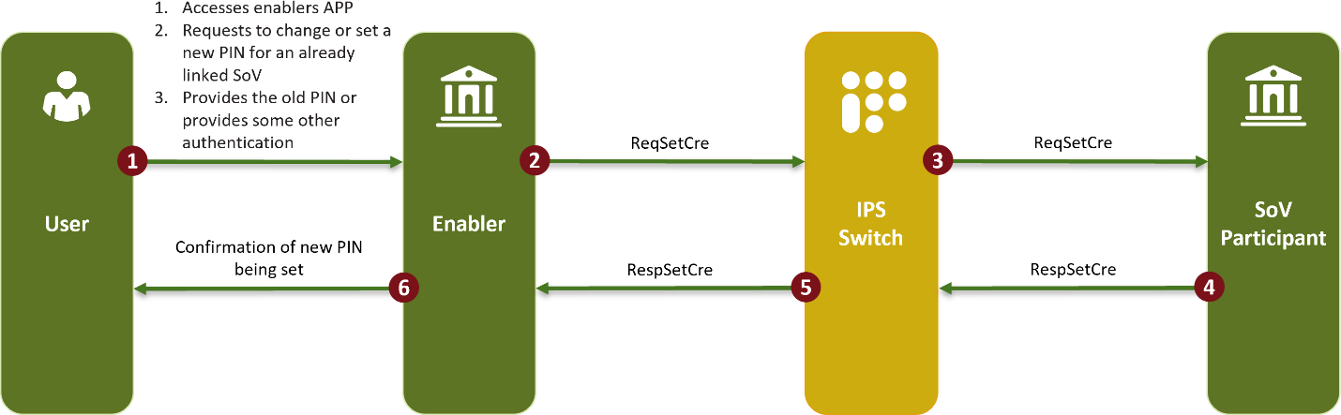
Figure 29: Set Pin and Changing Pin
Step ID | Actors | Action | Notes and references
1 | User | User requests to set or change a PIN through the IPSP.
2 | IPSP | IPSP sends a request to the IPS switch to set the PIN.
3 | IPS Switch | The Switch requests the SoV provider to set the pin. | Common library process: SoV Provider integrates the SDK page where the customer sets the PIN. In essence, the PIN is therefore set on a platform provided by the IPSP but accessible through the SoV provider’s channel.
4 | SOV  Participant | SoV Provider communicates to the switch that the PIN has been successfully set / changed.
5 | IPS Switch | Communicates to the IPSP that the PIN has been successful set / changed.
6 | IPSP | Provides the User with confirmation that the PIN has been successfully set / changed.

End of use case
Table 35: Use case ID IPP-UC131

Balance Enquiry

Use Case ID |  | IPP-UC132
Use Case Name: |  | Balance Enquiry
Use Case  Description: |  | In this use case, the User requests to see their balance enquiry through an IPSP
End Objective: |  | User views balance
Primary Actors: |  | - User  - User IPS Participant
Secondary Actors |  | IPS Switch
Trigger Event: |  | The User opens an IPSP’s channel and initiates a balance enquiry request
IPS Switch Business Rules
Basic Flow

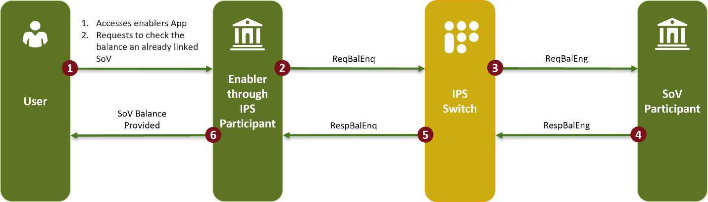
Figure 30: Balance enquiry
Step ID | Actors | Action | Notes and references
1 | User | User requests to check their balance at the linked SoV Provider.

2 | IPSP | IPS participant requests the IPS switch to get the  User’s balance.
3 | IPS Switch | The switch requests the SoV provider to provide  the User’s SoV balance.
4 | SOV  Participant | The SoV Provider responds to the request and provide the switch with the balance.
5 | IPS Switch | The IPS switch submits the IPS balance to the IPS participant.
6 | IPSP | The IPS participant shows the User their balance.
End of use case
Table 36: Use case ID IPP-UC132

DISPUTE MANAGEMENT PROCESS & QUERY MANAGEMENT

Dispute Management

The following dispute management process is provided for the IPS.






































Dispute
Management
Dispute by Custoner

Transaction Search
Txn Status –Approved
Txn Status – Approved/Deened Approved
Txn Status –Deened Approved
Good Faith
- Processin error related
- Fraud Related
- Service Related
Accept
Decline
TCC By Bene
To Renitter
RET By Bene
To Renitter
Accepted by Beneficiary
Representnent (By Renitter)
RRC By
Renitter To Beneficiary
Accepted by Pre-Arbitration
Renitter (By Renitter)

Accepted by Beneficiary
Declined by Beneficiary
Arbitration by Renitter
Accepted by Beneficiary
Arbitration Continue by Beneficiary
Verdict by Arbitrary Panel
Public
eback
Char
RRC by Renitter to Beneficiary

Credit Adjustnent
Figure 31: Dispute Management

- If the Transaction status is approved - Acquiring / Beneficiary bank can raise the credit adjustment (return) to remitter bank.
- Reversal confirmation – If any transactions will be marked Credit adjustment or RET by Acquiring / Beneficiary bank then remitter banks will perform reversal to original customer & need to update the status RRC (return reversal confirmation) in back office.
- No fees will be charged by the IPS Operator during a dispute management process.

Deemed approved.
- If the beneficiary participant does not respond with the status of transaction as success or failed, then such transactions will be treated as deemed approved transactions and funds are credited in favour of beneficiary participant. Beneficiary participants are expected to reconcile all such deemed approved transactions on T+1 day and initiate suitable actions so that customers shall get the funds latest by T+1 day otherwise refunds to the originator or else penalties will be imposed.
- If the Transaction status is Deemed approved - Acquiring / Beneficiary bank needs to update the status in back office as TCC (Transaction credit confirmation) or RET (Return)

- The following codes are provided for deemed transactions:
TCC - 102 - Customer account credited online but failed to respond online to the IPS Operator TCC 103 - Customer account NOT credited online – Credited post Recon.
RET - Customer account cannot be credited due to any reason. In such a case beneficiary participant should return the funds to remitting participant

Debit Reversal Confirmation (DRC)
- If the remitting participant does not send debit authorization to the IPS [OR] if beneficiary participant declines a transaction for any reason, then the IPS Operator will send debit reversal request message to remitting participant. If remitter participant fails to respond to the debit reversal message in online mode, then remitting participants are expected to reconcile, initiate suitable actions (wherever applicable), and update the status (i.e., Debit Reversal Confirmation) for such un-responded reversals in IPS back-office system (IRCS) on T+1 day applicable.
- The following codes are provided for debit reversal confirmation:
DRC 102 - Customer account has been reversed online but failed to respond in online mode to the IPS Operator
DRC 103 - Customer account has NOT been reversed online – Customer account is reversed post Recon.

DRC 104 - Customer account has not been Debited hence no reversal required.

Refund Reversal Confirmation (RRC)
- Customer participants (Remitting/Issuing participants) should download all the credit adjustments (received for approved transactions) & returns (received from deemed approved transactions) which are raised by the beneficiary participants/acquiring participants in IRCS on T+1 day and initiate credits to the respective customers in the core banking systems (CBS).
- Once the reversals are successfully processed in CBS, only then should the customer participant confirm the status in IRCS with status as RRC adjustment flag and reason code 501.
- In case a participant fails to update the status in the IRCS in T+1, a penalty would be applicable. This penalty will be provided for in the IPS Scheme Rules.

Refund Initiation by Merchant – Credit Adjustment
- Credit Adjustment – if Merchant has received online approved response from its Acquiring participant, however the merchant has not delivered the goods/services as agreed with the customer. Then post-settlement done by the Acquiring participant has to reconcile at their end and raise Credit Adjustment/Returns through Bulk upload file (for multiple refunds) or as a single entry directly on the IRCS (transaction search menu). This way excess funds must be given back to the Issuer participant.
- Issuer participant should download all the credit adjustments (received for approved transactions) by acquiring participants in the IRCS on T+1 working day and should refund the amount back to the customer.
- If the Acquiring participant has not raised Credit Adjustment/Returns, customer of Issuing participant will raise the Complaints to the Issuer participant who will then accordingly raise a complaint in IRCS.
- TAT – Merchant can refund the Transaction amount Up to 60 days from the next day of transaction date.

Chargeback

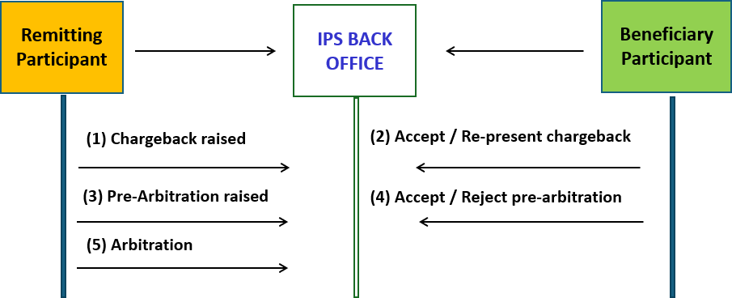
Figure 32: Chargeback

- All the above disputes will have to be accepted or rejected within TAT otherwise system will automatically close the window on deemed acceptance basis.
- After completion of settlement process between acquirer and issuer, the Issuing participant may raise the Chargeback to Acquirer for any of the reason listed. The Acquiring participant has rights to represent / accept the disputed transactions to the Issuing participant.
- Issuer participant can raise the Chargeback as per the disputed amount i.e. Full or Partial
- Issuer participant can raise the Chargeback in IRCS with applicable reason code. Once the Chargeback is raised, the disputed amount will be credited to the issuer participant subject to the acquirer response within the TAT.
- If the chargeback is accepted, the Acquirer needs to check with the merchant and acquirer can accept the chargeback within 7days or it will be deemed accepted.
- Chargeback Re-presented - Acquiring Institution may Re-present the transaction again to the Issuing participant. It should be backed by all the relevant documents whichever is applicable.

Pre-Arbitration

- The Issuing participant may use this message as a final attempt to mutually resolve the disputed transaction before an arbitration is filed with the IPS Operator to resolve the dispute.
- Issuer participant can raise the Pre-Arbitration as per the Chargeback disputed amount
i.e. Full or Partial.
- Issuing participant must raise Pre-Arbitration within 15 calendar days following the Chargeback Re-presentment date.
- Acquirer bank needs to check with merchant and acquirer can accept the case within 15 days or it will be deemed accepted.
- Acquiring Institution may Re-present the transaction again to the Issuing Institution. It should be backed by all the relevant documents whichever is applicable.

Arbitration

- When the Chargeback and Pre-arbitration process fails to resolve the dispute, the arbitration process allows the IPS Operator to assign liability to participants for the disputed transaction.
- The IPS Operator will review all documentation/information submitted by both participants to determine who has final liability for the transaction.
- The IPS Operator will decide which participant is liable for the disputed transaction. The decision taken by the IPS Operator in case of arbitration will be final and binding on the participants.
- The Issuing participant must raise Arbitration request with the IPS Operator within 60 calendar days following the Re-presentment date.
- The Acquiring participant must respond to the arbitration case filing within 15 days from arbitration received date.
- The IPS operator would respond with a verdict within 60 calendar days following the arbitration initiation date.

This table provides the dispute settlement process of instant payment transactions, including the transaction life-cycle and turn-around times for the IPS.
Dispute Stage | Initiating Member | Prerequisite | Fund Movement | TATs
Credit Adjustment/ Refund | Acquiring Participant | Approved Transaction | ACQ to ISS | 60 days from the next day of transaction date.
Customer Complaints/ Retrieval Request | Issuing Participant | Approved Transaction | NA | 60 days from the next day of transaction date.
Response to Customer Complaints | Acquiring Participant | Approved Transaction | NA | 15 days from the date of customer complaint.
Debit Reversal Confirmation (DRC) | Issuing Participant | Declined Transaction | NA | T+1 working day.
Transaction Credit  Confirmation (TCC) | Acquiring Participant | Deemed Approved | NA | T+1 till next 60 days.
Refund/Return Reversal | Issuing Participant | Credit Adjustment/ Returns | NA | Adjustment raised date  (A) : A+1 working day.
Chargeback | Issuing Participant | Approved Transaction | ACQ to ISS | 90 days from the next day of transaction date.
Chargeback Acceptance | Acquiring Participant | Chargeback | NA | 7 calendar days from the Chargeback processing date.
Representment | Acquiring Participant | Chargeback | ISS to ACQ | 7 calendar days from the Chargeback processing date.

Dispute Stage | Initiating Member | Prerequisite | Fund Movement | TATs
Pre−Arbitration | Issuing Participant | Representment | NA | 15 days from the next day of representment.
Pre−Arbitration Acceptance | Acquiring Participant | Pre−Arbitration | ACQ to ISS | Acquiring Institution must respond within 7 calendar days.  following the Pre−  Arbitration processing date.
Pre−Arbitration Decline | Acquiring Participant | Pre−Arbitration | NA | Acquiring Participant must respond within 15 calendar days  following the Pre−  Arbitration processing date.
Arbitration Case  Filing | Issuing Participant | Pre−Arbitration decline | NA | Within 15 calendar days from Pre−  Arbitration decline date.
Arbitration Case  Acceptance | Acquiring Participant | Arbitration | NA | Within 15 calendar days from Arbitration received date.
Arbitration Case  Continuation | Acquiring Participant | Arbitration | NA | If no response received from the Acquiring Participant within 15 calendar days, then  from Arbitration received date.
Arbitration Case Withdrawn | Issuing Participant | Arbitration | NA | Within 15 calendar days from Arbitration raising date.
Arbitration Case  Verdict | IPS Operator | Arbitration | If issuer wins the arbitration, then funds will be.  moved from ACQ to ISS | IPS Operator will give verdict within 60 calendar days  following the

Dispute Stage | Initiating Member | Prerequisite | Fund Movement | TATs
 |  |  | along with arbitration fee, which is collected  from Issuing. Participant (Debit Acquiring  Participant &  Credit Issuing Participant): | Arbitration initiation date.
a. TXN
Amount.
 |  |  | b. Interchange Fee.
c. Arbitration Fee
+
Applicable Taxes.
Table 37: Erroneous payments & Query management

RC | Description | TAT
1061 | Credit not Processed for Cancelled or Returned Goods and Services. | 60 Days
1063 | Paid by Alternate Means. | 60 Days
1065 | Goods or Services Not Provided/Not Received. | 60 Days
1084 | Duplicate Processing. | 60 Days
1102 | Retrieval Request not Fulfilled. | 60 Days
Table 38: Dispute resolution turnaround times
Note: For additional details please refer to “Dispute reason code list”.

FRAUD AND RISK MANAGEMENT

FRM Capability Overview

The Enterprise Fraud and Risk Management (EFRM) system forms an integral part of the IPS risk control framework. It provides a centralized fraud detection, prevention, and monitoring capability for all transactions processed through the IPS ecosystem.
The EFRM operates as the second layer of fraud mitigation supplementing first-level controls implemented by IPS Participants (banks, PSPs, MNOs, and other ecosystem entities). It ensures that even if a participant’s internal controls are bypassed, potential fraudulent behaviour can be detected at the network level.
The EFRM solution has been implemented and configured on the IPS infrastructure and leverages real-time transaction data from the IPS Switch through a high-throughput, low-latency integration layer. The EFRM integrates directly into the online IPS switch to inject transaction fraud scores into messages being transmitted between participants. Transactions below a threshold determined by the IPS Operator will be include a fraud score to be dealt with as per the participant’s internal controls, while transactions above the set threshold will be declined automatically by the IPS switch.

Purpose and Objectives

The EFRM system’s primary purpose is to provide a unified, centralized fraud risk monitoring framework for the IPS ecosystem, enabling real-time detection and analysis of suspicious patterns and high-risk transactions.
Objectives:
- Detect and prevent fraudulent or suspicious transactions across all IPS channels (Mobile App, USSD, QR, etc.).
- Apply configurable rule-based and model-based risk assessments in real time.
- Enable IPN operations and regulatory teams to view alerts, manage investigations, and maintain audit trails.
- Provide centralized visibility across participants and transaction types.
- Support compliance and reporting requirements of the IPN.

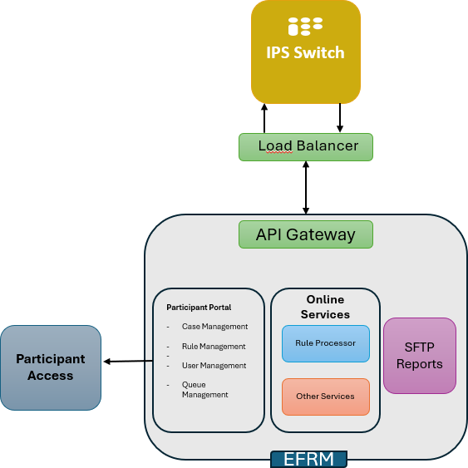

Figure 33: eFRM Architecture

Rule Configuration and Execution

- Fraud detection rules are centrally configured within the EFRM solution by IPN and NPCI based on transaction type, limit, velocity, frequency, and participant profiles.
- Each rule is assigned a risk weight and scoring parameter; the combined score determines whether the transaction is flagged for further review.
- Rules operate on event streams and include:
  - Velocity checks (number of transactions per time period)
  - Amount-based thresholds
  - Transaction frequency anomalies
  - Device and channel consistency
  - Beneficiary and sender behavioural profiling
- Rules can be applied in real-time blocking, alert-only, or simulation modes.

IPS Transaction Flow with eFRM
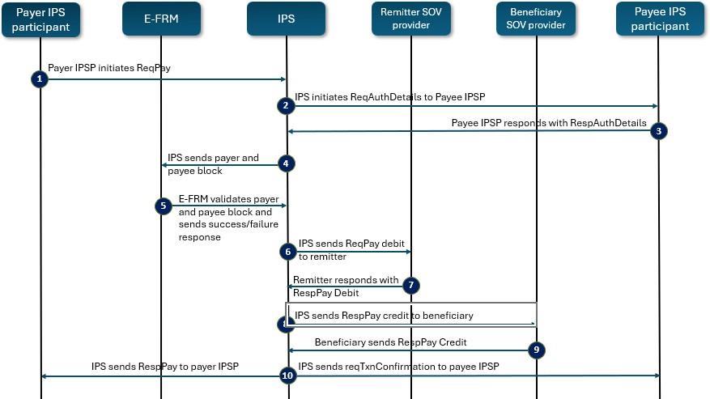
Figure 34: eFRM transaction flow

Transaction steps:

- Payer IPS Participant (Payer PSP) initiates ReqPay.
- IPS initiates ReqAuthDetails to Payee PSP.
- Payee IPS participant (Payee PSP) responds with RespAuthDetails.
- IPS sends payer and payee cred block to EFRM
- eFRM will validate the payer and payee cred block and respond in success or failure to IPS.
- IPS initiates ReqPay Debit to Remitter Bank/ SoV provider.
- Remitter Bank/SoV provider debits the money and confirms back to IPS.
- IPS initiates ReqPay Credit
- Beneficiary Bank accepts the money and confirms back to IPS
- IPS initiates RespPay to Payer IPS Participant (Payer PSP). IPS also initiates transaction confirmation to Payee IPS Participant (Payee PSP)

Operational Behaviour

- The EFRM operates 24/7 and continuously monitors transactions across all channels and message types (ReqPay, ResPay, ReqListAccount, ReqRegMob, etc.).
- Alerts are generated and classified as high, medium, or low severity depending on the risk score.

- Alerts are routed to the Case Management Portal, where analysts can investigate, link related transactions, or escalate to participant compliance teams.
- All transaction data, risk scores, and alerts are logged for audit and regulatory reporting.
- The system supports simulation mode, allowing IPN to test new rules before going live.

Configuration of EFRM Rules

- The IPS Operator will configure business and regulatory rules on the EFRM.
- Industry participants may suggest rules to be configured on the solution after having agreed as an industry on the type of rules to be configured. Such rules must then be submitted to the IPS Operator for assessment and approval.
- Individual participants may also submit customised rules (individual rules) to the IPS Operator. These rules will not be shared with other participants.

PART C: PARTICIPANT ONBOARDING

INFRASTRUCTURE REQUIREMENTS
To participate in the IPS, participants need to adhere to the requirements relating to infrastructure, application, and operations. There are 3 layers for IPS system readiness i.e., infrastructure layer, operations layer (which includes recon and dispute handling), and the application layer.
Requirement | Description
Infrastructure ready | - HSMs  - UAT, Production & DR Separate Environments  - Secured connectivity with the Bank of Namibia (IPS)
Operations ready | - 3-way Recon Back Office System  - Handling customer complaints and disputes (24x7x365)
Application ready | - Core banking / wallet system readiness  - API enabled switch.  - Support PKI Architecture  - 3 Keys required (SSL, Signer, HSM)  - Acquiring  - Mobile Application
Table 39: Infrastructure requirements

The above list is not exhaustive, and it is the responsibility of each participant to evaluate their own environments to determine the actual needs of integration and supporting infrastructure.

ONBOARDING AND CERTIFICATION

Participant Onboarding
The following diagrams provide the onboarding process of a new participant on the IPS.
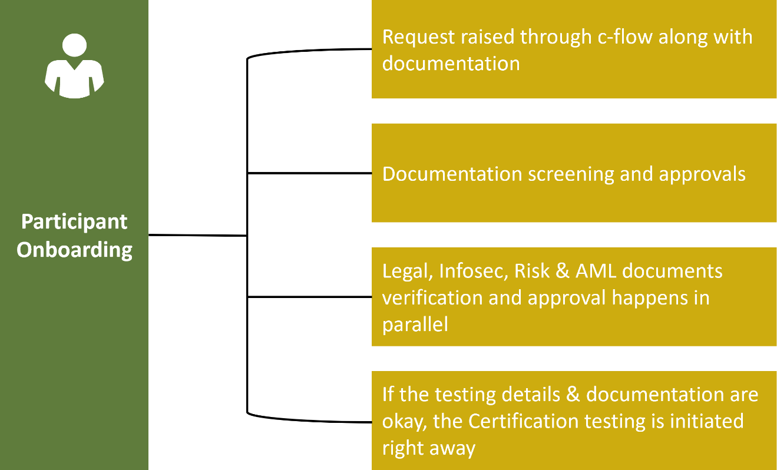
Figure 35: Participant onboarding

Certification Phase
- Applicants will use the IPS online testing tool to execute prescribed test cases.
- Automated test tools: applicants can execute test cases 24/7, independently; tools provide test results in real time (pass / fail)
- Once all the test cases are executed successfully in the comfort and UAT rounds of testing, the participant will be provided with a Certification testing sign-off post final log validation.

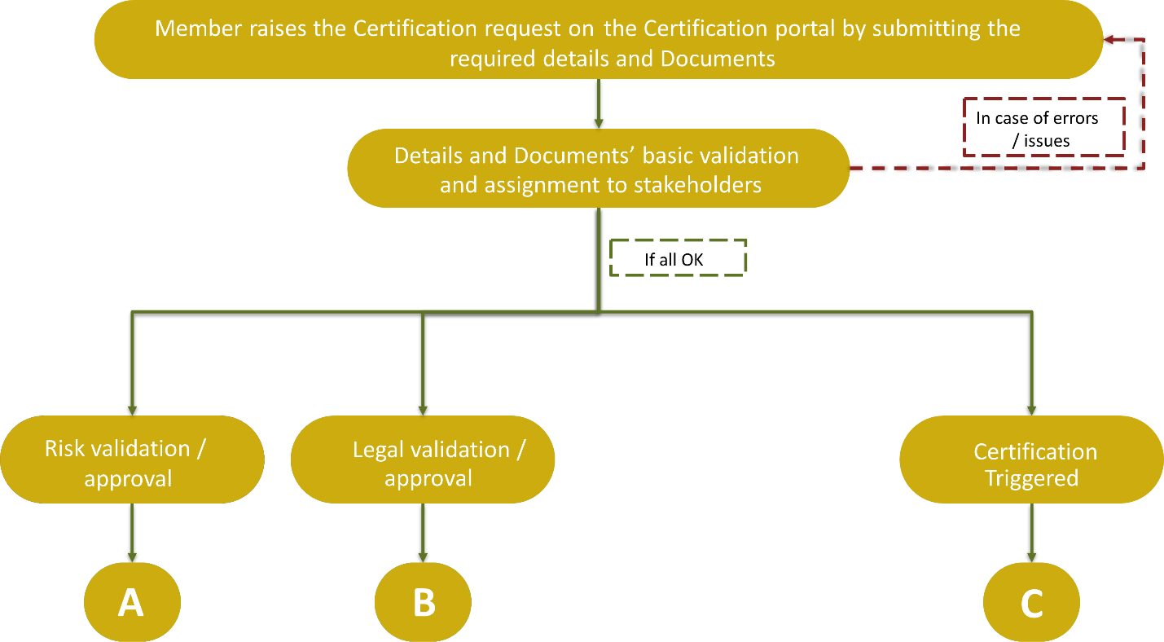

Figure 36: Certification phase diagram

Step | Description
A: Risk validation / approval | This is the risk and validation phase where the participant is required to provide the following information for assessment:  - Risk assessment report
B: Legal validation  / approval | This is the risk and validation phase where the applicant is required to provide the following information for assessment:  - Signed SLA
C: Certification | This is the certification stage:  - Applicants to be provided with login credentials for using the Certification management tool.  - Applicants to fill in the required details and submit the required documents in the Certification management tool.  - A Certification id will be generated for tracking purposes.  - The onboarding team will receive the request and will screen the soft copy of the documents submitted by the applicants.  - Once the documents received are successfully screened, the onboarding request will move to the next process
Table 40: Onboarding phases

Certification Process Diagram
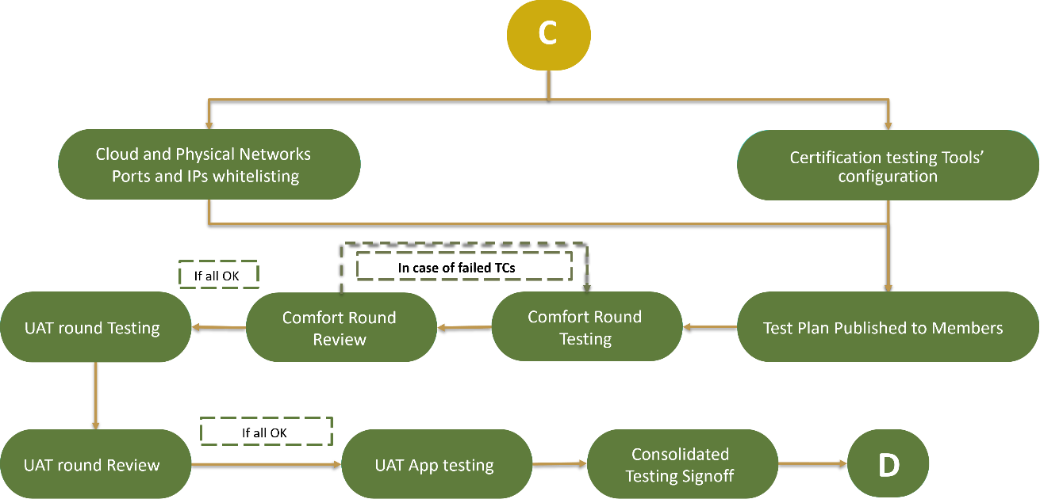

Figure 37: Certification process diagram

- Based on the IP details provided, the network team will do the whitelisting process.
- Whitelisting completed then the test bands/slots will be released to the member banks based on the rounds opted (i.e., comfort and UAT).
- Participant configuration in the certification zone will be done by the certification team based on the request submitted by the participant and allocate the desired slot for the participants.
- According to the test slots, participants will execute the test cases for the given slots.
- In the case of test cases fails, the participants will re-test the same and proceed for the review of the same in the certification zone.
- Once the comfort and UAT review has been completed, then the request will be moved to the mobile application testing.
- Post completion of all the test slot assigned to the participants, it will be put up review for sign-off process.
- The Certification team will validate the test cases executed by the participants and will certify the participant for the same.
- Once the certification sign-off has been received, the request will be triggered for the next process which is preproduction and go-live.

Production and Go-live.
This stage follows there has been sign-off of the certification and testing from the participant.

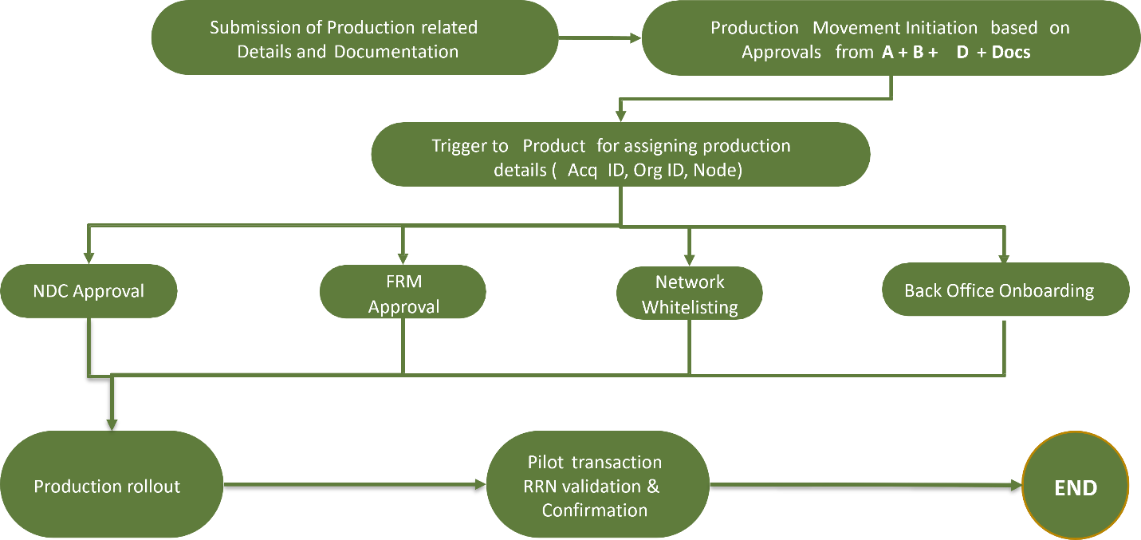
Figure 38: Production and go-live

- Once the Certification testing is successfully completed, the participant will be prompted to submit the required production movement details and documentation to go-live.
- Once the documentation has been verified by the IPS Operator, production teams of the IPS Operator and the participant get the participant live on the respective IPS products and perform sample transactions.
- Certified members are expected to go-live within 60 days of receiving certification testing sign-off.

HANDLE MANAGEMENT

Handle Registration
This section deals with the registration of a handle for an IPS participant. This is the handle that will be used to route IPS transactions and attached to the full form alias of a user to send and receive IPS transactions. The handle is unique to an IPS participant and is issued by the IPS Operator. The first step is that the applicant is required to submit a manual form to the IPS Operator. The following template depicts the information to be retrieved from the form and populated by the IPS Operator before a handle can be registered:

# | Requirement | Response
A. Participant Identification & Governance
1 | Participant Name
2 | Participation Type
3 | License Type
4 | Particiant Region Name | Text field
5 | Participant Town Name | Text field
6 | Settlement Arrangement
7 | Sponsor Bank | Text field (Bank name)
8 | Enabled use cases: | Indicate all that apply from below  list:
8.1 | P2P
8.2 | P2M
8.3 | G2P
8.4 | B2P
8.5 | Cash-in-at-Merchant
8.6 | Cash-out-at-Merchant
8.7 | Cash-out-at-ATM
B. Technical & Connectivity Setup
9 | Participant VAT Number
10 | Org ID
11 | Acquirer Institution ID
12 | Participant Identification Code (IFSC)
13 | Merchant Routing ID (2-Digit)
14 | Response IP (SIT)
15 | Response IP (UAT)
16 | Response IP (PROD)
17 | Enlisted Product | IPS
18 | SWIFT TEST BIC

19 | SWIFT PROD BIC
20 | Account Provider Codes | Text field
21 | Account Provider IP Codes | Text field
22 | Participant Debit Cap | Text field (Namibia Dollar Value)
23 | Settlement Sponsor Participant Net Debit Cab | Text field (Namibia Dollar Value)
C. Participant to provide to IPS Operator
24 | DocSignature - CA (Signer certificate)
25 | SSL Certificate - CA
26 | HSM Certificate - CA
D. IPS Operator to provide to Participant
27 | DocSignature - CA (Signer certificate)
28 | SSL Certificate - CA
29 | HSM public key-CA
30 | SIT Environment IP
31 | UAT Environment IP
32 | PROD Environment IP
Table 41: Onboarding Form Example

The process below describes how a handle is to be issued to a new participant on the IPS switch.

Use Case ID | IPP-UC171
Use Case Name: | Handle Registration
Use Case Description: | In this use case, the Operator registers a new participant and issues a handle.
End Objective: | IPS Operator issues a new handle
Primary Actors: | IPS Participant IPS Operator
Secondary Actors | None
Trigger Event: | A new IPS participant approaches the IPS Operator with a request to register a handle
IPS Operator Business Rules

- The handle registration will be performed by the IPS Operator
- Request raised through the web portal with documents submitted.
- Documentation screening and approvals
- Legal, Infosec, Risk and AML Documents, verification and approvals happen in parallel.
- Once documents are validated, certification testing will be initiated right away
Applicants Business Rules
- Must be a licensed banking institution or payment instrument issuer.
- Demonstrate technical capability to interface with the IPS switch.
- Signed the FSD and TSD
- Signed IPS Business Rules
Basic Flow
Step ID | Action | Notes and references
1 | A manual form must be submitted to the IPS Operator by the participant.
2 | The participants suggest and provides preferred handle name.
3 | The IPS Operator verifies if the handle is already taken or available.
4 | If the handle is available, the IPS Operator will communicate to the participant that handle will be assigned.
5 | The front-end portal will capture the information of the participant.
6 | Handle will then be registered in the IPS solution.
7 | The IPS Operator communicates to the participant that their handle has been successfully registered.
8 | IPS Participant gets an active ORG ID
9 | There will be an API end point where the handle of the participant will be communicated.
10 | A health check message will be exchanged between the participant and the IPS switch.
End of use case

Table 42: Use case ID IPP-UC171

Handle Deregistration, Deactivation, and Reactivation

The process of Handle Deregistration, Handle Deactivation and Handle Reactivation would be an offline process for which the documents will be shared with the industry participants on a later date.

BACK OFFICE AND SETTLEMENT SERVICES

Participant Identification Codes

    - Swift codes
For settlement, system participants will use their existing SWIFT codes for settlement purposes. SWIFT code will be alpha numeric with 8 digits followed by a 5-6 digits unique numeric code to be assigned by the IPS Operator. It is not required for IPS participants to have BIC codes if they are not settlement system participants. IPS participants that only route online messages on the IPS switch will be issued with participant identification codes which will also be referred to as an IFSC code¹.

    - IFSC Codes

All IPS participants will be issued with an alphanumeric IFSC code. This code will be used to route online messages among participants on the IPS switch. The alphanumeric code will be as follows:

- First 4 characters: participant BIC name (only letters)
- Fifth character: participant identifier (0 for banks and 1 for non-banks)
- Last 6 characters: unique number (only numbers)

For example, a bank A's IFSC code will be BANK0654321 while a non-bank's IFSC code will be NBNK1456789. These codes will be issued by the IPS operator as they will be used to identify participants in the switch. For settlement purposes, when transactions are downloaded to the back-office, these IFSC codes will be matched to the SWIFT codes to enable settlement. This also applies for tiered participation arrangements to identify the obligations of sponsored participants

1 IFSC code will be replaced with an appropriate term after go-live.

even though they do not have SWIFT codes (their IFSC code codes will be identifiable through the direct system participant's SWIFT code).

Back Office Management

















The Diagram depicts the envisaged back-office operations of the IPS back-office system also known as the IPS Real Time Clearing and Settlement (IRCS) system. Once a transaction is completed online in the IPS transaction engine, it immediately moves to the back-office system. The back-office system performs several functions such as attaching fees and charges to the transactions, reconciliation and settlement, dispute management, chargeback process, adjustment process, scheduling process and master configuration. The bank-office system also prepares settlement files between system participants, calculates fees and penalties for participants, generates settlement reports for the participants and the NISS. Once a transaction is cleared for settlement, it goes to the file processing generator (batch processor).
₹
₹
Access / User Management
IPS Transaction Engine
API
PORTAL
FILE SERVER
HTTPS Rest API
SFTP
KAFKA Topic
Monitoring
Audit Trail
Real Time Streaming
BO System
File Process Generator (Batch Processo)r
Recon & Settlement
Dispute
Chargeback
Management
Process
Adjustment Process
Batch Layer
Master
C on
onfigurati
Scheduling Process
Postgres
Contextual Batch View

Figure 39: Back Office Management

The components of the Bank office system are further described below:

Back-office component | Description
Recon & Settlement | - At every end of settlement cycle, IRCS system performs the reconciliation activity with IPS Switch database to revalidate the count transaction received through Kafka and available in IPS Switch. In case of any discrepancy, IRCS system will re-sync the missing transactions.  - The reconciliation is done automatically without any user intervention and the summary is available to the admin users in the portal.  - Funds Settlement among the members is done once or multiple times, the timing of settlement is configurable in IRCS. The timing is called as Settlement cycle.  - For each settlement cycle, member wise net amount to be credited or debited to each member bank is calculated and accordingly the amount fields are populated in a MNSB (Multi- lateral Net Settlement Batch) file.  - The file will be in ISO format PACS009 message system which is generated in IRCS and uploaded to SWIFT for settlement in the RTGS at the Bank of Namibia (NISS).
Dispute management and Adjustment Process | - Banks can raise disputes on transactions from the Participant operations portal.  - The operations Portal will allow the Participants to raise dispute as a single entry and by uploading a file to raise disputes in bulk.  - The portal will also allow the Participant users to view the raised Disputes.  - Also, the participants will get a pre-formatted Adjustment report in csv form at end of each settlement cycle cut off.

Back-office component | Description
 | - The report shall contain the records of disputes raised by the participant and disputes raised by other members against them.
Master configuration | - IRCS maintains several master data such as Participant master, Users, User Roles and privileges, Dispute type master, fee masters, etc.
Schedule process | - IRCS manages process schedules for automating processes. For example, settlement process is automatically triggered at pre- configured settlement timings.
File process generator | - The file reports are generated in predefined formats, which the Participant users can download for their reconciliation and other tasks. Various files are generated at pre-defined timings like RAW Data, NTSL file, Adjustment file etc.
User access management | - The access to all IRCS components (menu options) can be provided or restricted to the users by Admin users.
Table 43: Back-office system

Back Office Process flow
The Back Office settlement preparation and flow is depicted below:

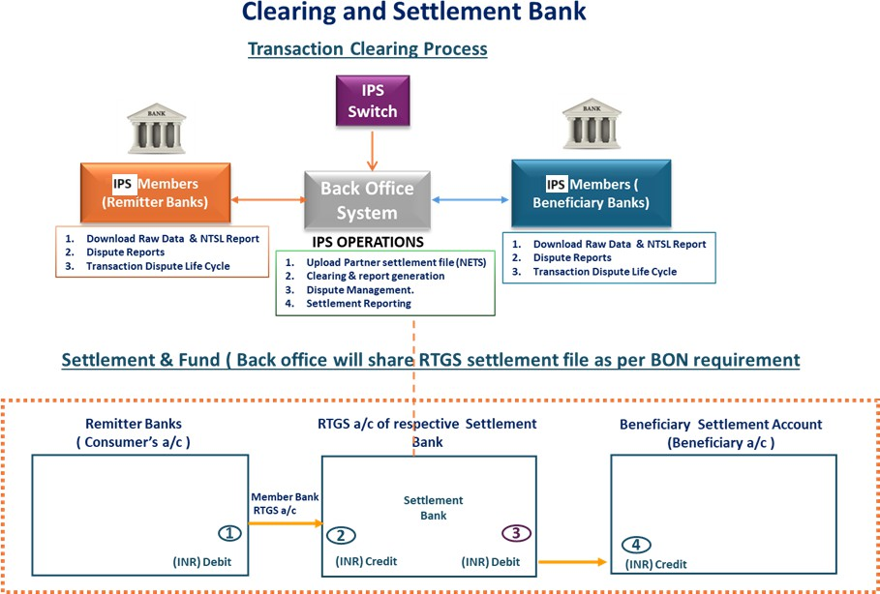

Figure 40: Transaction clearing process

Steps | Actors | Action
1 | IPS Switch | Once a transaction is completed, the IPS Switch sends the transaction for further action. If the transaction is successful or deemed, it is prepared for settlement.
2 | IPS Back Office | All success/unsuccessful/deemed transactions that go to IPSPs are sorted as per participant and sent to participant back-office for reconciliation and confirmation.
3 | IPS Participants | IPSPs will do reconciliation with RAW file, CBS file and Switch File.  Post reconciliation, exceptions if any needs to be actioned by IPSPs for e.g.  - In case of deemed transactions, the beneficiary participant needs to raise Transaction Credit Confirmation (TCC) in the back-office system to confirm beneficiary has been credited.  - In case of non-credit, beneficiary must raise Returns (RET) in back-office system that will transfer the funds back to remitter. Once remitter receives the return credit, remitting participant must raise Debit Reversal Confirmation (DRC).  - If the remitting participant does not send debit authorization to IPS or if beneficiary participant declines a transaction for any reason, then the IPS will send a debit reversal request message to remitting participant. If remitter participant fails to respond to the debit reversal message in online mode, then remitting participants are expected to reconcile, initiate suitable

 |  | actions (wherever applicable) and update the status as DRC (i.e., Debit Reversal Confirmation).
4 | IPS Back Office | The Back Office will prepare the clearing files considering online transaction and Dispute raise by participant to arrive at a net position (Payable/Receivable) of each participant. Back office will prepare the settlement file as per NISS RTGS format with instructions to debit or credit the NISS participants.
Notes
- This Back Office Process is only for successful transactions; disputed transactions are excluded.
- The reconciliation files from the Back Office to the IPSPs will be converted from IPS proprietary messages to ISO messaging. The return files will also be converted from ISO messaging to proprietary messaging before settlement.
- The settlement file submitted to NISS will also be converted from IPS proprietary messaging to ISO messaging (PACS009).
- The settlement file submitted to the NISS contains net positions among participants that have obligations towards each other and single instructions for all other participants.
- Settlement instructions submitted to the NISS are final and irrevocable
Table 44: Back-office process flow

Settlement Process
The settlement process for instant payment transactions begins in the IRCS wherein the IPS Operator will prepare batch files for submission to the NISS during three (3) settlement cycles. Multiple transaction between two specific participants will be netted off along with interchange as well as switching fees and settled in each settlement cycle. For example, as provided in the table below, Panel A shows that participant A owes N$300 to participant B and participant B owes N$100 to participant A, this transaction will be netted off in the back office and only a single entry of N$200 will be passed to the RTGS between participant A (debit) and participant B (credit) as depicted in panel B. The same example is provided for entries between participant C and B as

well as C and A. Note however that there are not mutual obligations between D and B (meaning, participant D owes participant B, but participant B does not owe participant D anything. In this regard, this entry is passed as a single entry in the NISS.

Panel A: Participant settlement data | Panel B: Settlement
BILATERAL GROSS SETTLEMENT WITH NETTING BETWEEN PARTICIPANTS FOR
BOM FOR IPN
 |  |  | Dr Participant | Cr Participant | Amoun t
 |  | NET ENTRY | A | B | 200
 |  | NET ENTRY | C | B | 400
 |  |  | A | D | 500
 |  | NET ENTRY | C | A | 600
 |  |  | D | B | 700
 |  | SWITCHING FEE | A | IPN | 0.4
 |  | SWITCHING FEE | B | IPN | 0.4
 |  | SWITCHING FEE | C | IPN | 0.4
 |  | SWITCHING FEE | D | IPN | 0.4
Table 45: Settlement process
PARTICIPANT LEVEL DATA
Dr  Participant | Cr  Participant | Amount
A | B | 300
B | A | 100
C | A | 800
A | C | 200
B | C | 400
C | B | 800
A | D | 500
D | B | 700

Interchange fee will be treated in a similar manner as the settlement transactions. The applicable switching fee will be debited and credited to the IPS Operator’s nominated settlement account in the RTGS.

All the IPS participants are required to have settlement accounts in the NISS at Bank of Namibia. If a participant does not have a settlement account in the NISS, then it is treated as a sponsored participant (known as an indirect system participant) by a system participant who has a NISS settlement account. The system participant who has the settlement account is referred to as the direct system participant. The amount for the indirect participant is to be credited or debited from the direct participant’s settlement account.

Pacs.009 File Specifications
The Pacs.009 file to be generated for the settlement needs to follow the following guidelines:
- A batch file will be created containing all pacs.009 messages.
- The files should be in XML format.
- The naming convention of the files will be in the following format: YYYYMMDDHHMMSS pacs.009<CBS number><CNS number>
- During each settlement window, two pacs.009 files will be generated for participants. One
Pacs.009 file that nets the transaction amount with the interchange amount and one Pacs.009 file that credits the IPS Operator for the switching fee.
- The details to be captured in pacs.009 are mentioned in the Excel attached below:

UPI_NPCIUPINGRTGS 20250926_3CBAPANA

Settlement Flow
There are two scenarios in a settlement process, namely a successful settlement process and an exception handling process (manual process). The diagrams below present both scenarios.
    - Successful Settlement Flow
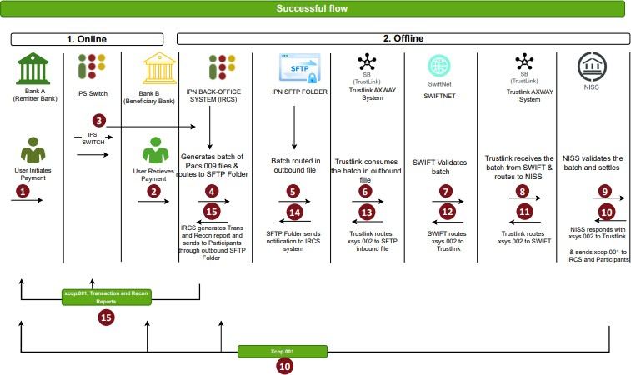

Step 1 | Remitter Bank | A user at Bank A (Remitter Bank) initiates payment, which is routed through the IPS Switch to a user at Bank B (Beneficiary Bank) receiving the payment.
Step 2 | Beneficiary Bank | User at Bank B (Beneficiary Bank) receives the payment.
Step 3 | IRCS Back Office  System | The transaction moves to IPN’s IRCS Back Office system (offline  environment).
Step 4 | IRCS Back Office System | In the IPN’s IRCS Back Office system (offline environment), transactions are batched, and the Net Settlement calculation for all participants is completed.  The back-office system generates a batch of Pacs.009 messages for each bilateral participant combination with a non-zero net settlement amount. No Pacs.009 messages are generated for  zero net settlements.
Step 5 | SFTP Folder | All generated batches of Pacs.009 messages are placed in the  outbound file via SFTP folder.
Step 6 | Trustlink AXWAY system | The Trustlink AXWAY system retrieves the outbound batch of pacs.009 messages from the SFTP folder for further processing and transmission to the SWIFT system.
Step 7 | SWIFT | The SWIFT system validates the Batch of Pacs.009 message. Upon successful validation, SWIFT transmits the batch of pacs.009  message to the Trustlink AXWAY system
Step 8 | Trustlink AXWAY system | The Trustlink AXWAY system routes the Batch of Pacs.009  messages from SWIFT to the National Interbank Settlement System (NISS) for settlement.
Step 9 | NISS | NISS validates the batch of Pacs.009 messages and processes the  settlement.
Step 10 | NISS | After successful settlement, NISS responds with a positive acknowledgement (xsys.002) via AXWAY and sends a copy of the Pacs.009 to the IRCS and to the relevant participants (Bank A and  Bank B)
Step 11 | Trustlink AXWAY  system | Trustlink AXWAY system routes positive acknowledgement  (xsys.002) to SWIFT
Step 12 | SWIFT | SWIFT routes positive acknowledgement (xsys.002) to Trustlink  AXWAY system
Step 13 | Trustlink AXWAY  system | Trustlink AXWAY system routes positive acknowledgement  (xsys.002) to SFTP Folder inbound file
Step 14 | SFTP Folder | SFTP Folder inbound file routes positive acknowledgement  (xsys.002) to IPN’s IRCS Back Office system
Step 15 | IRCS Back Office System | The IPN Back Office system generates and distributes through the SFTP outbound folder transaction and reconciliation reports to  relevant participants.
Figure 41: Successful settlement flow

    - Exception Handling Flow (Failed SWIFT validation)

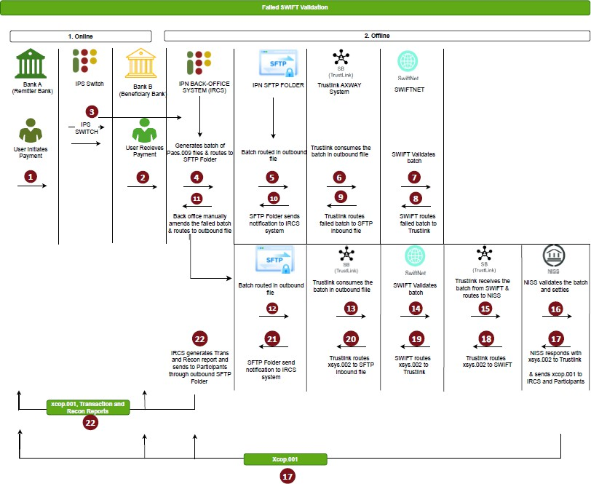
Step 1 | Remitter Bank | A user at Bank A (Remitter Bank) initiates a payment, which is routed through the IPS Switch to a user at Bank B (Beneficiary  Bank) receiving the payment.
Step 2 | Beneficiary Bank | User at Bank B (Beneficiary Bank) receives the payment.
Step 3 | IRCS Back Office  System | The transaction moves to IPN’s IRCS Back Office system (offline  environment).
Step 4 | IRCS Back Office System | In the IPN’s IRCS Back Office system (offline environment), transactions are batched, and the Net Settlement calculation for all participants is completed.  The back-office system generates a batch of Pacs.009 messages for each bilateral participant combination with a non-zero net settlement amount. No Pacs.009 messages are generated for zero net settlements.
Step 5 | SFTP Folder | All generated batches of Pacs.009 messages are placed in the  outbound file via SFTP folder.

Step 6 | Trustlink AXWAY system | The Trustlink AXWAY system retrieves the outbound batch of Pacs.009 messages from the SFTP folder for further processing and  transmission to the SWIFT system.
Step 7 | SWIFT | The SWIFT system validates the batch of Pacs.009 message.
Step 8 | SWIFT | Upon failed validation, SWIFT transmits the failed batch of  Pacs.009 message to the Trustlink AXWAY system
Step 9 | Trustlink AXWAY  system | Trustlink routes failed batch of Pacs.009 message to SFTP inbound  file
Step 10 | SFTP Folder | SFTP Folder sends notification to IRCS system
Step 11 | IRCS Back Office  System | Backoffice system manually amends the failed batch of Pacs.009  message and places it in the outbound file in the SFTP Folder
Step 12 | SFTP Folder | SFTP Folder Outbound file routes the amended batch of Pacs.009  message to the Trustlink AXWAY system
Step 13 | Trustlink AXWAY  system | Trustlink AXWAY system routes the amended batch of Pacs.009  message to SWIFT
Step 14 | SWIFT | The SWIFT system validates the amended batch of Pacs.009 message and upon successful validation routes the batch of  Pacs.009 message to Trustlink AXWAY system
Step 15 | Trustlink AXWAY  system | Trustlink AXWAY system routes the amended batch of Pacs.009  message to NISS
Step 16 | NISS | NISS validates the amended batch of Pacs.009 message and  processes the settlement.
Step 17 | NISS | After successful settlement, NISS responds with a positive acknowledgement (xsys.002) via AXWAY and further sends a copy of the amended batch of Pacs.009 message to the IRCS and to the  relevant participants (Bank A and Bank B)
Step 18 | Trustlink AXWAY  system | Trustlink AXWAY system routes positive acknowledgement  (xsys.002) to SWIFT
Step 19 | SWIFT | SWIFT routes positive acknowledgement (xsys.002) to Trustlink  AXWAY system
Step 20 | Trustlink AXWAY  system | Trustlink AXWAY system routes positive acknowledgement  (xsys.002) to SFTP Folder inbound file
Step 21 | SFTP Folder | SFTP Folder inbound file routes positive acknowledgement  (xsys.002) to IPN’s IRCS Back Office system
Step 22 | IRCS Back Office System | The IPN Back Office system generates and distributes through the SFTP outbound folder transaction and reconciliation reports to  relevant participants.

Figure 42: Exception handling flow (failed SWIFT validation)

    - Exception Handling Flow (Failed NISS validation)

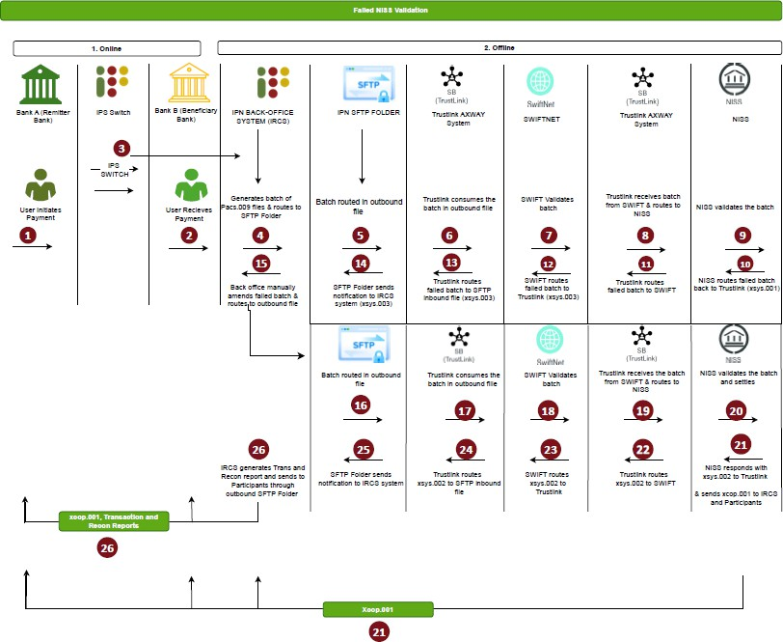
Step 1 | Remitter Bank | A user at Bank A (Remitter Bank) initiates a payment, which is routed through the IPS Switch to a user at Bank B  (Beneficiary Bank) receiving the payment.
Step 2 | Beneficiary Bank | User at Bank B (Beneficiary Bank) receives the payment.
Step 3 | IRCS Back Office System | The transaction moves to IPN’s IRCS Back Office system  (offline environment).
Step 4 | IRCS Back Office System | In the IPN’s IRCS Back Office system (offline environment), transactions are batched, and the Net Settlement calculation for all participants is completed.  The back-office system generates a batch of Pacs.009 messages for each bilateral participant combination with a non-zero net settlement amount. No Pacs.009 messages are generated for zero net settlements.

Step 5 | SFTP Folder | All generated batches of Pacs.009 messages are placed in the  outbound file via SFTP folder.
Step 6 | Trustlink AXWAY system | The Trustlink AXWAY system retrieves the outbound batch of Pacs.009 messages from the SFTP folder for further  processing and transmission to the SWIFT system.
Step 7 | SWIFT | The SWIFT system validates the batch of Pacs.009 message. Upon successful validation, SWIFT transmits the batch of  Pacs.009 message to the Trustlink AXWAY system
Step 8 | Trustlink AXWAY system | The Trustlink AXWAY system routes the batch of Pacs.009 messages from SWIFT to the National Interbank Settlement System (NISS) for settlement.
Step 9 | NISS | NISS validates the batch of Pacs.009 message
Step 10 | NISS | Upon failed validation, NISS issues a negative  acknowledgement (xsys.001) and transmits the failed batch of Pacs.009 message to the Trustlink AXWAY system
Step 11 | Trustlink AXWAY system | Trustlink routes failed batch of Pacs.009 to SWIFT
Step 12 | SWIFT | SWIFT transmits the failed batch of Pacs.009 message by sending an abort notification (xsys.003) to the Trustlink  AXWAY system
Step 13 | Trustlink AXWAY  system | Trustlink routes failed batch of Pacs.009 message to SFTP  inbound file
Step 14 | SFTP Folder | SFTP Folder sends notification to IRCS system
Step 15 | IRCS Back Office System | Backoffice system manually amends the failed batch of  Pacs.009 message and places it in the outbound file in the SFTP Folder
Step 16 | SFTP Folder | SFTP Folder Outbound file routes the amended batch of  Pacs.009 message to the Trustlink AXWAY system
Step 17 | Trustlink AXWAY  system | Trustlink AXWAY system routes the amended batch of  Pacs.009 message to SWIFT
Step 18 | SWIFT | The SWIFT system validates the amended batch of Pacs.009 message and upon successful validation routes the amended  batch of Pacs.009 message to Trustlink AXWAY system
Step 19 | Trustlink AXWAY  system | Trustlink AXWAY system routes the amended batch of  Pacs.009 message to NISS
Step 20 | NISS | NISS validates the amended batch of Pacs.009 message and  processes the settlement.
Step 21 | NISS | After successful settlement, NISS responds with a positive acknowledgement (xsys.002) via AXWAY and further sends a copy of the amended batch of Pacs.009 message to the IRCS  and to the relevant participants (Bank A and Bank B)
Step 22 | Trustlink AXWAY  system | Trustlink AXWAY system routes positive acknowledgement  (xsys.002) to SWIFT

Step 23 | SWIFT | SWIFT routes positive acknowledgement (xsys.002) to  Trustlink AXWAY system
Step 24 | Trustlink AXWAY  system | Trustlink AXWAY system routes positive acknowledgement  (xsys.002) to SFTP Folder inbound file
Step 25 | SFTP Folder | SFTP Folder inbound file routes positive acknowledgement  (xsys.002) to IPN’s IRCS Back Office system
Step 26 | IRCS Back Office System | The IPN Back Office system generates and distributes through the SFTP outbound folder transaction and  reconciliation reports to relevant participants.
Figure 43: Settlement Process Flow

Settlement Times

Table 46: Settlement times

There will be three (3) settlement windows during weekdays and two (2) settlement windows on Saturday with no settlement taking place on Sundays and public holidays. Each day of the week, the IPS will generate batch files after transaction cut-off time of 8:00am, 11:00pm, and 15:00pm respectively. For weekdays, batches will settle within an hour of being generated, save for Saturday whereby only 2 batches will settle at 9:00am and 12:00pm. All the batches created between Saturday 15:00 to Sunday 15:00 will settle with the Monday morning batch of 9:00am.

Settlement Reporting

The IPS Operator Back Office produces reports (Raw data, NTSL, Adjustment file, pending for response to Adjustment, Pending for status report, Time out report) daily from the IPS. These are settlement reports that are uploaded to the Clearing House Gateway by FTP and then sent to all the IPS Participants. The reports will be produced at multiple times during the day.

Participant Net Settlement Reports

The figure below is an example of what is contained in the pre-settlement file sent to each participant for reconciliation and confirmation during each settlement window. Each participant will receive a net settlement report (NTSL) containing their settlement obligations (both credits and debits), interchange to be paid and owed, as well as the switching fee owed to the IPS operator. The raw data file to accompany the NTSL report will contain the transaction level data breakup. Participants will only have access to transactions in which they are the beneficiary or the remitter. Settlement information and figures will be sent to participants at the same time when the IPS back office submits the file for settlement to the RTGS. Any discrepancies observed by the participants will be dealt with after settlement. Verification of settlement information and figures by participants will not impact the settlement process.
PARTICIPANT D
PARTICIPANT D
Txn Amt Interchange
500
-
Txn Amt Interchange
700
-
NET SETTLEMENT WITH D 500
NET SETTLEMENT WITH D
700
IPN SWITCHING FEE
IPN SWITCHING FEE
IPN SWITCHING FEE
IPN SWITCHING FEE

PARTICIPANT A NTSL  Description Dr Cr  PARTICIPANT B |  |  |  | PARTICIPANT B NTSL  Description Dr Cr  PARTICIPANT A |  |  |  |  | PARTICIPANT C NTSL  Description Dr Cr  PARTICIPANT A |  |  |  |  | PARTICIPANT D NTSL  Description Dr Cr  PARTICIPANT A
Txn Amt |  | 300 | 100 | Txn Amt | 100 |  |  | 300 | Txn Amt | 800 |  |  | 200 | Txn Amt |  | 500
Interchange | - |  |  | Interchange |  |  | - |  | Interchange |  |  | - |  | Interchange | -
NET SETTLEMENT WITH B | 200 |  | NET SETTLEMENT WITH A |  |  |  | 200 |  | NET SETTLEMENT WITH A | 600 |  | NET SETTLEMENT WITH A |  |  | 500
PARTICIPA | NT C |  | PARTICIPA |  | NT C |  |  |  | PARTICIPA | NT B |  | PARTICIPA |  |  | NT B
Txn Amt |  | 200 | 800 | Txn Amt |  | 400 | 800 |  | Txn Amt |  | 800 | 400 |  | Txn Amt |  | 700
Interchange | - |  |  | Interchange | - |  |  |  | Interchange | - |  |  |  | Interchange | -
NET SETTLEMENT WITH C |  |  | 600 | NET SETTLEMENT WITH C |  |  | 400 |  | NET SETTLEMENT WITH B |  | 400 |  |  | NET SETTLEMENT WITH B |  | 700

The following excel attachment contains examples of how net settlement will work, as well as the types of settlement reports that will be created during the settlement process and shared with the participation for reconciliation purposes:

Net Settlement Examples.xlsx

Once the IPS is operational, the examples provided above will be updated to reflect the actual sample files produced by the IPS Operator.

Liquidity Management
Settlement exposure values are available via the web interface. These exposure values are participant-on-participant, per settlement window for the instant payment stream. A participant is only able to view its own exposure against each bank. The Bank of Namibia (NISS Operator) and the IPS Operator can see all participants’ exposure for the settlement day.

PART D: IPS PRICING MODEL

PRICING COMPONENTS

The IPS pricing model will be applicable to both IPS Participants (IPSPs) and Store of Value Providers (SoV Providers). For go-live, there will be no pricing or fee for Enablers. The IPS Operator will charge switching (network) fees for transactions on the use cases. The IPS pricing model will also allow IPS participants to charge the store of value providers depending on the transaction. Pricing will be applied based on different criteria, namely, transaction type, purpose code (use case), initiation mode, merchant category code, and store of value type. The National Payment System Regulator has determined the Interchange Model for instant payment transactions as contained in PSD-11. The IPS Operator Scheme Rules will contain the pricing and charges applicable to participant.

Onboarding Fee
Participants (IPSPs and SoV Providers) will be charged an onboarding fee, payable during take-on and before connectivity and testing can commence. The fee will vary depending on the type of services the Participant intends to provide. The fee will also be different for those fulfilling the role of both IPSP and SoV Provider, and those only participating either as a IPSP or Store of value Provider on the IPS. The fee will be revised annually and will serve as a cost recovery mechanism for the IPS Operator.

Participation Fee
Participants (IPSPs and SoV Providers) will be charged a once-off non-refundable participation fee by the IPS Operator. This fee will be levied once a Participant has been successfully onboarded and is live on the IPS. The fee will be revised annually and will serve as a cost recovery mechanism for the IPS operator.

Switching Fees and Interchange Rates

This section outlines the IPS switching fee and interchange structure applicable to all participants and use cases. The switching fees are defined by IPN while interchange structure is determined by the Regulator.

Interchange type | Use case | Charge per transaction | Payer PSP | Remitter SOV  provider | Acquiring PSP | Beneficiary SOV  provider | TPAP | IPS
Normal interchange | P2M | 0.40%  transaction  amount |  | Credit |  | Debit
Reverse interchange | Cash in/ Cash out | N$ 1.25 |  | Debit |  | Credit
Reverse interchange | ATM financial transaction | Success − N$4.00 plus N$0.80 per  N$100 |  | Debit |  | Credit
 |  | Failed −N$4.80
Switching fee | P2P | N$0.40 |  | Debit |  |  |  | Credit
Switching fee | P2M | N$0.40 −  equally borne by Remitter SOV and  beneficiary SOV  provider |  | Debit N$0.20 |  | Debit N$0.20 |  | Credit N$0.40
Switching fee | Cash in | N$0.25 equally borne by  remitter SOV  and beneficiary SOV |  | Debit N$0.125 |  | Debit N$0.125 |  | Credit N$0.25
Switching fee | Cash out | N$0.40 −  equally borne by Remitter SOV and  beneficiary SOV provider |  | Debit N$0.20 |  | Debit N$0.20 |  | Credit N$0.40
Switching  fee | ATM cash  withdrawal | N$0.40 |  | Debit  N$0.40 |  |  |  | Credit  N$0.40
Switching fee | B2P | N$0.40 |  | Debit |  |  |  | Credit
Switching  fee | G2P | N$0.40 |  | Debit |  |  |  | Credit
Table 47: Switching Fees and Interchange Rates

The IPS Operator will charge a switching fee for the routing / switching of IPS off-us transactions but not for on-us transactions. This fee is to cover the cost of the network and a cost-recovery mechanism. In the case of P2P payments, the switching fee is paid by the remitter (SoV Provider) participant to the IPS Operator. If a Remitter participant or the payer has used an IPSP (different from the remitting participant), an IPSP fee is also payable by the remitter participant to the payer IPSP (see below).

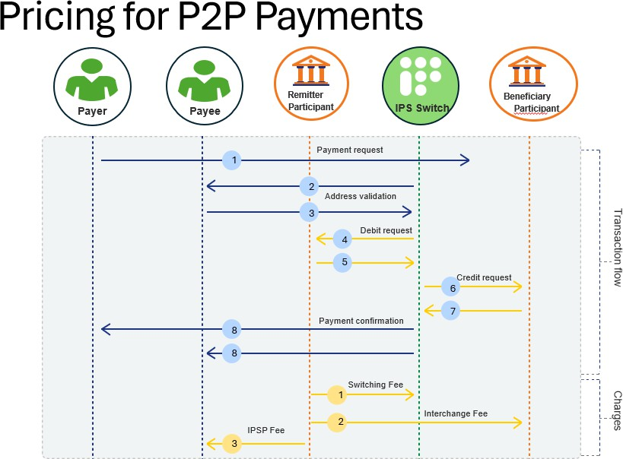

Figure 44: Pricing for P2P Payments

For person to merchant payments, the switching fee will be recovered from both the remitter participant as well as the merchant participant. This is also applicable to both merchant cash-out and cash-out in that both the remitter participant and merchant participant will be liable for a switching fee. The merchant cash-out switching fee will be higher when compared to merchant

cash-in fee to discourage high volume cash-out (albeit it being necessary during the early stages of the IPS with limited use cases, services, sand channels available). If the merchant has used an IPSP (different from the merchant SoV Provider), there will be an IPSP fee payable by the merchant’s IPSP to the customer’s IPSP. In normal circumstances, the merchant is liable for a merchant discount rate (MDR) fee to the acquiring participant. The MDR fee can be set by the acquiring participant.

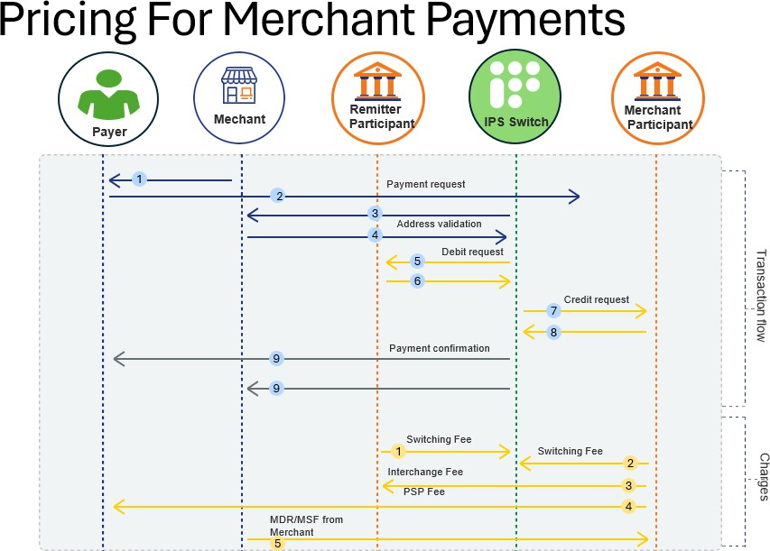

Figure 45: Pricing for Merchant Payments

    - Switching Fee for ATM withdrawals and B/G2P

The switching fee for both ATM withdrawals and Business / Government to person will be provided once these use cases are fullly developed.

Exiting Fee
The IPS Operator will charge an existing fee to participants based on the level of effort required by the Operator to remove the participant from the IPS. The exiting fee will not be applicable in cases where the removal of the participant is ordered by the Regulator.

Additional Fees
The IPS Operator will charge additional fees depending on the type of services required during operations. These fees will be provided for in the IPS Scheme Rules and pertain to:
    - Onboarding additional use cases
    - Onboarding additional channels
    - Onboarding additional IPSPs
    - Suspension of services
    - Late invoice payments to the IPS Operator

PART E: IPS BUSINESS AND PRODUCT RULES

The IPS Operator shall specify business and product rules to be followed by participants. These rules will be specified in the IPS Scheme Rules Document. The IPS Scheme Rules Document will also contain pricing information and procedural guidelines in providing IPS services. The Document will be guided the Payment System Management Act, 2023 (Act No.14 of 2023) as well as the Determination for the Authorisation of Payment System Operators and System Participants in the National Payment System (PSD−6). Some of the business and product rules are already provided below while some are also provided in the various flows throughout this document.

IPS BUSINESS RULES
Only the USSD rules as well as the transaction limits and frequency are provided below. The IPS Scheme Rules will provide further information.

USSD Rules

    - For go-live, only centralised USSD will be allowed for registration, send money, merchant payment, merchant cash in and merchant cash out.
    - The centralized USSD will be operated by the IPS Operator.
    - The IPS Operator will be assigned with a handle to route transactions through the USSD channel.
    - Although centralised, the services enabled on the USSD channel will be those of the payer IPSP or the store of value provider.
    - The provision of Value-added services (buying airtime, electricity, water, insurance etc) will not be mandated on the centralised USSD platform for go-live. Participants may provide these services directly from their own channels.
    - A switching fee will be applicable to the payer store of value provider for send money and for both payer store of value provider and merchant acquirer.
    - The USSD Channel will be zero-rated for Users when dialling the short code.

. Mobile Application Rules
    - .A mobile application should be able to detect the type of mobile device and allow a user to bind their mobile number to the mobile device.
    - Even if a mobile device has 2 sim cards, only one can be used for the device binding process.

    - A mobile application should be able to detect that the registered sim card has been removed from the mobile device and prompt the User to perform another device binding process.
    - A mobile application on which a User can access IPS services should be password protected. This includes facial recognition and fingerprint identification.

Purpose Codes
The following purpose codes have been configured on the IPS.

Purpose code | Description | Category
00 | Default (for any P2P transaction apart from mentioned below) | P2P
01 | Salary | B2P, G2P
02 | Pension | B2P, G2P
03 | Value added tax(VAT) refund | G2P, G2B
04 | Annuity | B2P
05 | Dividend | B2P
06 | Interest (Interest earned) | B2P
07 | Merchant payments | B2B, B2P
08 | Payment to creditor (Credit Transfer) | P2P
09 | Bank use – credit transfer (Payment to creditor) | P2M
10 | ATM cash out | P2M
11 | Merchant cash out | P2M
12 | Merchant cash in | M2P
13 | Goods/services purchased (for any P2M transaction for  reasons apart from mentioned above) | P2M
14 | Government disbursement (for any G2P transaction for  reasons apart from mentioned above) | G2P
15 | Merchant payments (for any B2P transaction for reasons apart  from mentioned above) | B2P
Table 48: Purpose codes

Initiation Modes
The following initiation modes will be used to describe how a transaction was initiated.
Initiation mode  value | Description | Offline / Online | Mode
01 | STATIC QR Code | Offline | This is used for QR generation
02 | STATIC Secure QR Code | Offline
15 | Dynamic QR Code | Offline
16 | Dynamic Secure QR Code | Offline
19 | STATIC QR Code | Online
20 | STATIC Secure QR Code | Online

22 | Dynamic QR Code | Online
23 | Dynamic Secure QR Code | Online
04 | Intent | NA | Non- QR initiation modes
05 | Secure Intent
18 | Dynamic ATM withdrawal  through OTP.
00 | Default
03 | USSD
Table 49: Initiation Modes

Transaction Limits, Purpose Codes, and Initiation Modes

This section defines the consolidated transaction framework applicable across all IPS use cases. The table below provides an integrated view of the transaction limits, purpose codes, and initiation modes for each use case across both Mobile App and USSD channels. The defined limits are set at the IPS level and apply per user, per day, across all Store of Value (SoV) accounts and wallets.
- Limits are defined by the combination of Use Case, Purpose Code, and Initiation Mode.
- MCI (Merchant Cash−In) and MCO (Merchant Cash−Out) limits are exclusive of the general P2P and P2M limits.
- The initiation mode defines how a transaction is triggered through a mobile app, USSD, or other supported channel.
- Where a purpose code applies to multiple initiation modes, all relevant modes are listed together.
- All limits are set at the IPS level and are reviewed periodically by IPN.
- Bulk File Upload channels are applicable only for G2P and B2P transactions.
- MCI (Merchant Cash-In) and MCO (Merchant Cash-Out) limits apply solely to their respective purpose codes and are not included in P2P or P2M daily cumulative limits.
- The Initiation Mode column lists system-recognized mode codes; detailed classification (static/dynamic, online/offline) remains defined in the Initiation Mode Reference Table (Section 22.3).
- In case of conflict between IPS-level and participant-level limits, the lower limit will apply.

Use Case | Purpose Code | Channel & Initiation Mode | Description | Daily Txn Amount Limit | Daily Txn Count Limit | Limit Set on | Limit inclusive in
Transaction Limits through Mobile App
P2P | P2P = '00/08' | Mobile App  Initiation Mode  ='01/02/15/16/19/20/22/23' | Txn through any SoV Account | N$ 10,000 | 10 | Payer/ Remitter | Overall P2P
 |  |  | Txn through any Wallet Account | N$ 10,000 | 10 | Payer/ Remitter | Overall P2P
P2M | P2M= '09/ 13' | Mobile App  Initiation Mode  ='01/02/04/05/15/16/19/20/22  /23' | Txn through any SoV Account | N$ 10,000 | 100 | Payer/ Remitter | Overall P2M
 |  |  | Txn through any Wallet Account | N$ 10,000 | 100 | Payer/ Remitter | Overall P2M
MCI | MCI = '12' | Mobile App  Initiation Mode  ='01/02/15/16/19/20/22/23' | Txn through any SoV Account | N$ 2,000 | 5 | Payee/ Beneficiary | Exclusive of P2P
 |  |  | Txn through any Wallet Account | N$ 2,000 | 5 | Payee/ Beneficiary | Exclusive of P2P
MCO | MCO = '11' | Mobile App  Initiation Mode  ='01/02/04/05/15/16/19/20/22  /23' | Txn through any SoV Account | N$ 2,000 | 2 | Payer/ Remitter | Exclusive of P2M
 |  |  | Txn through any Wallet Account | N$ 2,000 | 2 | Payer/ Remitter | Exclusive of P2M
Transaction Limits through USSD mode
P2P | P2P = '00/08' | USSD  Initiation Mode ='03' | Txn through any SoV Account | N$ 3,000 | 10 | Payer/ Remitter | Overall P2P
 |  |  | Txn through any Wallet Account | N$ 3,000 | 10 | Payer/ Remitter | Overall P2P
P2M | P2M= '09/ 13' | USSD  Initiation Mode ='03' | Txn through any SoV Account | N$ 3,000 | 100 | Payer/ Remitter | Overall P2M

 |  |  | Txn through any Wallet Account | N$ 3,000 | 100 | Payer/ Remitter | Overall P2M
MCO | MCO = '11' | USSD  Initiation Mode ='03' | Txn through any SoV Account | N$ 2,000 | 2 | Payer/ Remitter | Exclusive of P2M
 |  |  | Txn through any Wallet Account | N$ 2,000 | 2 | Payer/ Remitter | Exclusive of P2M
Transaction Limits for use cases which are channel independent
ATM | ATM  ='10'  (Categor y = P2M) | Mobile App  Initiation Mode ='18' | Txn through any Wallet Account | N $ 2,000 | 2 | Payer/ Remitter | Exclusive of P2M
Transaction Limits through Bulk File upload mode
G2P | G2P= '01/ 02/  03/ 14' | Bulk File Upload | Txn by Govt to a user | N $ 10,000 | Unlimited | Payee/ Beneficiary | G2P only
B2P | B2P= '01/ 02/  04/ 05/  06/ 07/  15' | Bulk File Upload | Txn by a merchant to user | N $ 10,000 | Unlimited | Payee/ Beneficiary | B2P only
Table 50: Transaction limits, purpose codes, and initiation modes

P2P Transactions
- Limits will be established at the account level, meaning that if a user has two distinct accounts, such as a SoV account and a wallet, the limits will be applied separately to each account. Therefore, the limits for P2P transactions will be N$ 10,000 and a transaction count of 10 for the wallet, as well as N$ 10,000 and a transaction count of 10 for the SoV account.
- For USSD transactions, the limits will be included within the P2P/P2M limits and will be set at the initiation stage. Consequently, the overall limit for USSD, regardless of the use case, is N$ 3,000. For example, if an individual makes a USSD payment of N$ 3,000 in a single day, the total limit available for P2P/P2M transactions for that individual will be N$ 7,000.
- A MCI transaction is regarded as a P2P whereby the merchant will make a payment to the customer with MCC =0000 and purpose code MCI = 12).
- The MCI limit of N$ 2,000, exclusive of overall P2P limits, applies to the Beneficiary’s SoV Account/ Wallet end, meaning that a user cannot receive more than N$ 2,000 for MCI purpose codes.

P2M Transactions
  - In the case of P2M transactions, the limits will also be N$ 10,000 for each SoV and N$ 10,000 for each wallet, thereby confirming separate limits for each account type.
  - MCO limits, where the customer is making a payment to a merchant, will be N$ 2,000 and will be excluded within the N$ 10,000 limits for a P2M transaction, with this limit being applied at the Remitter end.
  - P2M will serve both purchases at merchants and cash−out at merchants. A merchant should have 2 QR codes to distinguish between payments to merchants for purchases and payments to merchants for cashing out. The appropriate purpose code should be used.

ATM Transactions
- ATM cash withdrawal limits will be separate from the P2M limits, providing the user with an additional N$ 2,000 limits for ATM withdrawals.

- ATM transactions will occur only through Wallets, thus the limit of N$ 2000 will be on Wallet only.

IPS PRODUCT RULES
To be covered in the IPS Scheme Rules Document

SERVICE LEVEL AGREEMENT
To be covered in the IPN Operational SLA

ANNEXURES
To be updated as relevant.

